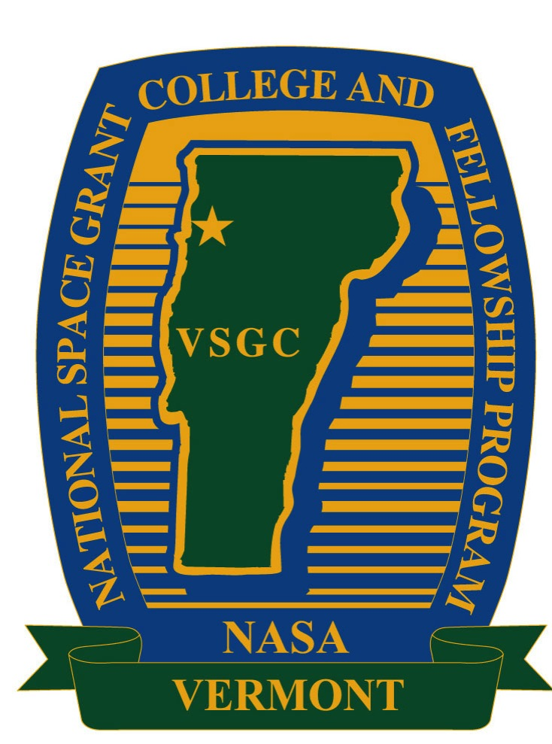 | Vermont Space Grant and Vermont NASA EPSCoR Program  2019 NASA Center Travel  Grant Program  Proposal Deadline: March 8, 2019 @ 11:59 PM | 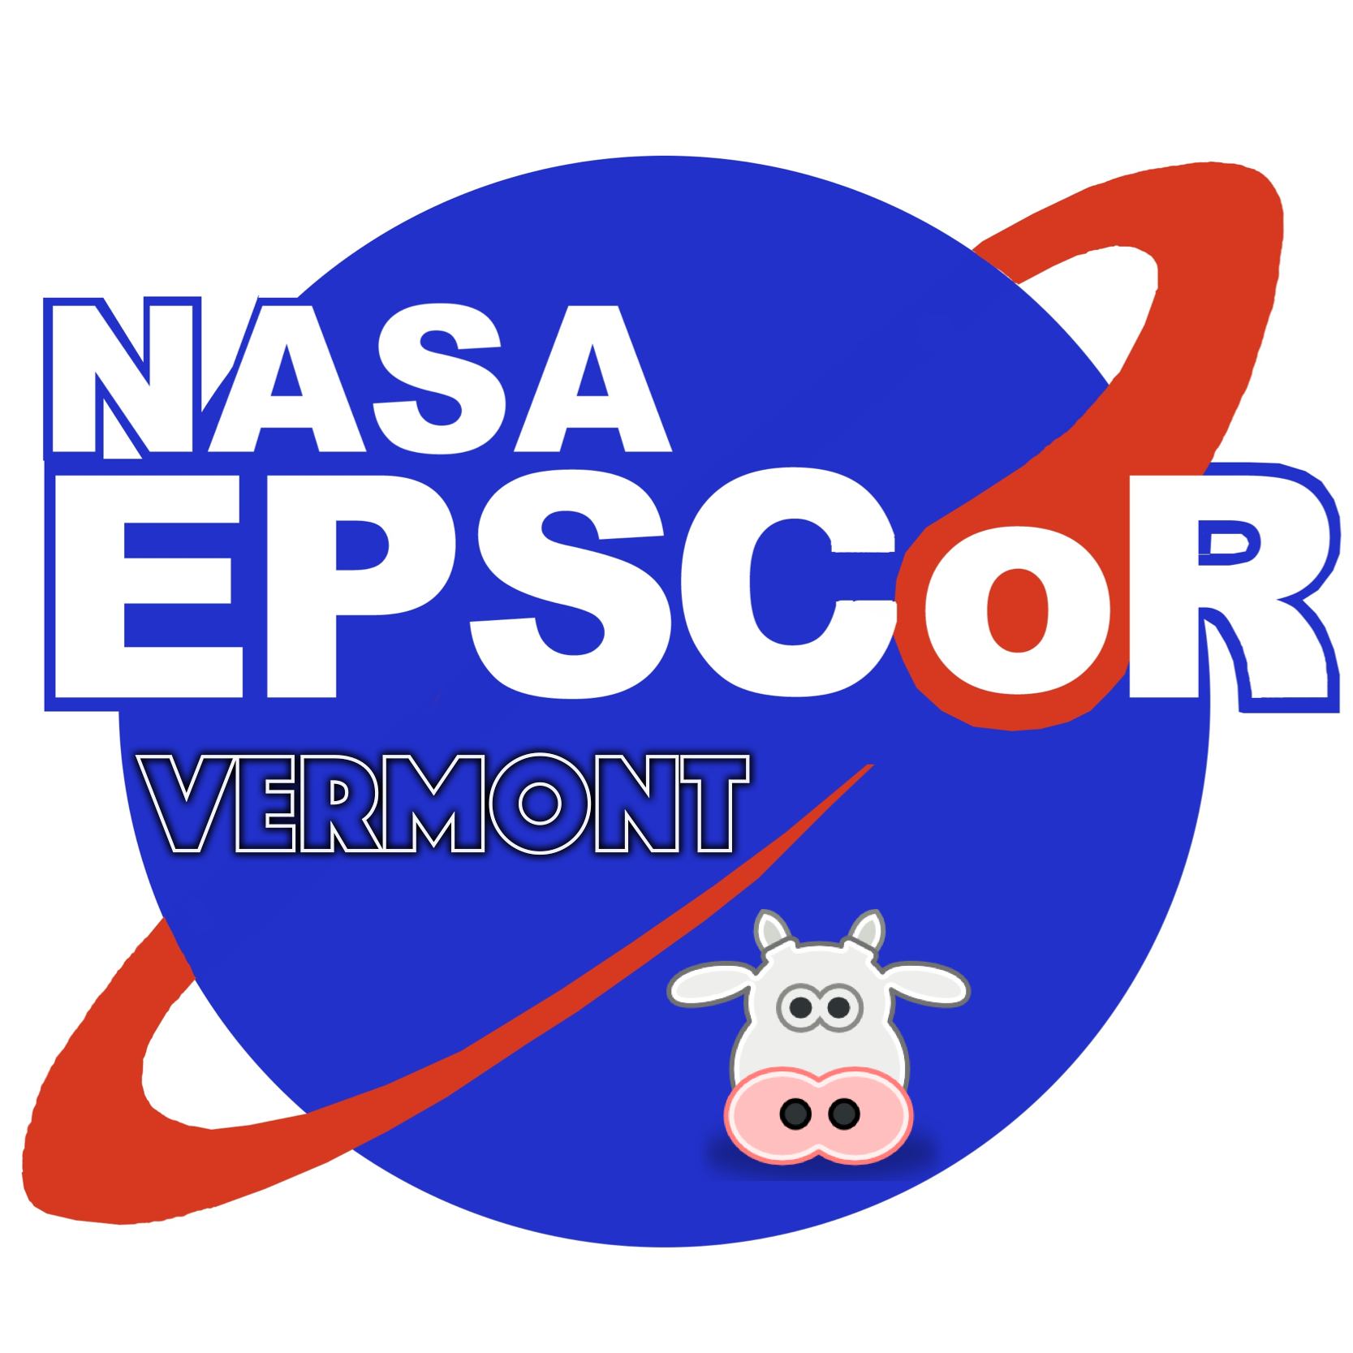

BACKGROUND: Key goals of the Vermont Space Grant Consortium (VTSGC) and Vermont's NASA EPSCoR Program are to build research infrastructure and help Vermont's academic faculty establish ties to NASA and become nationally competitive for external research funding. To support these goals, the VTSGC and VT-NASA EPSCoR Program annually offers a limited number of NASA Center Travel Grants. These travel grants are intended to promote new collaborations with NASA researchers or foster existing collaborations.

WHO IS ELIGIBLE: Eligible principal investigators are those persons who are full-time faculty members at any of Vermont's higher educational institutions. However, any support from VTSGC-based funding is restricted to US citizens only.

AREAS OF INTEREST AND NASA LINKS: Research projects linked with the travel request must be in an area that is strongly aligned with a new or continuing NASA research priority or technology need, and the request must make an explicit connection with NASA. The request should also detail plans for establishing or strengthening links with NASA researchers. If contact has been established with colleagues at a NASA Center or Mission Directorate, a letter or email of support for the project from a NASA contact will significantly strenghten the case for support.

REVIEW CRITERIA: Projects chosen for NASA Center Travel Grants will be in research areas that strongly align with new or continuing NASA research priorities and technology needs. Priority consideration will be given meritorious proposals submitted by: (1) junior tenure-track faculty and (2) investigators who have not previously received support from the Vermont NASA programs.

BUDGET: A detailed budget request and justification for the travel expenses is required. The awards are typically limited to a maximum of $2,500.

APPLICATION PACKET: The completed application packet shall include the following items:

- Cover Page ___
- Justification for Travel (limit of two pages, exclusive of any references) ___
- Explanation detailing NASA alignment of research topic and/or existing NASA contacts; include letter/email of NASA support if relevant (limit one one page, exclusive of attachments) ___
- Budget and justification for travel costs___

ELECTRONIC APPLICATION PROCEDURE: All proposal applications must be submitted electronically to the Space Grant Office. The electronic submission must be made no later than 11:59 pm on March 8. The proposal packet described above must be saved as a single PDF file and emailed to the VT Space Grant Office to Ms. Debra Fraser (dfraser1@uvm.edu) with CC to Director Darren Hitt (SG.Director@uvm.edu).

Note that the availability and number of these awards are subject to annual NASA funding allocations.

