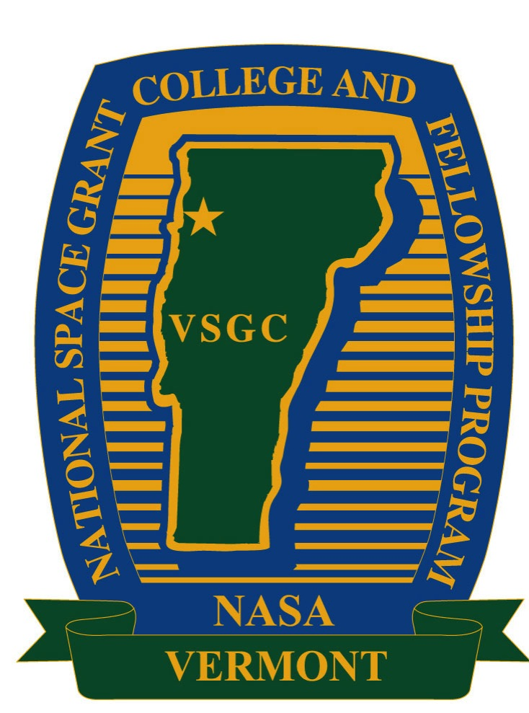 | Vermont Space Grant & Vermont NASA EPSCoR Program  2019 Travel Grant Application | 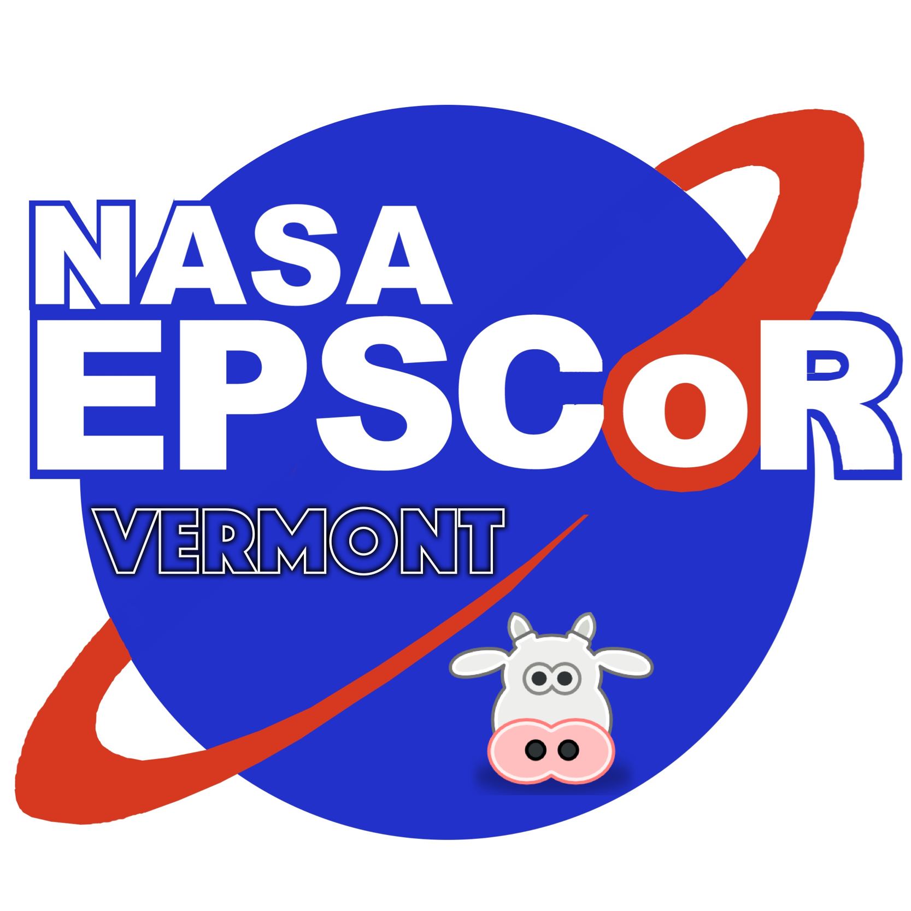

Name and Title of Faculty Applicant: ______________________________________

Project Title: __________________________________________________________

Faculty Affiliation: _____________________________________________________

Faculty E-mail: ________________________________________________________

Phone number: ________________________________________________________

NASA Center for Visitation: _____________________________________________

Area(s) of Interest for NASA: _____________________________________________

Amount Requested: ____________________________________________________

Signature:

Faculty Member:

________________________________________________________________ Print Sign Date

Checklist: COMPLETE APPLICATION DUE BY 11:59 p.m. on March 8, 2019:

- Cover Page ___
- Justification for Travel (limit of two pages, exclusive of references) ___
- Explanation detailing NASA alignment of research topic and/or existing NASA contacts; include letter/email of NASA support if relevant (limit one one page, exclusive of attachments) ___
- Budget and justification for travel costs___
- Two-page CV for faculty applicant___

The complete application must be saved as a single PDF file and emailed to the Space Grant Office to Ms. Debra Fraser (dfraser1@uvm.edu) with CC to Director Darren Hitt (SG.Director@uvm.edu).

