How to send a portfolio back to a student for editing:
- Open the portfolio. In the upper right corner, you’ll see three tabs: Assessment Tools, Extensions, and Feedback. Click Extensions.
- Click Edit Due Date in the upper right corner.
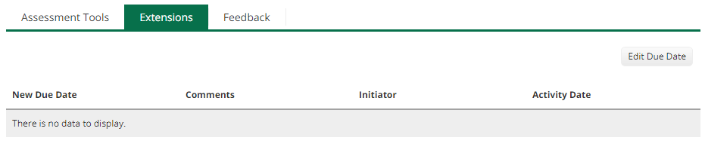
- Type in a new date where it says New Due Date / Time. Then click the green Update button at the bottom.
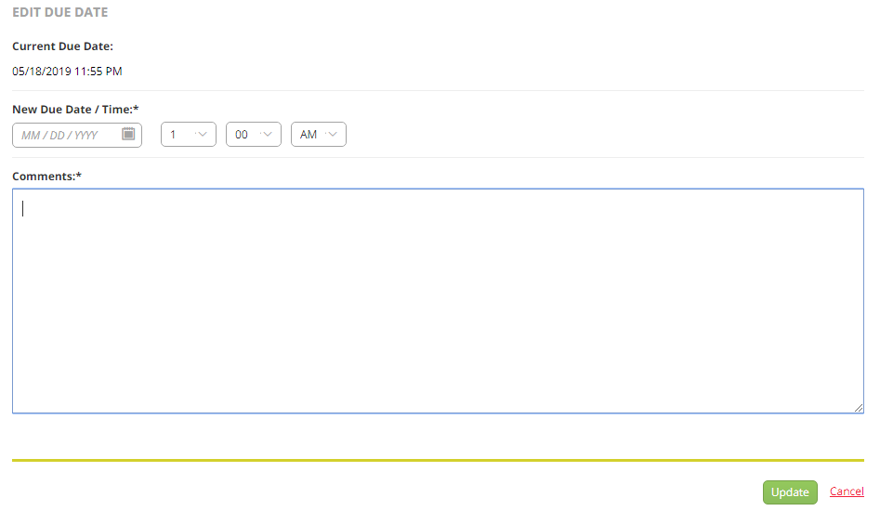
- Just close it from there. DO NOT hit Submit in the upper right corner!

