Before sending out an assignment, check to make sure you have access to the appropriate rubric. If you are using a new rubric, please email Lisa.Cota@uvm.edu to get the rubric into the system.
- Click the Courses menu, then click Coursework. The Assignments menu will open; click Send.
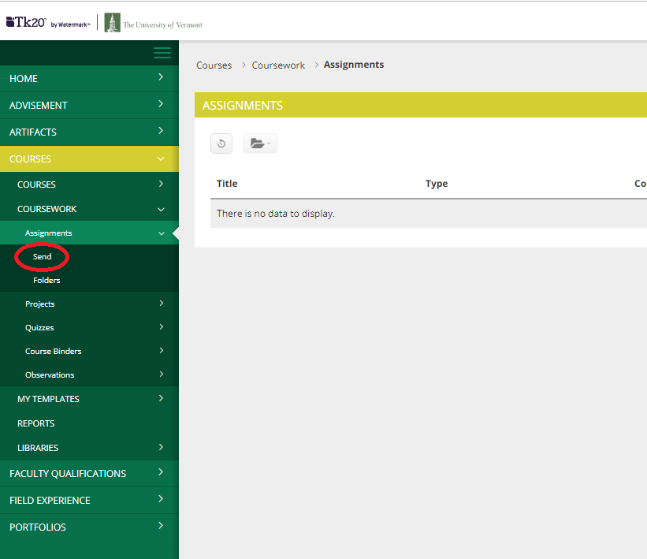
- Select the course(s) for this assignment, then click Next.
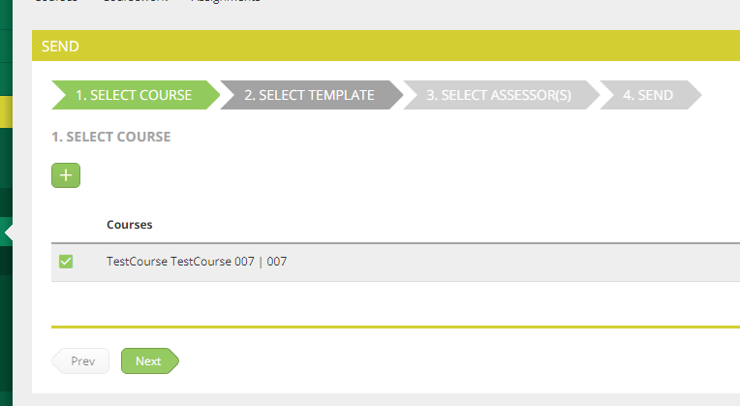

- Select your assignment template, then click Next. If you do not see your assignment listed, please email me!
- Select assessors, click the box next to your name, then click Next.
- Name the assignment, then set a due date.
- Click the arrow next to Advanced Options. Scroll down and make sure you have selected “Yes” in response to “Would you like to automatically send this Assignment…”
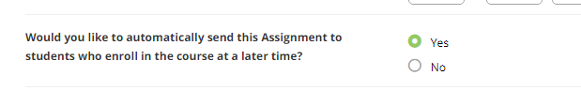
- Click Send!

