**IRB**



**UVMClick Website https://www.uvm.edu/ovpr/uvmclick Email Support** [**UVMClick@uvm.edu**](mailto:UVMClick@uvm.edu)

**UVMClick Login** [**https://irb.connect.uvm.edu/IRB**](https://irb.connect.uvm.edu/IRB) **Phone Support (802) 656-5040**

**How to Request Reliance on Another IRB (External IRB)**

Requests to rely upon another IRB must be submitted through UVMClick-IRB. These are referenced in Click as External Studies.

You can request to rely on another IRB by entering information into a series of online forms. The number of forms included may change based on the answers you provide. The forms tell you where to attach files to provide supporting information.

**Before you begin,** gather files and information about your study as required in Section 13.3 of the Manual.

**To create a new external study for review:**

1. From “My Inbox” or the IRB > Submissions screen, Click **Create New Study**.



1. Fill in the applicable boxes and answer the questions.

Note: New UVMClick protocols will have a new numbering scheme. Example: “STUDY000001”

**\*\*Tip\*\*** A red asterisk (**\***) precedes each question that requires an answer. If you cannot answer a required question at this time, or if you need to stop and continue at a later time, click the SAVE link at the top of the Smartform. If you do not answer a required question initially, you must return and answer it before you can submit the study to the RPO Office for review.

**\*\*Tip\*\*** When you create a study, you are assigned to be the primary contact who receives all communications from the IRB on behalf of the study team. (The principal investigator you specified also receives the communications.) You can change the primary contact by clicking the activity on the left side of the screen called “Assign Primary Contact”.



External reliance includes at a minimum two institutions, typically a reviewing IRB and multiple IRBs relying on that one IRB, therefore, UVMClick-IRB produces two records. One record is the overarching External Study and the second record is a specific site(s). You will be filling out the necessary forms for each.

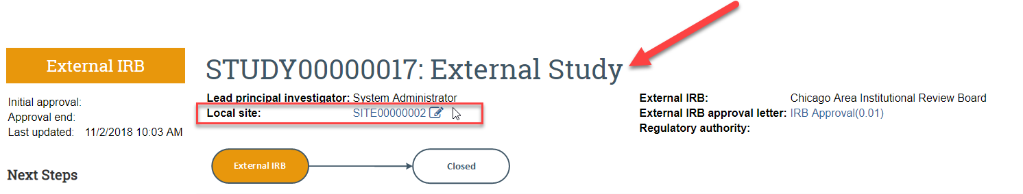

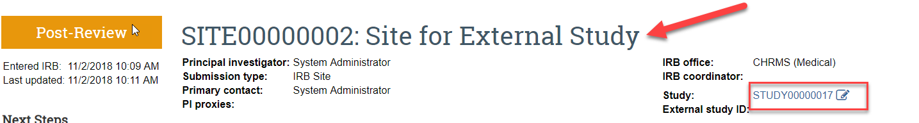

You can toggle between the two using the links indicated.

1. On the first SMART form page called “Basic Information

For External Studies you must answer all of the required fields and specifically the following questions in this manner. Don’t forget to upload the protocol that has been provided by the lead site. Continue to next page.

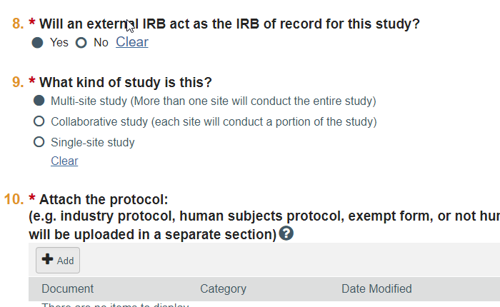

1. For External IRB page of the SMART form page only the first field requires completion, all others can be disregarded. Continue to next page.
2. Complete the Funding Sources and Study Scope pages and continue.
3. Please use the guidance below to correctly complete the Study-Related Documents page.

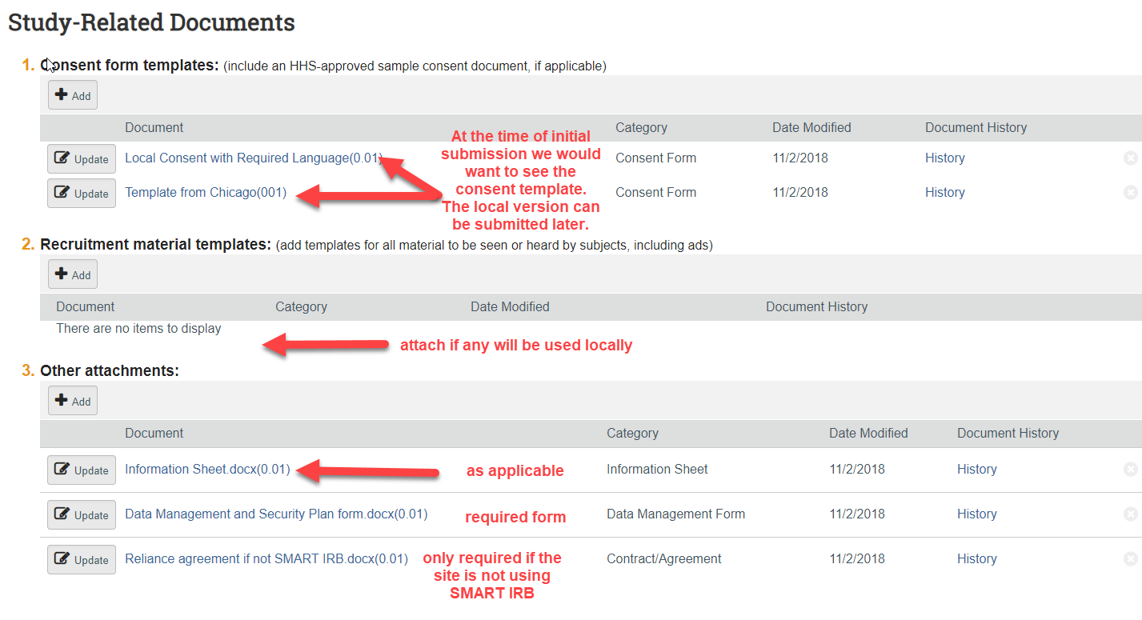

1. When you reach the final page, click **Finish** to exit the study. You have successfully created a request for reliance, but it is not ready to be submitted yet.

8. Open the new SITE record as indicated below to enter some site specific information. Click on Edit Study once you are in the site record.

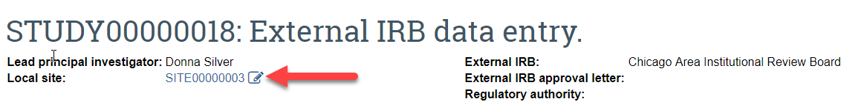

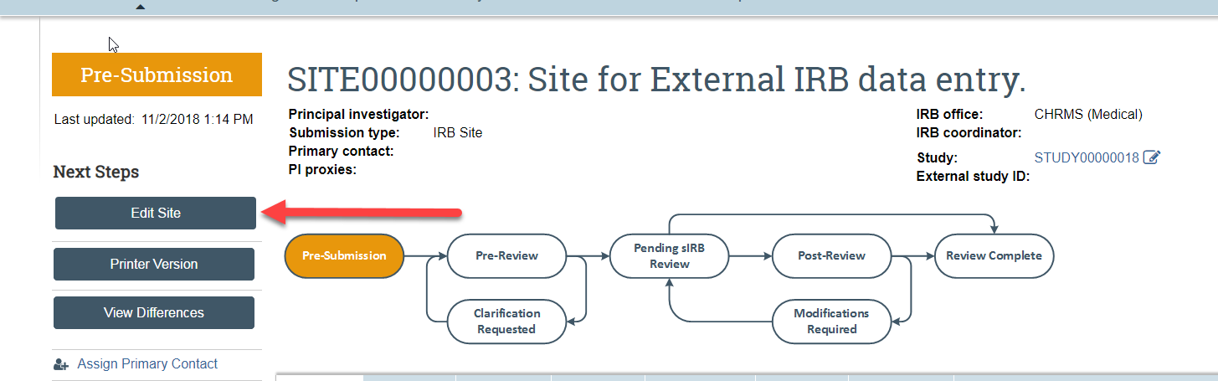

Click on Hide/Show Errors and complete only those additional items.



Below is a picture of what you will see. The fields at the bottom are what you need to complete to finish data entry on this External Study. **There will be many fields that are blank, however these have already been capture under the overarching study. You only need complete the required fields as displayed by the hide/show errors tab.** Click on each blue hyperlink to get to the field that requires completion and then click on Save back at the top of the page.

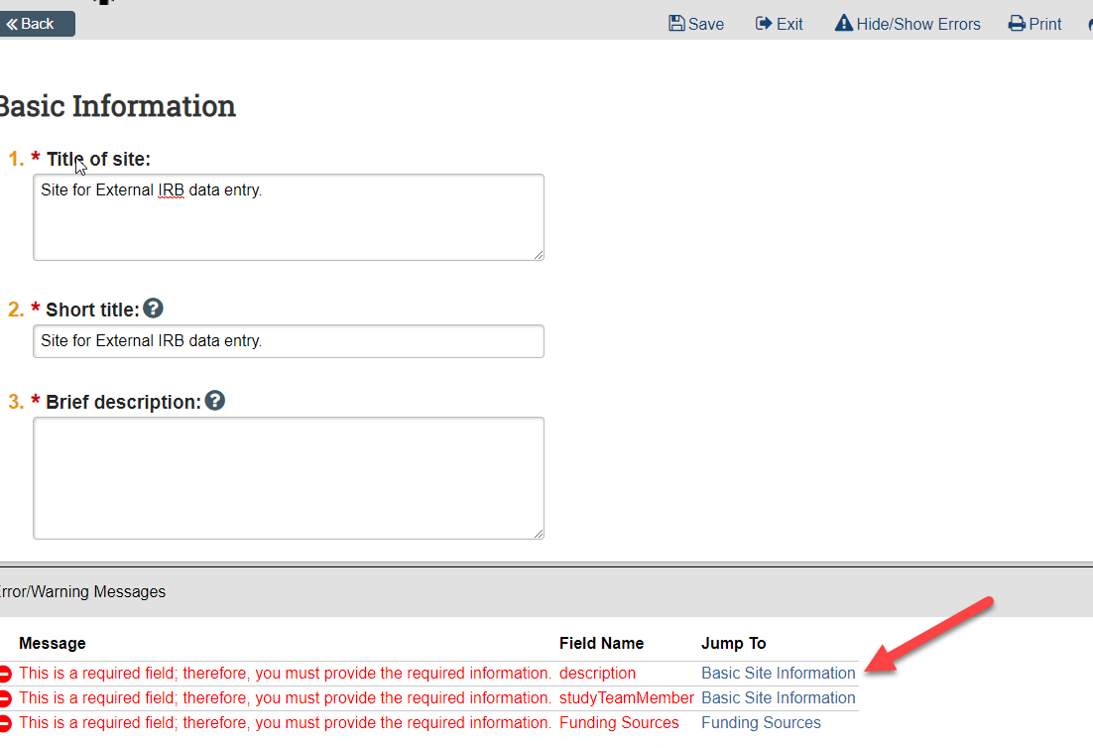

**Submitting the Study for Review**

After reaching the final page of a new protocol and clicking “Finish” to exit the study, the status of the protocol will still display as “Pre-Submission” and will remain visible in your “My Inbox” until submitted to the IRB Office for processing.

Click the activity on the left that says “Submit”.

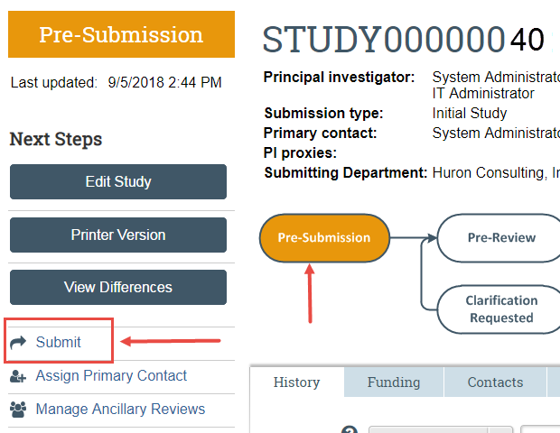

If there are any required fields that you forgot to enter, the Submit process will display them. You can use the pop-up to Jump to those particular screens quickly and enter the missing data.

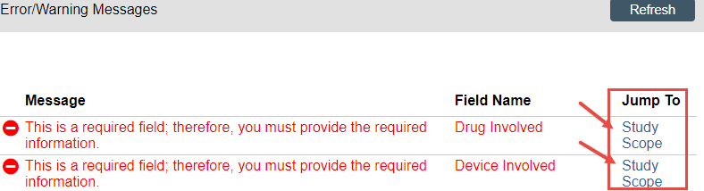

**NOTE:** These Errors/Warning Messages only appear if required field entry was missed.

When clicking the **Submit** activity, once all required field entry is complete, certification text will appear. Read the text and click **OK**.

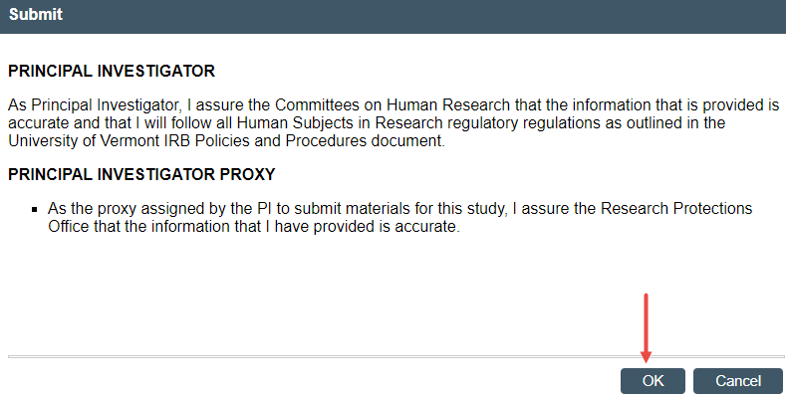



The status of the protocol is no longer “Pre-Submission”. It has changed to “Pre-Review” indicating it is in the hands of the IRB Office for processing.

You will also note that the protocol is now in View Mode and no longer in Edit mode.

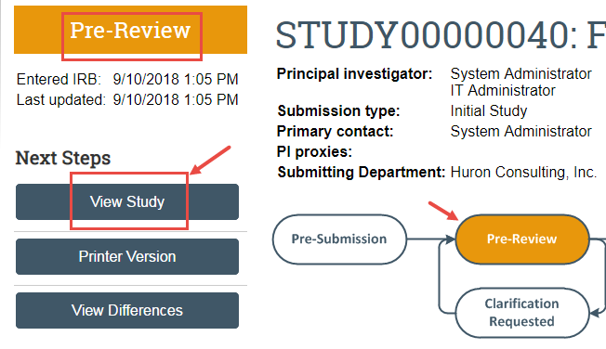

The protocol has now been submitted and removed from your “My Inbox.” It now displays in the IRB Office “My Inbox.”