IRB

UVMClick Website https://www.uvm.edu/ovpr/uvmclick Email Support UVMClick@uvm.edu
UVMClick Login https://irb.connect.uvm.edu/IRB Phone Support (802) 656-5040

How to Create and Submit an RNI (Safety) Submission for an External IRB

In UVMClick, Report New Information (RNI submission) is synonymous to
- Safety
- Adverse Event
- Noncompliance
- Unanticipated Problem(UAP)

Please Note: Many of the IRB Forms have transitioned into our UVMClick online smartforms. The Safety form has been retired and transitioned into an online smartform.

Create a new RNI Submission

- From “My Inbox” or the IRB>Submissions screen, navigate to the appropriate protocol and click on the name to open it.

For External IRB Protocols you must submit RNIs through the Site record not the study record. Make sure you are in this record
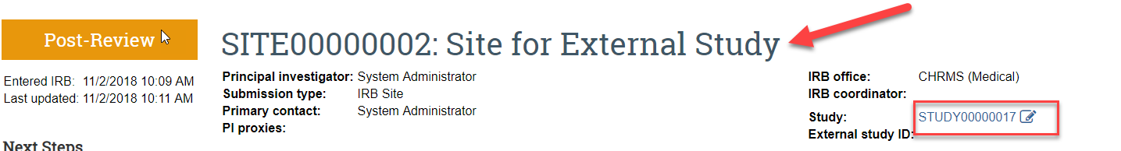

Not this record
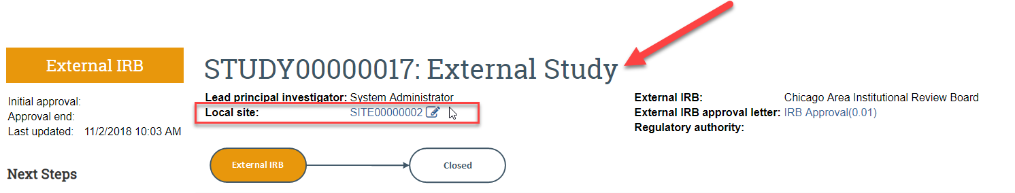

- Click Report New Information on left side of screen.

- Answer all questions and hit Continue. Those questions with a red asterisk are required.

- If you miss any required fields, there will be a message at the top of the screen
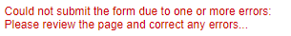
- Scroll through the page. Missing fields will display the following red text:

Enter all missing information and click the Continue button.

Submit the RNI to the IRB Office for Processing

After completing the RNI online form, the status of the RNI submission will display as “Pre-Submission” and will remain visible in your “My Inbox until submitted to the IRB Office for processing.

To submit a finished RNI submission to the IRB Office for their review and processing,
- Make sure the RNI is open
- Click the activity on the left that says “Submit”

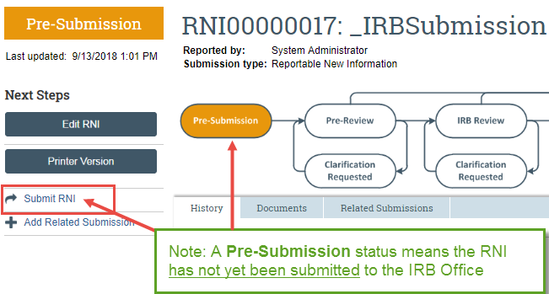

When clicking the Submit activity certification text will appear. Read the text and click OK.

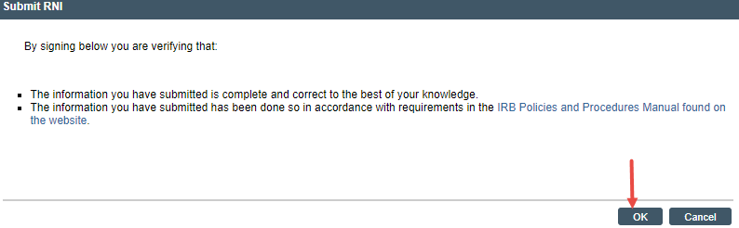
The status of the RNI is no longer “Pre-Submission”. It has changed to “Pre-Review” indicating it is in the hands of the IRB Office for processing.
You will also note that the RNI is now in View Mode and no longer in Edit mode.

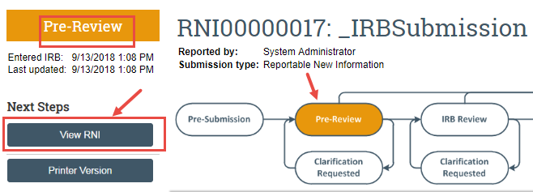

The RNI has now been submitted and removed from your “My Inbox.” It now displays in the IRB Office “My Inbox” for review and processing.

