IRB

UVMClick Website https://www.uvm.edu/ovpr/uvmclick Email Support UVMClick@uvm.edu
UVMClick Login https://irb.connect.uvm.edu/IRB Phone Support (802) 656-5040

How to Create and Submit a Modification (Study Team Member) for an External Study

Please Note: Many of the IRB Forms have transitioned into our UVMClick online smartforms. The Key Personnel Change form has been retired and transitioned into an online smartform.

Create a Modification (Study Team Member)

- From “My Inbox” or the IRB>Submissions screen, navigate to the appropriate protocol and click on the name to open it.

For External IRB Protocols you must submit RNIs through the Site record not the study record. Make sure you are in this record
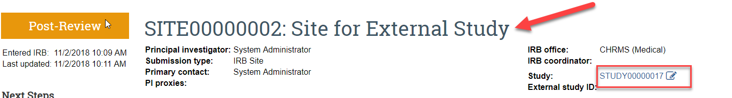

Not this record
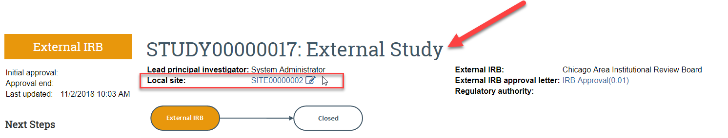

- Click Create Modification/CR.

- Select The Modification radio button and hit Continue.
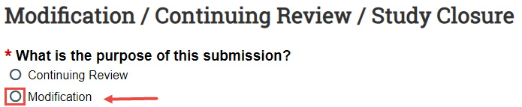
- Check the option “Study team member information”.

- Complete the question “Summarize the Modifications” by listing the study team members you wish to add, update or remove. Note that this is required field entry as it is prefixed with a red asterisk.
Note: When filling in the question “Summarize the Modifications” this text will appear on the future approval letter. Please make sure to type the text carefully as there isn’t any spellcheck in UVMClick.

Add a new study team member
Add new study team members via the +Add button.
Important!
- Required Human Subject training (and GCP training if applicable) should be completed prior to adding a new study team member.
- Make sure that the study team member name you are adding was noted in the previous question “Summarize the Modifications” text box.

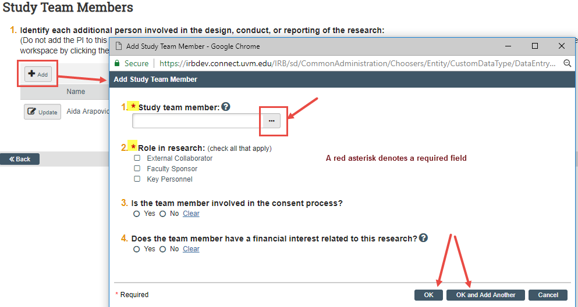

NOTE: If you are not able to find the team member name you wish to add, contact the IRB Office for assistance via UVMClick@uvm.edu or 656-5040.

Updating an Existing Study Team Member

- Click the UPDATE button next to an existing study team member’s name to update their team member information.
- Click OK

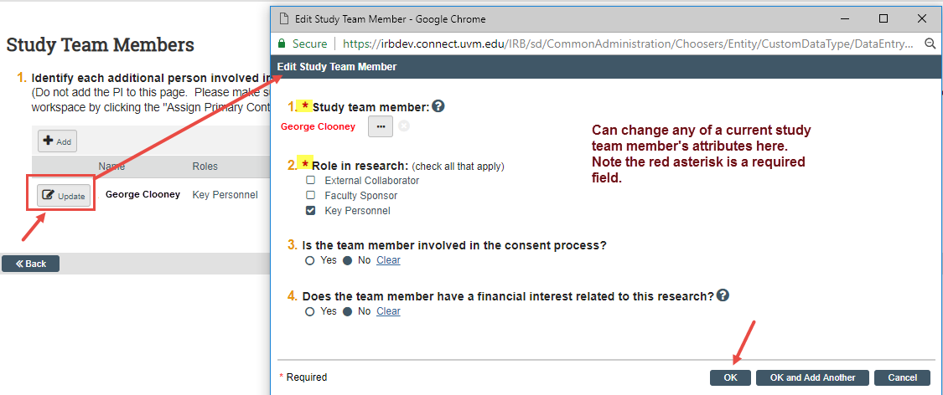

Submit the Modification to Change Key Personnel to the External Study

After clicking “Finish” to exit the Modification, the status of the submission will continue to still display as “Pre-Submission” and will remain visible in your in-box until submitted to the IRB Office for processing.

To submit a finished Modification submission to the IRB Office for their review and processing,
- Make sure the Modification is open
- Click the activity on the left that says “Submit”.

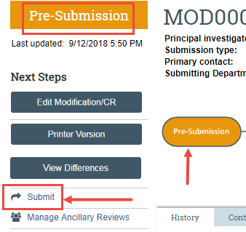

When clicking the Submit activity, certification text will appear. Read the text and click OK.
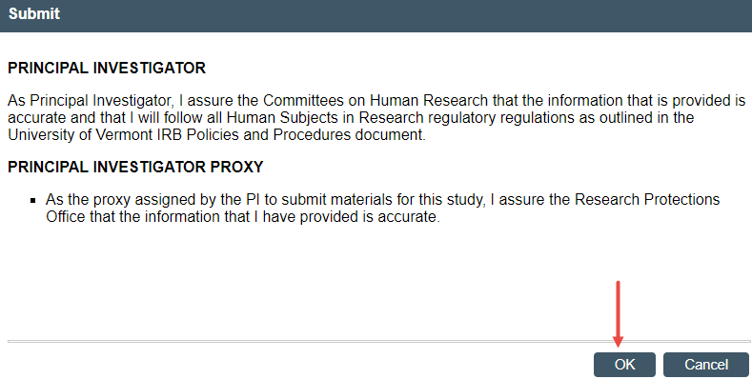

Once submitted, the status of the Modification is no longer “Pre-Submission”. It has changes to “Pre-Review” indicating it is in the hands of the IRB Office for processing.
You will also note that the Modification is now in View Mode and no longer in Edit mode.
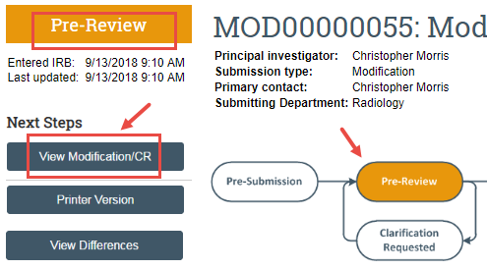

The Modification has now been submitted and removed from your In-Box. It now displays in the In-Box for the IRB Office.

