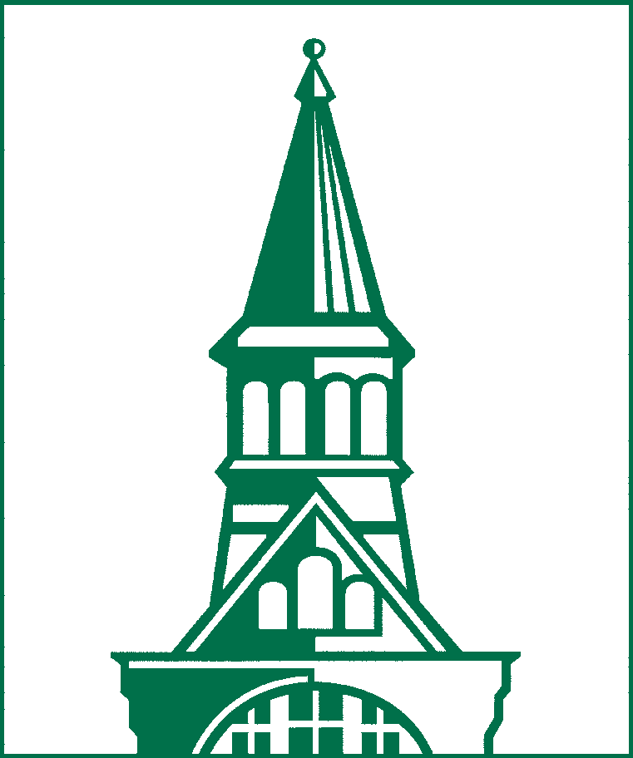
The University of Vermont
GRADUATE COLLEGE ADMISSIONS

UVM ACCELERATED MASTER’S DEGREE PERMISSION FORM
Upload as an addendum to UVM’s Graduate College Application

Accelerated Master’s Degree programs are designed to allow current UVM undergraduate students to initiate graduate coursework while still an undergraduate, thus decreasing time and cost to obtain the master’s. Descriptions of current accelerated master’s programs are found in the Graduate Catalogue. See page 2 of this form for this student’s planned coursework.

The purpose of this form is for the prospective master’s program applicant to review their academic plan with their undergraduate Dean’s office to ensure they will be on track to complete their undergraduate degree program in the time frame expected prior to enrolling in the accelerated master’s program. This review process will require permission from the undergraduate Dean’s office for the applicant to apply to the master’s program. This completed form (both pages) must be submitted to the Graduate College within the application to the accelerated master’s program.

Student Name: _____________________________________________ Student ID#: __________________________

Undergraduate Major(s) _________ __________ _____________________________________________________________

College/School: ________________________________________________________________________________________

Term (Fall, Spring or Summer) /Year you expect to graduate: ___________________________________________________

Accelerated Master’s Program to which you are applying: ______________________________________________________

Term (Fall, Spring or Summer) /Year for which you are applying: _________________________________________________

Anticipated Graduate College Application Submission Date (month/year): __________________________________________

By signing below, all parties grant permission for the named Student to apply to the Master’s program indicated above. In addition, all parties acknowledge that the student’s planned graduate coursework (p.2) to be taken prior to completion of the bachelor’s is appropriate to the graduate program and that taking these courses will not extend the time to degree for completion of the bachelor’s..

__________________________________________________ Date: _________/_________/_________
Student Signature

__________________________________________________
Undergraduate Dean’s Office Printed/Typed Name

__________________________________________________ Date: _________/_________/_________
Undergraduate Dean’s Office Signature

_________________________________________________
Graduate Program Director Printed/Typed Name

__________________________________________________ Date: _________/_________/_________
Graduate Program Director Signature

Program Plan for graduate courses taken prior to completion of the bachelor’s

After acceptance into the Master’s Degree Program, students may take up to six (6) credits of graduate-level courses at UVM toward both the bachelor’s and master’s degrees. In some programs, an additional three (3) credits of graduate-level coursework taken prior to award of the bachelor’s, beyond the six double counted credits, may be used for the master’s, provided the course does not also count toward the bachelor’s degree.

Students must be admitted by the Graduate College before taking any courses that will apply to the master’s degree, i.e., all courses used for the master’s degree must be taken after formal admission to the Graduate College. The graduate program will be entered in Banner as a secondary curriculum and will become the primary curriculum following completion of the bachelor’s. In most cases, students will apply to the graduate program in their junior year for admission in the fall of their senior year.

NOTE: If you intend to take a 200 level course, it must be listed in the current graduate catalogue as approved for graduate credit. And you must email the professor teaching the course on or before the start of the course to let them know you are taking it for graduate credit and should be treated as a graduate student in the course in terms of specific expectations and assessment. That email must be copied to gradcoll@uvm.edu for inclusion in your file. The subject line for this email should be “Accelerated Masters’ Program Course”. Failure to send this email will result in the Graduate College not allowing the course to count for graduate credit. (Even though you are an undergraduate, 300 level courses are always graduate level and don’t require any notification.)

Courses must be graded with letter grades (not P/F, S/U, SP/UP). Independent study and research credits are not available for this option.

Please list up to two courses (6 credits) you intend to take for graduate credit prior to completion of the bachelor’s that will also count towards the graduate transcript. Include the course catalogue number and name. Also indicate the term (summer, Fall or Spring) and year you expect to take each course. Should your plan change, please notify the Graduate College and the Graduate Program Director prior to taking a different course.

Course #1: ______________________ ______________________________________ ____________________________
Number Name Term to be taken

Course #2: ______________________ ______________________________________ ____________________________
Number Name Term to be taken

If the accelerated master’s program to which you are applying allows an additional 3 credits at the graduate level taken prior to completing the bachelor’s to count for graduate credit (but not also count towards the undergraduate degree), please indicate the course you plan to take for those credits:

Course #3: ______________________ ______________________________________ ____________________________
Number Name Term to be taken

Process: Following completion of your first term as a full time graduate student after completion of the bachelor’s, Graduate College Student Services will notify the Registrar to have the courses added to your graduate transcript.

Consult the Graduate Catalogue for the accelerated master’s program for any program specific requirements (grade minima, for example).

For general questions, contact the Graduate College Admissions

330 Waterman Building, 85 South Prospect Street
Burlington, VT 05405-0160
(802) 656-2699 • fax: (802) 656-0519
Email: graduate.admissions@uvm.edu

