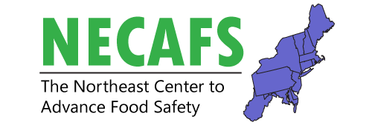
Needs Assessment Workgroup Meeting
February 12, 2020
9:30 – 12:30 pm
Independence Ballroom
Overall intent of this meeting: Overview of produce safety needs assessments for the northeast region. What is the biggest need and the most important influencing factor and how can each be addressed?
Time | Presenter(s) | Title
9:30 | Chris Callahan | Welcome and Introduction to Meeting
9:35 – 10:00 | Betsy Bihn &  Laura Pineda-Bermudez | Summary of Local Food Safety Collaborative Needs Assessment Survey Report
10:00 – 10:35 | Hannah Doyle | NECAFS Food Safety Needs Assessment Systematic Review
10:35 – 10:45 |  | Break
10:45 – 11:15 | Facilitated by: Chris Callahan & Hannah Doyle | Break-out Group Session  Discussion: examples of support that resulted in grower successfully overcoming specific need
11:15 – 11:25 |  | Reporting of Break-out Groups  Summarize successes, highlight examples
11:25 – 11:55 | Facilitated by: Chris Callahan & Hannah Doyle | Break-out Group Session  Discussion: examples of existing challenges
11:55 – 12:05 |  | Reporting of Break-out Groups  Summarize challenges, highlight examples
12:05 – 12:30 | Facilitated by: Chris Callahan & Hannah Doyle | Group Discussion  Discuss future work that remains, vote on biggest need and most important influencing factor, and articulate potential projects to address each.

