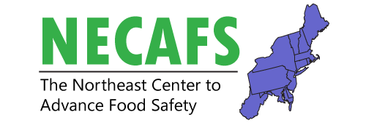
Buyer Workgroup Meeting
February 12, 2020
9:30 – 12:30 pm
Headhouse Tower Lounge
(9th floor, room key needed for elevator)

Overall intent of this meeting: The 2019 buyer meeting articulated the need “to put together a new and updated standard for produce safety annually.” In response, NECAFS received FSOP funding in 2019 to develop an online handbook of produce safety standards for buyers. We have a blank slate, what information and development framework are needed to ensure the handbook is addressing our region’s common challenges?

Time | Presenter(s) | Title
9:30 – 9:40 | Elizabeth Newbold | Welcome and Introduction to Meeting and Review of 2019 Albany Meeting
9:40 – 10:00 | Hans Estrin | Introductions and Discussion  Any thoughts/changes/additions to summary of 2019 meeting?
10:00 – 10:30 | Elizabeth Newbold & Hans Estrin | Developing a Handbook of Produce Safety Standards for Buyers
10:30 – 10:50 | Gina Clithero & Kristina Sweet | Vermont Produce Program: Buyer Outreach Initiative
10:50 – 11:00 | Sedona Chavez | Development of State Implementation Matrix
11:00 – 11:15 |  | Break
11:15 – 12:30 |  | Concurrent Break-out Groups
 | Buyer group facilitated by: Hans Estrin & Wes Kline | Buyer Break-out  Headhouse Tower Lounge | Educator/Regulator Break-out  Liberty Ballroom C
 | Educator/Regulator group facilitated by: Elizabeth Newbold

