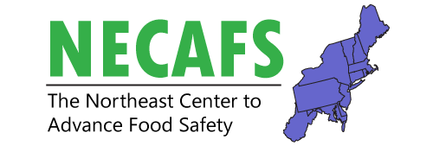
Preventive Controls Workgroup Meeting

February 11, 2020

1:00 – 4:30 pm

Headhouse Tower Lounge (9th floor, room key needed for elevator)

Overall intent of this meeting: Updates and overview of preventive controls needs assessment for the northeast region and subgroup activities. What are the needs and how does that inform our work?

Time | Presenter(s) | Title
1:00 | Andrea Gilbert & Dave Seddon | Welcome and Introduction to Meeting
1:05 – 1:35 | Andrea Gilbert | Needs Assessment Review and Summary Results
1:35 – 2:05 | Glenn Bass | FDA Update
2:05 – 2:25 | Bill Lachowsky | FSPCA Update
2:25 – 2:40 |  | Break
2:40 – 4:00 | Luke LaBorde  Nicole Richard  Beth Demmings  Facilitated by: Andrea Gilbert & Dave Seddon | Subgroup Updates  Awareness  Evaluation  Resources  Group discussion - Discuss future work that remains based on needs assessment, identify the biggest need(s) and articulate any adjustment to project proposals to address each.
4:00 – 4:25 | Facilitated by: Andrea Gilbert & Dave Seddon | Open Mic  Group report out on current and future planning of PCHF projects in the Northeast
4:25 – 4:30 |  | Closing and Next Steps

