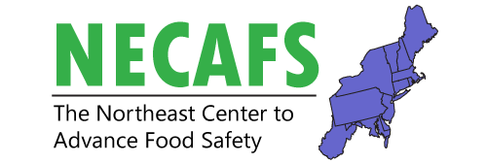**Produce Safety Workgroup Meeting**

February 11, 2020

1:00 – 4:30 pm

Independence Ballroom

Overall intent of this meeting: We’ve gone from education to practice to inspection. How can we build research and educational programs that address the challenges that still exist in the field?

|  |  |  |
| --- | --- | --- |
| **Time** | **Presenter(s)** | **Title** |
| 1:00pm | *Chris Callahan* | **Welcome and Introduction to Meeting** |
| 1:10 – 1:25 | *Gretchen Wall* | **Produce Safety Alliance Update**  Training evaluation results |
| 1:25 – 1:40 | *Chris Callahan* | **Summary of NECAFS PSA Pre and Post Test Results** |
| 1:40 – 1:55 | *Meredith Melendez* | **Summary of On-Farm Readiness Review Evaluations** |
| 1:55 – 2:10 | *Andre Cantelmo* | **Growers Perspective – OFRR and Farm Inspections** |
| 2:10 – 2:25 | *Socrates Trujillo* & *Marianne Solomotis* | **Produce Safety Research Consortium** |
| 2:25 – 2:25 |  | **Break** |
| 2:25 – 4:30 | *Facilitated by: Chris Callahan* & *Betsy Bihn* | **Group Discussion**  How do we address challenges that still exist?  Discussion about practices, training, and research. |