DEVELOPING YOUR LEARNING AGREEMENT



(A how-to-guide for mapping your path through the concentration year field and learning agreement)

Ann Pugh, MSW, ACSW

UVM Department of Social Work

ann.pugh@uvm.edu

August 2018-May 2019

Revised 8/30/18

MAPPING YOUR JOURNEY

(TABLE OF CONTENTS)

PART 1: GETTING READY

Thinking, reflecting, planning and researching pg 3

PART 2: PUTTING THE PLAN IN WRITING

Describing all the sections & identifying the format pg 4

PART 3: Appendix

Field Assignments example pg 12

Department Safety Plan Policy……………………………………..pg 13

PART 4: GETTING THERE ON TIME

Due Dates pg 14

Step 1: PLANNING YOUR JOURNEY 

Thinking, Reflecting, Researching and Mapping

*Purpose: As an example of a deeply relational document, the learning agreement, a student written assignment, requires significant input from your field instructor as well as your review of the course blackboard page containing the syllabus and assignments and the department web site outlining field policies and expectations. It presents a wonderful opportunity for collaboration, curiosity, discovery, exploration, visioning, agreement, and building some authentic connections*

1. j0297749Reflect on the path you’ve taken to date in terms of social work practice and experience as well as your goals for the future. Where have you been? Who are you becoming as a social worker? Where do you want to be as a social worker at the end of this year? What do you bring to this year’s field learning experience? What are your hopes and aspirations for it? Take the time to think deeply so as to not miss any “overlapping issues” that just might reveal connections to some piece of your work this year.
2. MCj00902330000[1]Collaborate with your field instructor for identification of learning assignments, practice opportunities and tasks. Discuss how to integrate your classroom assignments with potential activities/assignments in the field. Don't forget that they, along with your field liaison and other Department of Social Work faculty, are your guides, consultants and partners on this journey.
3. MMj02969100000[1] Be curious and discover as much as you can about your agency and the opportunities available to you. Take this opportunity to meet with other employees (both staff & administrators) to learn about their work. This will not only help you write the description of your field site agency but also identify possible assignments and activities to discuss with your field instructor.
4.  Don’t forget to review the course requirements and policies on the web and on the course blackboard page as well as in this Guide. <http://www.uvm.edu/~socwork/?Page=field/default.html>
5. MCj03308620000[1] Based on these discussions and research, along with your field instructor make a list of what you will be doing in your field placement. Along with direct contact with clients (individual, family, group), consider such activities as participation in team meetings and trainings, interviews with employees in your agency, advocacy on behalf of your client population, consulting research literature. Together these set the stage for your learning assignments in the field this year. *Remember that over the course of two semesters you must show that you’ve had assignments reflective of work with or on behalf of individuals, families, small groups, communities and organizations.*
6. MCj01051920000[1]It is absolutely appropriate to use some field hours to prepare and write the learning agreement. It will help to have a discussion now with your field instructor about how to preserve time not only for this, as well as the four course-required process recordings, and the field evaluations.

MCj02955670000[1]Step 2: Writing the Learning Agreement

(If you haven’t completed Step 1-Planning, turn back and start at the beginning!) Where you start and how you plan for this year-long journey informs where and how your adventure will go. Planning is key!

*Purpose: Following the structure outlined below gives you practice in following a prescribed written format. Ensuring that your written product is in the format required is something you will have to do often, whether you are involved in work with individuals, families, groups, (case notes, court reports, insurance billing), organizations (program proposals, manuals, evaluations, grant requests) or communities (advocacy plans, opinion pieces, policy proposals).*

There are eight distinct sections of the Learning Agreement as well as a separate cover page which taken together set the frame for your work this year. Start at the beginning (agency/organization; relationship to the work) and not the middle (section three: identification of field assignments connected to objectives) as clearly your assignments will flow from what you bring to the work as well as your goals and they are framed by what experiences and activities the field agency can provide.

# COVER PAGE

*Purpose: Easy to locate clarity re schedule and necessary contact information.*

Names and contact information –

Your own: plus a phone #

Field Liaison: Ann Pugh, ACSW [–ann.pugh@uvm.edu](mailto:–ann.pugh@uvm.edu); my cell phone #

MSW field instructor, email, best contact phone

Other agency supervisors (as relevant); email; contact phone

Agency and program name,

Address including both physical and mailing if different

Student Schedule agreement

(Beginning and ending dates for the year, day of the week and arrival and departure times)

Anticipated dates you will be absent from field

**SECTION 1: AGENCY/ORGANIZATION DESCRIPTION**

*Purpose: Transformative practice involves understanding the context of our work. In order to be most effective, we need to understand the purpose, focus, and scope of the organization in which we work. Understanding the agency’s structure, policies, and funding enables you not only to be a more effective practitioner for your client, but also to be a better advocate for systems changes to benefit them. In addition, you are an ambassador for your field placement. You’ll be asked on several occasions (whether in inter-agency meetings or at gatherings with friends and family) to explain, for example, “What does the Happy Heart Agency really do?” Consider this a learning opportunity for you to more fully understand and then be able to better answer that question.*

You can discover much about your field placement through formal and informal conversations, brochures and web pages (as part of Step 1) along with “word on the street”. In your own words (NOT cut and paste or direct quotations) describe the agency such as its mission, its function and purpose, its organizational structure (governance, staffing, source of funding, type) and the particular program you will be part of. Thinking about what you don’t know at this juncture and what you are curious about could then frame one of your learning assignments for this year.

**SECTION 2: YOUR RELATIONSHIP TO THE WORK**

*Purpose: Consider this as practice for when you go job hunting with your MSW in hand and have to talk about yourself and what you would bring to that particular setting.*

How is this setting reflective of a long-held or recent interest of yours? What do you bring in terms of any personal, educational or work experience/background to the work of the agency/organization? Please take the time to think deeply so as to not miss any “overlapping stories” that just might reveal some connection to some piece of where you have chosen to do your field placement this year. Possible areas might include:

20rrcm1u[1]a)Personal and professional knowledge and experiences, you entered the MSW program with, along with those you've further developed and gained after your first year in the MSW program and your internship. Consider as well any additional understandings, knowledge and skills you gained over the summer.

10hivmum[1] b) Your own personal and professional goals for growth and development in transformative social work practices as a result of being in this year’s field placement. Reach for the stars!

**SECTION 3: FIELD ASSIGNMENTS**

MCj02510200000[1]*Purpose: This is where the rubber meets the road in mapping your journey. It shows the direct link between your goals, the various field tasks and assignments available at your site and the course objectives. These objectives and their accompanying practice behaviors are found in the course syllabus for SWSS 390. Because this document is due within the first month of placement, your work will be fluid and may change within the complexity of your organization’s context. In other words, it is quite likely that the ideas presented in this section could change over the lifecycle of your internship. An example is in the appendix.*

Assignment Description

This includes the actual work you will do with clients, patients, service-users, students, members, policy makers, administrators. It also includes collaborations you will be developing with colleagues and outside community members. Typically students have between 4-6 different field assignments. Make certain that your assignments, considered in totality will give you the opportunity to make progress on the practice behaviors related to each of the course learning objectives.

Keep wording clear, concise, and specific (such as how many clients, what type of group, the specific theories you will learn about and how, the type of contact with families, your role, etc.). Do your best to use language that reflects what you are learning in the curriculum.

Related Course Objectives

Look at your assignments in conjunction with the learning objectives in the field syllabi. Determine whether your assignments (above) will give you the opportunity to meet these learning objectives and then show the specifics of your determination next to each assignment. Please only list those objectives that seem “most” pertinent. You may find that the 9 course objectives could possibly be addressed by a single field assignment or task, as generally any one activity offers multiple areas for learning. Nevertheless for each particular assignment, select no more than those 3-4 learning objectives and practice behaviors which are most direct relevant to the skills you will be demonstrating through it. This is very important as your ending evaluation will document your progress on the learning objectives – therefore, you really want to make sure you have assignments that will give you the opportunity to make progress and meet each of those objectives. These objectives have been approved as “outcome measures of student learning” by our national accrediting body (CSWE). Therefore a student’s identification of the relationship between field assignments and learning objectives indicates that the student’s work in the field is related to these overall academic program outcome measures.

Evaluation Process and Progress

Evaluation is also a practice activity. Discuss the plan for how you and your field instructor will be able to determine your progress for each of your assignments Methods should identify not only the process (the means by which you and your field instructor and others-including clients- will evaluate your progress on each assignment as they relate to the specific learning objectives) but also the criteria (how will you and others know you are making progress met the objective?).While not required, the practice behaviors accompanying specific objectives could be incorporated into the description of the process for determining your progress/supervision plan

**SECTION 4: Incorporation of a Justice Lens**

*Purpose: To be intentional in exploring agency practice, policy and organizational structure as a part of your learning this year. A definition of anti-oppressive practice has been articulated by Lena Dominelli: “Anti-oppressive practice embodies a person-centered philosophy; an egalitarian value system concerned with reducing the deleterious effects of structural inequalities upon people’s lives; a methodology focusing on both process and outcome; and a way of structuring relationships between individuals that aims to empower users by reducing the negative effects of hierarchy on their interaction and the work they do together”*

There are multiple places in any social work curriculum that has students looking specifically at practice skills and philosophical approaches to our work with people and systems through an anti-oppressive and racial justice lens. Please ask your field instructor about practices and perspectives in the program and organization “where you are this year” that will inform and extend your learning in these ways and record a summary of salient points from that discussion here.

**SECTION 5: SUPERVISION AND SUPPORT**

j0185878[1] *Purpose: Supervision is an integral and essential element of social work practice. Writing this section should be used as an opportunity to start the conversation with your field instructor(s) about what you both want and expect out of supervision. Who and what else might be involved with the supervision and support of your learning? What agency trainings or practices will be involved?*

Because your work with your supervisor(s) will be central to your learning, describe your plan for supervision and support. In describing this include both the informal and formal processes and structures. If you have both off site and on site instructors describe their respective roles in their supervision of your practice. Consider including any other significant ‘mentor’ or ‘consultant’ to your work as well

Include here the agreed upon identified day/time of the weekly formal supervision with your field instructor. Because your field instructor’s feedback is integral to the process recording assignments, inquire as to how much lead time in terms of getting it from you that they will need in order to have time to discuss their feedback with you prior to when the process recordings are due. Include those dates as well.

**SECTION 6: STUDENT SAFETY PLAN**

 *Purpose: Planning ahead, clarity about expectations and protections*

After reviewing the particulars of the SW Department Student Safety Agreement Policy and discussing it with your field instructor please narrate your understanding of the relationship between safety and your work within the agency. The Department Policy can be found in the appendix as well as on line.

**SECTION 7: MONETARY COMPENSATION**

 *SW Dept Policy: Students are expected to pay their own transportation costs to and from their placement agency. Agencies are expected to pay transportation costs (mileage) in connection with field assignments that include transport of clients or use of an agency vehicle (gasoline). If the student uses his/her own vehicle for transportation of clients or in connection with field assignments, the student is required to carry the appropriate automobile insurance coverage. Students should contact their insurance agency.*

If you are receiving any stipend or payment from your field setting, indicate what that agreement is here.

**SECTION 8: SIGNATURES**

 *Purpose: Similar to a contract, by signing this both you and your field instructor indicate your agreement with and support for the activities, goals and objectives of this learning agreement. In addition, the subsequent signatures of the field liaison and the field coordinator indicates that this document meets the curricular requirements of a specialized practice (second year) field placement.*

Leave spaces for your signature, those of your field instructor (s), your field liaison, and the field coordinator. Type the names under each line and leave space for the date notation. Prior to turning it into your field liaison, make sure that you and your field instructor (s) have signed and dated it.

MCj03663540000[1]When lost or confused, stop and ask for directions from your field instructor, your field liaison and your classmates.

Remember that this is a journey and there will be unexpected detours and delays, as well as changes of direction and new opportunities and destinations once you think you've got it all mapped out. That’s fine. The learning agreement is a “work in progress” and will be revised and updated.

Have fun and enjoy the ride…wherever it takes you!

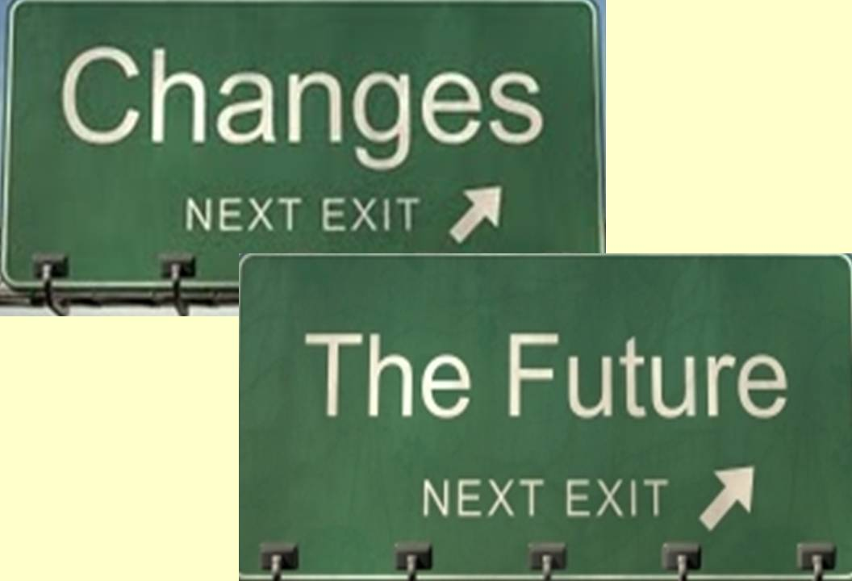 At the beginning of second semester your learning agreement is to be formally revised in order: 1) to respond to any field liaison feedback on the original document regarding areas needing to be addressed, 2) to identify the changes as a result of completed assignments, 3) and to identify any new or clarified assignments which were identified during the December conversation or 4) to indicate no changes.

# Appendix

 **FIELD ASSIGNMENT EXAMPLES (FOR SECTION 3)**

**Assignment #1: I (or Ann) will be an active member of the North End Enterprise Zone work group with the goal of working with the community to promote economic development. I will facilitate 2 meetings, prepare reports and make recommendations for community change in this area.**

**Related Objectives**

1. Demonstrate ethical and professional behavior

2. Engage diversity and difference in practice

3. Advance human rights and social, economic and environmental justice

5. Engage in policy practice

6. Engage groups and communities

**Evaluation:**

I will complete the tasks as assigned. Reports will be well written, comprehensive and free of jargon. I will request feedback from work group participants as well as my field instructor regarding my advanced practice skills such as listening openly and collaboratively and advocating for reforms that enable transformative change. Supervision discussions as well as the content of reports written will reflect my integration of the N.A.S.W. Code of Ethics. In supervision I will outline the elements of my critical thinking re choice of the policy practice intervention. The reflection section of process recordings will illustrate increasing depth in my self-awareness.

**Assignment #2:** In the role of a school social worker, I will have a caseload of 3 students. I will meet regularly with each student individually and initiate parent/guardian contact. Additionally, I will complete clinical and organizational documentation required by both the school and the community mental health center.

**Related Objectives**

2. Engage diversity and difference in practice

7. Assess individuals, families

8. Intervene with individuals, families

9. Evaluate practice with individuals, families, groups, organizations and communities

**Evaluation**

Tasks as outlined will be completed. Feedback from field instructor, teachers, and clients will be obtained. Process recordings will demonstrate how I am employing competing theories of human behavior as well as practice interventions and prioritizing client narratives.

**Assignment #3:** I will attend at least one training session that is informed by research on practice with people from diverse backgrounds. In addition I will consult research based literature that is focused on working collaboratively with families from different cultures. I will critically examine these research informed practice approaches in supervisory meetings with my field instructor and will thoughtfully apply what I have learned to my practice.

**Related Objectives:**

4. Engage in practice-informed research and research-informed practice

9. Evaluate practice with individuals, families, groups, organizations, and communities

**Evaluation:**

Training session attended. Research based articles presented in clinical rounds. Supervision discussions and process recordings will demonstrate thoughtful application of research based knowledge related to diversity.

# S.W. Department Policy on Student Safety Agreements (section 6)

*Field agencies and organizations are responsible for communicating a plan of safety for any and all students confirming a placement with them. Since most agencies and organizations have existing safety procedures, policies, or practices they should feel free to refer to that which already exists. However, it is important that field instructors and students discuss general plans for safety within the first two weeks of the field placement. Safety issues could include things like approaches to working with potentially violent or unpredictable client situations, making home visits to places where the student may be unwelcome or there is doubt about the acceptance of the visit, working with clients who are incarcerated or on furlough for violent assaults, and responses to threatening statements, letters, phone calls, e-mails or other communications directed to the student or other agency personnel.*

*Section Six of the student’s Learning Agreement will be the student’s understanding (a description/summary of the discussion between student and field instructor) of the relationship between “safety” and their work within the agency.*

*If an incident occurs in which a student is personally threatened or hurt, or if the student is involved in an accident of any kind, the student will immediately inform the field instructor and faculty field liaison. The faculty field liaison will inform the field education coordinator. An incident report will be completed by the field education coordinator and placed in the student’s file. The field education coordinator will review the situation with the student, faculty field liaison, and field instructor, and together they will determine the student’s readiness to return to the field.*

Step 3: Getting There On Time

Due Dates

MCj02935120000[1]

The learning agreement is due no later than Sept. 28 with update Feb. 4.

Your field instructor needs to have provided input, reviewed it and signed it before your field liaison receives it. The signed original then is placed in your field file (which you have access to) in the Social Work Department. Make sure that both you and your field instructor keep a copy for yourselves.

Your learning agreement describes the map for your journey as a social work student in the field this year. You will want to regularly review it with your field instructor during supervisory meetings as a way of keeping on course.

Field Seminar #1 – Group A Wed, Sept 5th (10:00– 11:30)

Field Seminar #1 – Group B Thurs, Sept 6th (11:45-1:15)

Learning Agreements due Fri, Sept 28th

Field Seminar #2 – Group A Wed, Oct 10th (10:00 – 11:30)

Field Seminar #2 – Group B Thurs, Oct 11th (11: 45-1:15)

Process Record #1 due Weds, Oct 10/Thurs, Oct 11th

Field Seminar #3 – Group A Wed, Nov 14th (10:00 – 11:30)

Field Seminar #3 – Group B Thurs, Nov 15th (11:45-1:15)

Process Record # 2 due Weds. Nov 14/Thurs, Nov 15th

Signed December Evaluation due Fri, Dec 7th

Field Seminar #4 – Group A Weds evening, Jan 30

Field Seminar #4 – Group B Thurs evening Jan 31

Updates and Revisions to Learning Agreement due Fri, Feb 8th

Field Seminar #5 – Group A Weds evening , Feb 27

Field Seminar #5 – Group B Thurs evening, Feb 28

Process Record #3 due Weds, Feb 27/Thurs, Feb 28

Field Seminar #6 – Group A Weds, April 10

Field Seminar #6 – Group B Thurs, evening April 11

Process Record #4 due Wed, April 10th / Thurs, April 11th

Ending Evaluation due Fri, May 10th