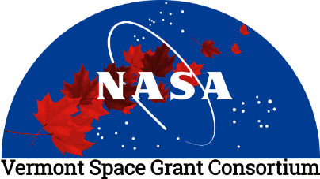
VERMONT SPACE GRANT CONSORTIUM
2021 Graduate Fellowship Competition
Cover Sheet

Name of Graduate Student Applicant: Project Title:
Student Academic Affiliation:

Degree Program (Please Check One): MS Ph.D.

Student E-mail & Telephone:

Name and Title of Faculty Supervisor: Faculty E-mail & Telephone:
Area(s) of Interest for NASA:

Signatures:

Graduate Student:

Print Sign Date

Faculty Advisor:

Print Sign Date Checklist: COMPLETE APPLICATION DUE BY 11:59 pm on January 1, 2021:
- Cover Sheet
- Project Narrative (4 pages max)
- NASA Relevance (1 page max)
- Student resume (2 page max)
- Student academic (unofficial) transcript

The complete application must be saved as a single PDF file and emailed to the Space Grant Office to Ms. Debra Fraser (dfraser1@uvm.edu) with CC to Director Bernard F. Cole (sg.director@uvm.edu).

