Application Cover Page
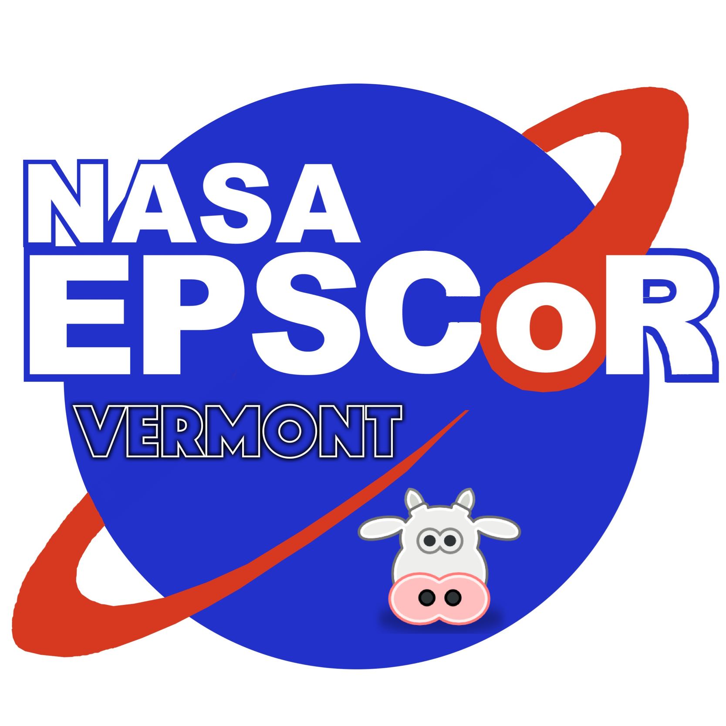
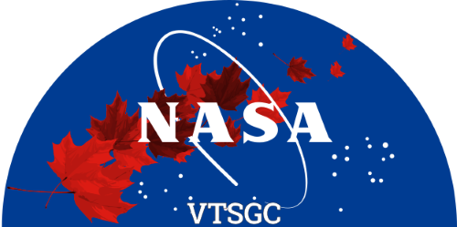

Vermont Space Grant Consortium

and Vermont NASA EPSCoR

2024 Faculty

Research Grant Program
Application Deadline: March 21, 2024 at 11:59 pm

Principal Investigator:

Project Title:

Academic Affiliation:

E-mail: Telephone:

Grant Type (please indicate your preference; however, the actual award source and performance dates might differ depending on the availability of funding):

VTSGC Small-Scale Grant (June 2024 – May 2025)
VTSGC Pilot-Grant (June 2024 – May 2025)
VT NASA EPSCoR Small-Scale Grant (October 2024 – September 2025)
VT NASA EPSCoR Pilot Grant (October 2024 – September 2025)

Principal Investigator Signature:

Authorizing Official Signature:

Checklist:

- Cover page
- Project narrative (limit: 5 pages for Small-Scale Research Grant; 3 pages for Research Pilot Grant, exclusive of references)
- NASA alignment (limit: 1 page)
- Biosketches for the principal investigator and co-investigators (limit: 2 pages each)
- Budget detail and narrative, including matching plan
- Letters of support (electronic is acceptable) from NASA collaborators (required for small-scale grant applications)
- A signed letter of commitment from the appropriate institution or other official responsible for the source of matching funds

In addition to the above, non-UVM applicants are requested to submit a subrecipient monitoring form. This form can be found at:
https://www.uvm.edu/sites/default/files/Sponsored-Project-Administration/subrecipientcommitmentform.pdf

The application packet must be saved as a single PDF file and emailed to SG.Director@uvm.edu using the subject line “2024 Faculty Research Grant Application”.

