Developing a Small Scale Perennial Cropping and Poultry Production System:
The Main Street Project, Northfield, Minnesota

Contributed by
Greg Schweser
Associate Director Local Foods and Sustainable Agriculture
University of Minnesota
Regional Sustainable Development Partnerships
411 Borlaug Hall
1991 Upper Buford Circle
St. Paul, MN 55108
http://www.extension.umn.edu/rsdp/
http://www.extension.umn.edu/rsdp/community-and-local-food/
office: 612-625-9706
schwe233@umn.edu

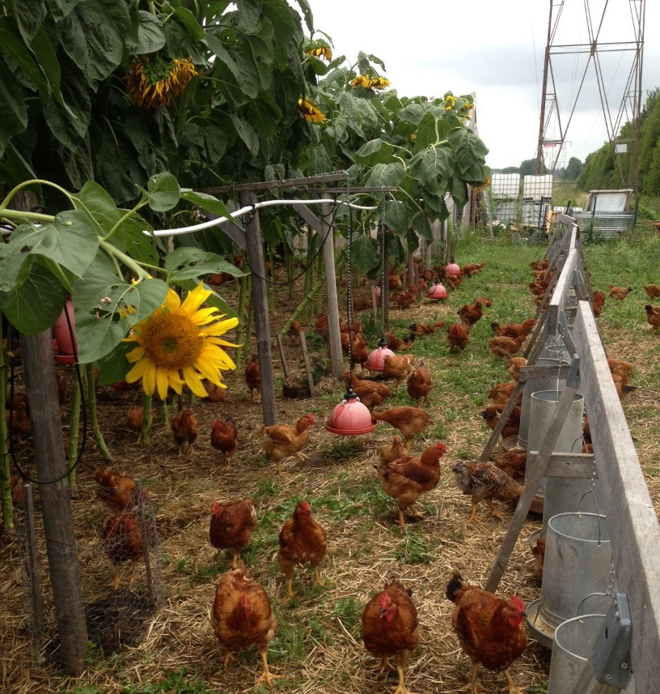
The Main Street Project in Northfield, Minnesota has developed a holistic farming system that utilizes forest farming and alley cropping and recycles waste whenever possible. The Freedom Ranger breed of broiler chickens free range in heavily planted paddocks of perennial woody hazelnuts, sweet corn, sunflowers, and sprouted forage crops like barley, flax, camelina, wheat, and others. Also on site, annual vegetable crops are alley cropped between rows of perennial elderberries. Chicken manure is used both fresh to fertilize the perennial paddock as well as through sheet composting in the annual alley crops. Paddock management and managing chicken access is important with this system. Paddocks need time to rest so avoid damage and enable seeded grains time to grow.
The model is designed to be scalable with production ‘units’ of 1000 freedom ranger chickens per flock free ranging on paddocks within a 1/2 acre production unit, with the maximum intended scale at 8 units (8000 chickens on 4 acres). An 8-production unit farm is considered an Economic Unit with a total annual production capacity of up to 4 flocks or a maximum total of 32,000 broilers per farm per year plus related stacked enterprises. Although the keystone enterprise is the broiler chicken, hazelnuts, elderberries and annual vegetable crops provide additional income and directly support the environment for healthier poultry production.

Recent ongoing analyses have determined that producers managing one production unit with this system are earning a net return on their labor of between $15 and $20 per hour. While these figures are promising, this analysis was conducted in a year where corn prices were at a multi-year low. Additionally, start-up costs that include chicken coop production were not considered as these facilities already existed as the farmers adopted the system. Yearly net returns are expected to fluctuate based on these and other factors. Those adopting this system need to consider the greater infrastructure their local food system offers. Producers will need access to state or federally licensed meat packing facilities in close proximity that have the capacity to process for smaller scale producers.

In addition to the potential for economic benefits, the symbiotic relationship between the free-range poultry and the perennial woody cropping systems provide ecological benefits. Perennial systems do not require tilling and protect soil from the constant disturbance that is common even in organic systems. Woody perennial systems with deep root structures can retain moisture or find moisture in subsoil strata, drive deeper into the subsurface for nutrients, and fix nitrogen all while creating marketable products (Lehman, 2003; Kautz et al., 2012; Schroth et al., 2001). Furthermore, woody perennial crops might be superior to standard grasses as pasture as they provide protection and shade and encourage chickens out into the pasture (Jones et al., 2007).
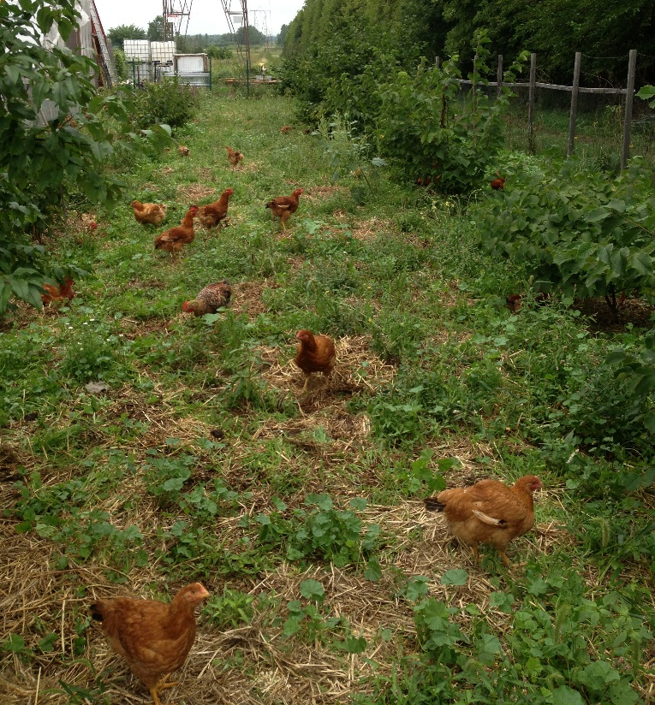
Low labor costs, time requirements, and the stackability of enterprises on the same parcel of land provide the opportunity for additional enterprises without additional land requirements. Additionally, the use of a specialized chicken breed that free ranges on pasture with woody crops is potentially a highly marketable crop. This system, although rare in the United States is common in France and is marketed under the Label Rouge label (Fanatico & Borne, 2002). In Great Britain, after experiencing market success, Tesco grocery stores now enforce a standard requirement of including trees in pastures for their brand’s free range poultry products (Jones, et al., 2007). All of these factors combined have the potential to increase the social outcomes of disadvantaged farm workers, increase profitability through exploiting a high-value product niche, and improve the natural resource base and ecology on which farmers practice this production method.

The Main Street Project model was designed to incorporate stacked enterprises with low entrance costs to assist immigrant farmers into agricultural entrepreneurship and increase the quality of life for those commonly at the bottom rungs of the agricultural ladder in the US. In addition to immigrant farmers, the University of Minnesota Regional Sustainable Development Partnerships (RSDP) believe this model could also appeal to beginning farmers and existing sustainable agricultural producers interested in diversifying their operations. Main Street Project and RSDP are working together with University of Minnesota researchers to conduct case study analyses of this system to address issues like food safety, worker health, business feasibility, product testing, and flavor analysis. With this knowledge available, prospective adopters of this system will be able to make more informed choices when deciding to employ on this production model.

Questions for Students
How does this attempt to create an ecologically sound production system? (Perennial crops reduce need for tilling and create deep root systems that retain moisture and can access nutrients from deep in the subsoil.)
What are some ways this production method uses closed loop systems? (Manure produced on-site is used on site in fields; chickens fertilize and provide weed and pest control for hazelnut crops; perennial and annual crops provide shade and protection for chickens.)
Many perennial crops like hazelnuts and elderberries can take several years before a crop can be harvested. How can this system help facilitate the adoption of perennial cropping systems? (Chickens integrated in system provide income immediately)
How is this system designed to be economically accessible to small farmers? (This system is possible to adopt on small tracts of land (1/2 acre minimum), with fixed chicken coop labor requirements are kept to a minimum (no moving of chicken tractors is required), the central marketing component of the system is a highly marketable niche poultry product that can receive a premium price in some marketplaces.)
What are concerns that some might have about this production system that the University of Minnesota is seeking to address? (Food safety, worker health and safety, feasibility, product quality).

References

Fanatico, A., & Borne, H. (2002). Label Rouge: Pasture-based poultry production in France. Appropriate Technology Transfer for Rural Areas (ATTRA). Last retrieved on March 31, 2014 at: http://cecentralsierra.ucanr.org/files/122130.pdf
Jones, T., Feber, R., Hemery, G., Cook, P., James, K., Laberth, C. & Dawkins, M. (2007). Welfare and environmental benefits of integrating commercially viable free-range broiler chickens into newly planted woodland: A UK case study. Agricultural Systems 94, 177-188.

Kautz, T., Amelung, W., Ewert, F., Gaiser, T., Horn, R., Jahn, R., ... Koepke, U. (2012). Nutrient acquisition from arable subsoils in temperate climates: A review. Soil Biology & Biochemistry, 1-20.

Lehman, J. (2003). Subsoil root activity in tree-based cropping systems. Plant and Soil 255, 319-331.

Schroth, G., Lehman, J., Rodrigues, M.R.L., Barros, E., & Macedo, J.L.V. (2001). Plant-soil interactions in multistrata agroforestry in the humid tropics. Agroforestry Systems 53, 85-102.

