UVM Health and Safety Plan template
for Field Work

To be reviewed daily by the Site Safety Officer with all site personnel
at a tailgate meeting before field activities commence.

Site Address/Location

______________________________________________________________________________

______________________________________________________________________________

Site Safety Officer: ____________________________________________

Research Tasks: (check all that apply)

- Topographic survey (e.g., total station equipment, survey rod, tripod, GPS)
- Unmanned aerial survey or terrestrial lidar survey
- Canoe, kayak or boat operations
- Water sampling
- Soil sampling
- Instrument maintenance (e.g., staff gauge, rain gauge, weir, structural health monitoring sensor)
- Discharge measurement
- Other: __________________________________________________________________

Emergency Notifications

Police: Emergency: 911 Non-Emergency: ( ) ____________-_________________
Fire/EMS: Emergency: 911 Non-Emergency: ( ) ____________-_________________
UVM Contact/Advisor:
Name: ____________________________________
Phone: ( ) ____________-_________________
Report major injuries to UVM Contact/Advisor or Site Safety Officer listed above.
Contact your Lab Safety Coordinator for further information, safety@uvm.edu

Nearest Hospital and Directions

Hospital Name: ________________________________________________________________

Phone: ( ) ____________-_________________

Address: __________________________________________

__________________________________________

(Insert Map and Directions from Site Address to Nearest Hospital)

Field Hazards and Risk Reduction Measures

Flora & Fauna Awareness:
(Check all that may apply and add any additional hazards specific to your site in other)

_____ Insect Stings: Bee and/or wasp bites.
- Wear long sleeves and light-colored clothing to lessen chance for a sting
- If stung, run a clean fingernail or gauze from a first aid kit over the sting to draw the stinger out
- Apply ice to reduce swelling
- Monitor for signs of allergic reaction and, if so, seek medical attention immediately
_____ Venomous Spiders: Black widow
- Avoid wood piles, rock piles, outbuildings – and spider webs in these locations
- If bitten, wash the bite with soap and water, apply a cool compress or ice, and elevate the bite site above the heart, if possible
- Seek immediate medical attention for black widow spider bite
_____ Ticks: Carriers of Lyme disease, Anaplasmosis and (rarely) Powassan virus in the Northeast. (and Rocky Mountain spotted fever in the western US)
- Wear light colored long pants with pant legs tucked into socks
- Tie back long hair
- Use DEET or insect repellent
- Perform end-of-day tick check
- Remove field clothes to laundry and shower soon after end of field day
- Seek medical attention for confirmed tick bites
_____ Animal Bites: Skunks, foxes, bats, dogs, cats, raccoons, horses, snapping turtles, beers, moose, leeches, other: ____________________________________________________
- Avoid work at dawn & dusk hours
- Seek immediate medical attention for an animal bite that breaks the skin
_____ Poisonous Plants: Poison ivy, Poison oak, Poison parsnip, other: ___________________
- Wear long sleeves, long pants
- Avoid tall weeds, brush – stay on travelled paths where possible
- Wash exposed skin with soap and water as soon as possible

_____ Other: __________________________________________________________________

_____ Other: __________________________________________________________________

River/ Lake Awareness:
(Check all that may apply and add any additional hazards specific to your site in other)

_____ Canoe/Boating
- Always wear personal flotation device
- Proficiency in swimming required
_____ Waders/Boots
- Always wear belt with chest waders to minimize waders filling with water
- Use walking stick or river staff to prevent slipping

General Physical Hazards:
(Check all that may apply and add any additional hazards specific to your site in other)

_____ Falls/ Trips: Steep Slopes, Rocks, Tree Roots
- Seek immediate medical assistance for suspected sprain or broken bones
- Use bandages in first aid kit for small lacerations, abrasions
_____ Heat Stress
- Avoid field work during mid-day or very hot conditions
- Wear a hat/cap
- Take regular breaks in the shade and hydrate often with water
- Use the buddy system and monitor for signs of heat stress
- If a person is affected by heat stress, remove them to shade or a cooler location
- Apply cold packs, ice, or cool water compresses
- Encourage regular intake of cool water
- Seek medical attention
_____ Cold Stress
- Avoid field work during very cold conditions
- Wear layers of loose-fitting clothing and waterproof and insulated boots
- Take regular breaks to warm up indoors or in a car
- Stay hydrated and avoid caffeine or alcohol.
- Use the buddy system and monitor for signs of frost bite or hypothermia
_____ Electrical: (marine batteries, other power sources)
- Minimize the interaction of water with electrical cables
_____ Traffic
- Wear a reflective vest
_____ Construction Sites
- If entering a construction site, report to general contractor or site supervisor and follow prescribed safety guidance

_____ Weather Emergencies: Flash flooding, thunder and lightning
- Avoid field work on days where extreme weather is forecast
- If extreme weather occurs unexpectedly, immediately leave the river, lake or any water body; seek shelter.in a building, car, or away from hilltops, trees, and utility lines

_____ Other: __________________________________________________________________

Other General Precautions
Personal Protective Equipment (PPE)
Field PPE includes equipment necessary to safely carry out the field work:
_____ Waders
_____ Sunscreen/Sunglasses
_____ Reflective Vest
_____ DEET/ Insect Repellent (to repel ticks)
_____ Sturdy, closed-toe boots
_____ Hard hat
_____ Safety Glasses
_____ Steel-toed boots
_____ Baseball cap or other hat
_____ Light colored pants with socks (to see ticks)
_____ Other: __________________________________________________________________
_____ Other: __________________________________________________________________

First Aid Kit (Review the location of the first aid kit with all site personnel)
_____ Soap, biodegradable (to wash off wild parsnip oils or insect sting sites)
_____ Tecnu (to remove poison ivy oils from skin)
_____ Band-aids/ Bandages / First Aid Cream
_____ Ace Bandage
_____ Chemical hot packs
_____ Salt (for leach removal)
_____ Tick Remover
_____ Other: __________________________________________________________________
_____ Other: __________________________________________________________________

*Each participant must also complete the Acknowledgment of Risk Form below.
This form may also be found on the Risk Management and Safety: Safety for Field Work and Farm Operations website (https://www.uvm.edu/riskmanagement/safety-field-work-and-farm-operations)

University of Vermont
Acknowledgment of Risk and Consent for Treatment during Field Labs or Activities

Section 1 (To be completed by field lab leader)

Class: ______________________________________________________

Field lab leader: _______________________________Telephone: ______________________________

Address: _____________________________________________________________________________

Field lab date(s): _______________________________________________________________________

Equipment/supplies to be provided:
- by participant: _________________________________________________________________
- by field trip leader: _____________________________________________________________
Immunizations required (check with Student Health Center): ____________________________________

____________________________________________________________________________________

Physical activities to be undertaken include: _________________________________________________

____________________________________________________________________________________

Risks inherent in this field trip include bodily injury due to: _____________________________________

Section 2 (To be completed by field lab participants)

I acknowledge that there are certain risks inherent in field laboratories, including but not limited to those indicated in Section 1. I acknowledge that all risks cannot be prevented. I represent that I am physically able, with or without accommodation, to participate in this field laboratories for this course, am able to use the equipment and/or supplies described above, and have obtained the required immunizations, if any.

Should I require emergency medical treatment as a result of accident or illness arising during the field lab, I consent to such treatment. I acknowledge that the University of Vermont does not provide health and accident insurance for field laboratory participants and I agree to be financially responsible for any medical bills incurred as a result of emergency medical treatment. I will notify the trip leader in writing if I have medical conditions about which emergency medical personnel should be informed.

If a student, I will follow the Code of Student Rights & Responsibilities [insert www.uvm.edu/~uvmppg/ppg/student/studentcode.pdf]. I will not possess or use alcohol or unlawful substances while participating in course work. I will wear a seatbelt at all times during transportation to and from the field site.

_____________________________________________
Name (please print)
_____________________________________________ ________________________________
Signature Date
_________________________________________ _____________________________
Signature of parent/guardian (if participant is a minor) Date

Section 3 (General Information)

To request disability accommodations for this field trip, please notify your trip leader or contact the Specialized Student Services Office at least 10 days in advance of the trip by calling (802) 656-7753 (voice); (802) 656-3865 (TTY); or (802) 656-0739 (FAX).

Immunizations may be obtained through the Student Health Center (802) 656-0847 or your primary care physician.

Section 4 (Health Insurance Information)

Participant’s Name: _________________________________________

Participant’s Health Insurance Company: ___________________________________________

Policy # _____________________________________

POSION IVY
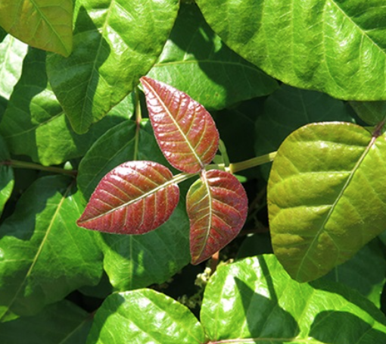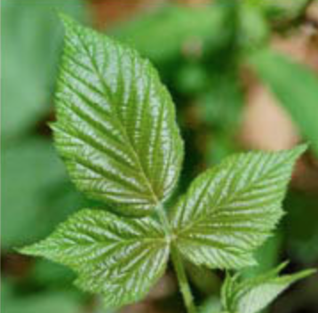
(https://www.pennmedicine.org/updates/blogs/health-and-wellness/2018/july/poison-ivy-sumac-oak)

POISON PARSNIP: SAP BURNS IF SAP GETS ON SKIN IN THE SUNLIGHT
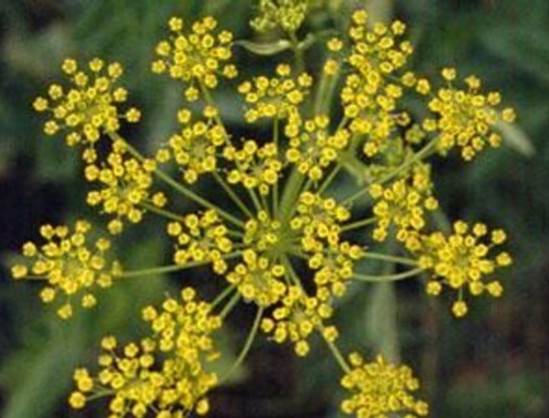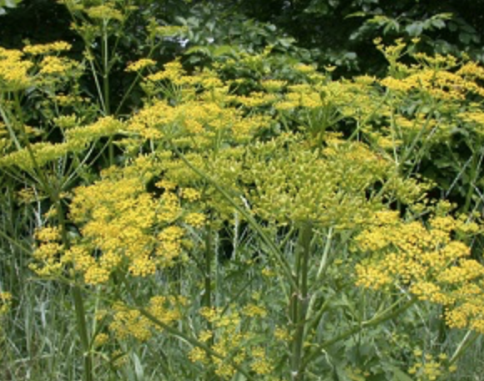
(https://www.burlingtonfreepress.com/story/life/2019/07/11/dangers-wild-poison-parsnip-vermont/1692017001/)
(https://www.dec.ny.gov/animals/105364.html)

COW PARSNIP BURN
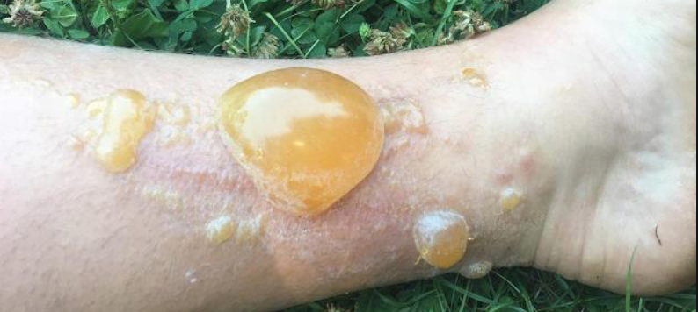
(https://www.usatoday.com/story/news/nation-now/2018/07/19/dangerous-hobo-parsnip-plant-severely-burns-blisters-woman/799636002/)

