Thesis/Dissertation Template Starter
APA 7, 2021

This template is meant to help you put your thesis or dissertation in order before you bring it in for a successful format check. Presented herein are all possible sections you might need for your document (i.e., Table of Contents, Table of Figures, Acknowledgements, etc). Page numbers, margins (1.5” left, 1” right), font styles (12pt Times New Roman) are already set in this template in order to help you out.

Table of Contents, List of Figures, and List of Tables can be tricky sections to complete. As such, there is a link in this document to a Table of Contents helper that should aid in the creation of these components of your final document.

If you already know how to set the style of your section headings you are ready to go. Under styles you will find: ChapterNum (CHAPTER 1: INTRODUCTION- CAPS, already centered), ChapSub (1.2 Thesis Fun - already centered), ChapSubSub (1.2.1 Types of Thesis Fun- always left). All section titles are 12pt font, bold, and Times New Roman. Table of Contents requires just Level Three headings.

Highlighted words are words that should be either be deleted or changed before you compose your final draft.

Delete this introduction page from your final draft. The first page should be the title page which follows on the next page.

Enjoy!

This is where your title goes. It should be capitalized AND SINGLE SPACED.

A (Thesis or Dissertation) Presented

by

Your Name

to

The Faculty of the Graduate College

of

The University of Vermont

In Partial Fulfillment of the Requirements
for the Degree of (Master of Science, or Master of Arts, or Doctor of Philosophy)
Specializing in Your Program/Department

(January, October, or May), Year degree is awarded (example: May, 2022)

Defense Date: July 25, 2021
Thesis (or Dissertation) Examination Committee:

Lewis R. First, M.D., Advisor
John P. Smith, Ph.D., Chairperson
Wanda L. Johnson, Ph.D.
Cynthia J. Forehand, Ph.D., Dean of the Graduate College

ABSTRACT

This is where you place your abstract. An abstract is simply a concise (usually between ½ of a page and ¾ of a page) explanation of your document from motivation to conclusion. The abstract page is single spaced. It is officially page i but it is not labeled (you will see that there is no page number below).

The first line of each paragraph is indented ½ an inch, and double space between paragraphs.

CITATIONS (for journal article only)

This page may be used if the dates are ON OR BEFORE the day you submit your final copies. Any article comprising a major portion of a thesis or dissertation must be the work of the student. The student must be the sole author or the primary and first listed

author of articles. This page must be approved by the Graduate College during the format check.

Material from this thesis (or dissertation) has been published in the following form:

Swenson, R.M, Smith, J.D.. (2021). The effect of eating New York Super Fudge Chunk on the productivity of graduate students. Journal of Ice Cream Eaters, 10, 235-255.

AND/OR

Material from this thesis (or dissertation) has been accepted for publication in (name of journal) on (month, day, year) in the following form:

Swenson, R.M.. (Year, if known). The effect of eating New York Super Fudge Chunk on the productivity of graduate students. Journal of Ice Cream Eaters.

AND/OR

Material from this thesis (or dissertation) has been submitted for publication to (name of journal) on (month, day, year) in the following form:

Swenson, R.M, Jones, J.D.. The effect of eating New York Super Fudge Chunk on the productivity of graduate students. Journal of Ice Cream Eaters.

A Citation page (for journal article only) must be approved by the Graduate College. If one is used it would be numbered ii and follow the Abstract. The Acknowledgements page would be next and be numbered iii

Page numbers for the preface pages should be lower case Roman numeral and be centered 1” from the bottom of the page.

ACKNOWLEDGEMENTS (not required)

The acknowledgements section is double-spaced, as is the remainder of the document, with an extra space between paragraphs. Do not indent the first line of each paragraph.

You might want to take this opportunity to thank everybody significantly influential in your endeavor to complete your thesis. You should keep this section to a page, 1.5 pages maximum. It has been suggested that the only people who truly read this section are those who know they are mentioned within it.

TABLE OF CONTENTS
Page
ACKNOWLEDGEMENTS (not required) ii
LIST OF TABLES (if you have any Tables) v
LIST OF FIGURES (if you have any Figures) v
CHAPTER 1: CHAPTER NAME (CAPS) 1
1.1. Section Name 1
1.2. Section Breaks 1
1.2.1. Page Numbering 1
1.3 Figures 2
1.3.1. Inserting a Figure 2
1.3.2. Tables 3
1.4. Creating Tables 3
CHAPTER 2: CHAPTER NAME 4
2.1. Page Breaks 4
2.2. More Help 4

The Abstract nor the Table of Contents should be listed in the Table of Contents as pages.

LIST OF TABLES (if you have any Tables)

Table Page
Table 1: See below for how to create a table caption 3
The caption here should match that in the body of the document exactly.
LIST OF FIGURES (if you have any Figures)

Figure Page
Figure 1: Center the caption under the figure and center the figure on the page 2

The caption here should match that in the body of the thesis exactly.

CHAPTER 1: CHAPTER NAME (CAPS)

1.1. Section Name
Here you can write your thesis. Perhaps you would like to make a reference [1]. Or, maybe you have many references saying the same thing [4-7].
Begin a new paragraph with an indentation

1.2. Section Breaks
Below, Page Breaks will be discussed. Here, Section Breaks, a different animal than Page Breaks, will be covered. A Section Break is the tool that allowed us to switch from the List of Tables on page v to Chapter 1 on page 1. Thus, Section Breaks allow one to define distinct sections in a single document, each governed by its own formatting.
One of the beauties of the Section Break is mentioned above, specifically, the ability to stop one form of page numbering and begin another on the next page. In this template, at the end of Title page, one section ends and another section begins with the Acknowledgements page. By placing the cursor after the last line of the page, open the Insert drop-down menu (at the top of the window) and select Break… On the resulting menu, choose the “next page” option under Section Break. This will move the cursor to a new page. If the previous page had a certain numbering system, the new page can have an entirely new numbering system.
1.2.1. Page Numbering
Numbering pages can be controlled a number of ways. Most notably, to start numbering pages, use the Insert menu and select Page Numbers. This will open a menu that governs the style, starting point, location, etc of page numbers. Further, one can access this menu more directly once page numbers are placed on the page. Simply double click on the page number you wish to change and proceed to make the changes.

1.3 Figures
1.3.1. Inserting a Figure
To insert a figure, copy the desired image from its source. Then, in this document, right click on the location where you would like to place the figure, and select Copy from the menu that appears. To add a caption, right click on the figure and select Caption to insert the word “Figure” and the number of the figure. You add the caption in the document itself. The Caption menu just lets you add the word Figure, Equation, Table, etc. See below for how to reference a Figure, Table, etc. (Figure 1).
Figure 1:

Left justify the Caption Above the Figure and Center the Figure on the Page

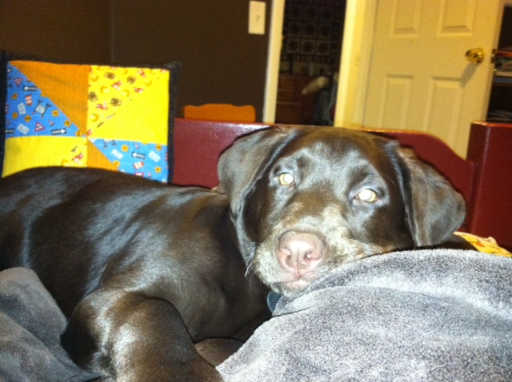

(Do not leave any Widow Headings; go to next page.)
1.3.2. Tables
Place a table caption above the actual table. Do this by right clicking on the table, selecting caption, and changing the option within the caption menu.
Table 1:
See Below for How to Create a Table Caption
Data 1 | Value 1
Data 2 | Value 2

1.4. Creating Tables
Creating a table starts with the Table menu. Select Insert from the drop-down menu, and choose Table. Select the size and options as you require. Adding a caption is accomplished in the same manner as with figures. In order to reference the Table in the body of the text, click the Insert menu and select Reference → Cross-reference. From the menu that appears, choose Table from the Reference Type drop-down list and select how you want the reference to appear, such as just the label and the number (Table 1). Tables should only have horizontal lines as in example above.

CHAPTER 2: CHAPTER NAME

2.1. Page Breaks
The new chapter should start on a new page.
To accomplish a new page without relying upon returns, use the Insert menu. Place the cursor at the end of the previous chapter, after the last sentence. From the Insert drop-down menu, select Break… and choose Page Break from the resulting menu. This will ensure that the next Chapter begins on a new page with continuous numbering.

2.2. More Help
There are going to be many questions left unanswered by this template. However, you have volumes of resources at your disposal. Aside from the Thesis and Dissertation Guidelines on the Graduate College web site, Microsoft Word Help Menu, the CIT (Computer and Information Technology) office is quite knowledgeable on thesis/dissertation matters. You can find out more about contacting CIT through their website www.uvm.edu/cit/.

