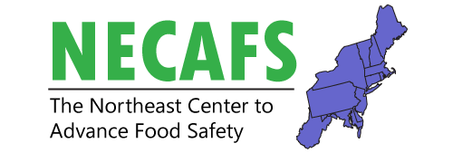
Regulator One Day Meeting
______________________________________________________________________________

Tuesday, February 16, 2020

Time | Room | Session
9:00 – 10:30 am |  | Welcome and State Presentations
10:30 – 12:00 pm |  | Group Discussion
12:00 – 1:00 pm |  | Lunch
1:00 – 3:00 pm |  | Group Discussion

NECAFS Annual Conference and Meeting
______________________________________________________________________________

Wednesday, February 17, 2020

Time | Room | Session
8:30 – 9:00 am |  | Morning Coffee Networking
9:00 – 9:30 am |  | Welcome and Plenary Session  Summary of next steps articulated at past Annual Meetings, NECAFS 2020 project outputs and collaboration exercises  - Chris Callahan and Elizabeth Newbold, NECAFS
9:30 – 11:30 pm |  | Concurrent Workgroup Meetings
 |  | Produce Safety Workgroup Meeting | Preventive Controls for Human Food Workgroup Meeting
11:30 – 12:30 pm |  | Live Virtual Poster Session
12:00 – 1:00 pm |  | Lunch
1:00 – 3:00 pm |  | Concurrent Workgroup Meetings  Produce Safety Workgroup Meeting Preventive Controls for Human Food Workgroup Meeting
3:00 – 4:00 pm |  | Networking

NECAFS Annual Conference and Meeting
______________________________________________________________________________

Thursday, February 18, 2020

Time | Room | Session
8:30 – 9:30 am |  | Morning Coffee Networking
9:30 – 10:30 am |  | Federal Updates
10:30 – 12:30 pm |  | Concurrent Workgroup Meetings
 |  | Produce Safety Workgroup Meeting | Preventive Controls for Human Food Workgroup Meeting
12:30 – 1:30 pm |  | Lunch
1:30 – 2:30 pm |  | Report Out and Closing Remarks

