Cost Share Business Process & Summary Job Aid

Overview
Cost sharing is the commitment of University or third party resources to support part of the costs of a sponsored project. Cost sharing is either mandatory (required by the sponsor) or voluntary (offered in the grant proposal although not required by the sponsor). Voluntary cost sharing is strongly discouraged due to the University’s limited resources, which must be used as strategically as possible. Regardless of whether cost sharing is voluntary or mandatory, once described in a proposal and accepted by the sponsor, it is committed and the obligation must be met.

Roles and responsibilities for cost sharing
- Dean - Approves college commitments for cost sharing.

- Department Head - Approves unit cost sharing from unit funds. Aligns grant effort with overall workload.

- Principal Investigator – Receives approval from Dean, Department Chair, or other individual authorized to make financial commitment regarding cost sharing commitments. Ensures cost share requirements are met. Obtains documentation for third party cost share. Works with business unit administrator to ensure cost share expenses are properly managed.

- Business Unit Administrator - Confirms chartstrings for cost share commitments. Processes budget entry for cost share in OPS_CH ledger. Makes salary distribution changes to the project for cost share commitments. Monitors cost share commitments in SP_CHILD2 and OPS_CH. Assists PI to ensure commitments are met.

- SPA Pre-Award Research Administrator – Reviews sponsor requirements for cost share and communicates the requirements to the PI. Incorporates required cost share in SPA budget worksheet and indicates such on the routing form for the Dean or Department Chair approval. Obtains a valid cost share chart string provided by PI and business unit administrators.

- SPA Post Award – Sets up cost share chartstrings in SP_CHILD2 and records cost share requirements in PeopleSoft during the award set up process. Audits cost share commitments and activity. Completes and submits reports of financial activity, including cost share, to sponsors.

Monitoring cost share commitments in PeopleSoft
When an award is made, SPA sets up cost share chartstrings and budgets for the project in SP_CHILD2 in Commitment Control and enters text about the cost share requirements on the Award Profile page in PeopleSoft. GCA also notifies the principal investigator, department administrator, and Dean’s office staff in some units when a new award or subaward is set up or amended and will include the cost share requirements in the notifications. Department administrators and/or Dean’s office staff process the budget adjustments in OPS_CH to fund the cost share and work with the PI to monitor cost share and effort requirements and ensure commitments are met.

Details about cost share requirements are recorded in the Additional Information link on the Award Profile page (Grants>Awards > Award Profile) in PeopleSoft. GCA will use standard text, as outlined in this document, to ensure cost share requirements are clear. These requirements will be updated as needed during award continuations, amendments, and extensions.

Effort

It is common for cost share requirements to be in the form of effort, which is tracked in PeopleSoft when the individual’s salary is distributed against a cost share chartstring in PeopleSoft. Actual salary and fringe benefits expenses are then recorded in the GL as part of the total project costs.

If cost share requirement is based solely on effort:
J. Smith 5% 7/1/09 – 6/30/10

If cost share requirement is a specific dollar amount and is proposed to be met with effort:
J. Smith 5% 7/1/09 – 6/30/10
Note: required cost share is 1:1, or
$20,000, or
25% of total project costs
Department will monitor and adjust as needed to ensure commitment is met.

If multiple departments are funding the cost share commitment, it will be noted as follows:
J. Smith 5% 7/1/09 – 6/30/10 (51020)
I. Jones 12% 7/1/09 – 6/30/10 (51080)

Note that PI and key personnel effort is expected to continue at the proposed level during a no-cost extension period. If there are not sufficient funds from the sponsor to cover that effort, then it must be cost shared. If applicable, PIs will provide PAS with a valid cost share chartstring during the no-cost extension request process. GCA will then enter the appropriate cost share budget in SP_CHILD2 and description in the Additional Information link in conjunction with processing the no-cost extension in PeopleSoft.

Operating Expenses

Cost share requirements are sometimes in the form of operating expenses, in which case the transactions should be allocated to the cost share chartstrings when initially processed. Again, the actual operating expenses are recorded in the GL as part of the total project costs.
- Travel $2,500 or Equipment $10,000

Third Party

Less frequently cost share requirements are met by a third party, such as another institution providing in kind effort on a project or a subrecipient providing cost share as part of the subaward agreement with UVM. In the case of in kind effort provided by another institution, the cost share is documented by a signed memorandum from the other institution to UVM indicating the names of the individuals who contributed effort, the associated salary and fringe benefits amounts, and the dates during which the effort was expended. For a subrecipient, the cost sharing will be documented on invoices provided to UVM and scrutinized by the PI, business unit administrator, and SPA prior to processing the invoice for payment. Note: As progress is made in meeting third party cost share commitments, the appropriate SPA Post Award Administrator will record this information in the Additional Information link.

- In Kind: Subrecipient X has committed $1,000 of cost share.
Per invoice #1234 dated 1/1/10, subrecipient X has contributed $500 of cost share.

Unrecovered F&A

Some sponsors do not pay UVM’s full, negotiated F&A rate so the difference between UVM’s actual F&A rate and the rate the sponsor reimburses is considered unrecovered F&A and often contributes to overall cost share commitments. In those cases, the unrecovered F&A is not budgeted in Commitment Control since there are not any associated financial transactions in Commitment Control or the GL, however the commitment is still noted in the Additional Information link on the Award Profile page.

- Waived F&A
Cost share commitments will be met with unrecovered F&A.

NIH Career Development (K) Awards

NIH K awards have specific effort requirements and a cap on the amount of PI salary that the sponsor will pay (typically 75% effort with a maximum salary of $75,000 per budget year); anything over the maximum allowed amount must be cost shared. The cost share requirements will change each year, depending on sponsor terms & conditions and the PI’s salary. For that reason, K award cost share will be budgeted annually rather than at award set up. If there is not a cost share requirement during year one of a K award, due to the PI’s salary, GCA will need the potential cost share requirement as follows:

- There is potential for cost share in future years. Please monitor regularly to determine if needed.

Salary Cap

Some sponsors, most notably NIH, limit the salary that they will cover. These salary limitations are called salary caps. For example, if a sponsor limits salary to $190,000, and a PI earns $200,000 per year and expends 10% effort on an award that is subject to a salary cap, then $19,000 may be distributed to the sponsored chartstring and $1,000 must be cost shared. Note that these cost share requirements change each year due to varying sponsor caps and PI salaries. For that reason, salary cap cost share will be budgeted annually rather than at award set up.

Complex Cost Share Requirements

A handful of awards have cost share requirements that are too detailed and complex to include in the Additional Information link. In those cases, GCA will note to see the proposal, budget worksheet, and award document for cost share requirements.
Cost Share Summary report

A cost share summary report has been developed to monitor cost share requirements and ensure cost share commitments are met on an ongoing basis. Unit business administrators will run and review the report at least quarterly to proactively manage cost share commitments and replaces the historic reactive approach to monitoring cost share.

Directions
- In PeopleSoft Financials, go to UVM Reports > Cost Share Summary.
- Add a new Run Control, if appropriate, or choose an existing Run Control.
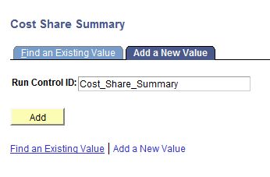

- At the following screen:
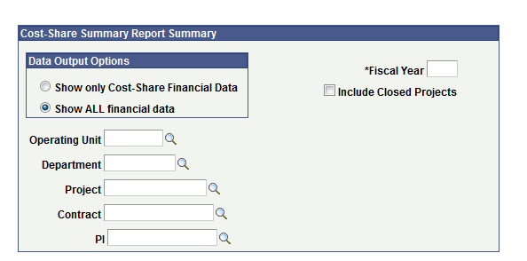
- Select the operating unit, department, project, contract/award, or principal investigator (PI EmplID) based on the desired data. Leave any or all of these fields blank to get data for all values.
- Enter the fiscal year. This is used to determine the Year-to-Date expenses for this fiscal year.
- Check the checkbox on the field “Include Closed Projects” to report on projects that have been closed.
- Choose “Show ALL financial data” to include all charstrings associated with the project or “Show only Cost-Share Financial Data” to include only cost share chartstrings. Note: cost share chartstrings are determined by the function on the chartstring.

- Save the search parameters by clicking on “Save,” then click on “Run” to run the report. Click OK on the Process Scheduler Request page.

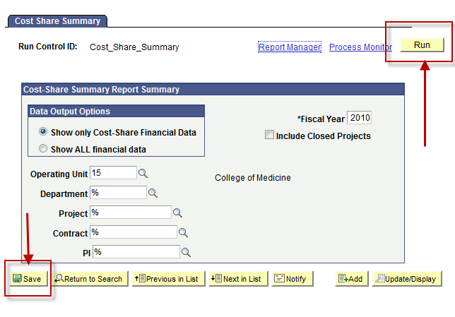
You will then have a Process Instance and should click on the Process Monitor hyperlink.

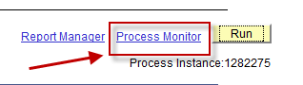

When the report has run to success, click on the Details hyperlink,
then on the View Log/Trace hyperlink,
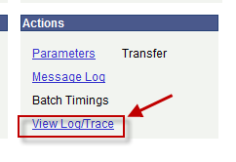
then on the csv file name to open the file in Excel.
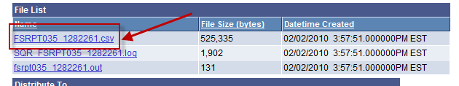

- The report only produces excel output. There is no PDF output.

- The report includes the following data.

Column | Description
Award # | PeopleSoft Award Number. Also known as contract number and in most cases, this is also the InfoEd proposal ID. Identifies the award. An award can have multiple projects.
Ref Awd # | Sponsor-assigned award number
Start Dt | The project start date
End Dt | The project End date
Cust Name | Sponsor Name
PI Name | The Principal Investigator’s name
Project ID | Project Id
Project Descr | Description of project
Account | Chartfield values. This is the budgetary account
OU | Chartfield values.
Dept | Chartfield values.
Fund | Chartfield values.
Source | Chartfield values.
Function | Chartfield values.
Project | Chartfield values.
Program | Chartfield values.
Purpose | Chartfield values.
Ppty | Chartfield values.
Budget | Expense Budget Amount for the chartstring
Pre-Encumbrances | Pre-Encumbered amount
Encumbrances | Encumbered amount
Total Project Expenses | Total project-to-date expenses for this chartstring. This is up to and including the moment the report is run.
Year-To-Date Expenses | Total year-to-date expenses for this chartstring. This is up to and including the moment the report is run.
Remaining Balance | Budget less Pre-Encumbrances, Encumbrances, and Total Project Expenses.
Cost Share Requirements | Text that describes the cost-share requirements. These six fields (Grants > Awards > Award Profile > Additional Information link) are filled out by GCA. If it is blank, either there are no requirements or the field has not been filled out.

Data Analysis
With the exception of NIH Career Development (K) awards and NIH salary cap cost share requirements, cost share will be budgeted in total during the award set up process. During the quarterly cost share monitoring process, unit business administrators will review the following:
- Cost share budget, actuals, encumbrances, and budget balances compared to project start and end date. This review should ensure that cost share commitments will be met by the end of the project and that any potential overdrafts in the cost share chartstrings will be resolved prior to the end of the project, either through a budget increase processed via request to the appropriate GCA administrator or by pro-actively moving encumbrances from cost share to sponsored chartstrings.
- Ensure PI and key personnel effort is not reduced by more than 25% of the commitment made to the sponsor.
- Review budget checking errors to ensure all OPS chartstrings have been appropriately set up.

Additional Resources

Sponsored Project Administration - http://www.uvm.edu/spa/

UVM Effort Management & Reporting policy - http://www.uvm.edu/~uvmppg/ppg/grants/effortreporting.pdf

