How to Complete the Animal Handler Questionnaire on Mywellbeing
(for enrolled students)
- Log on to https://mywellbeing.uvm.edu (smart phone not recommended).
- Select “Messages” from the menu.

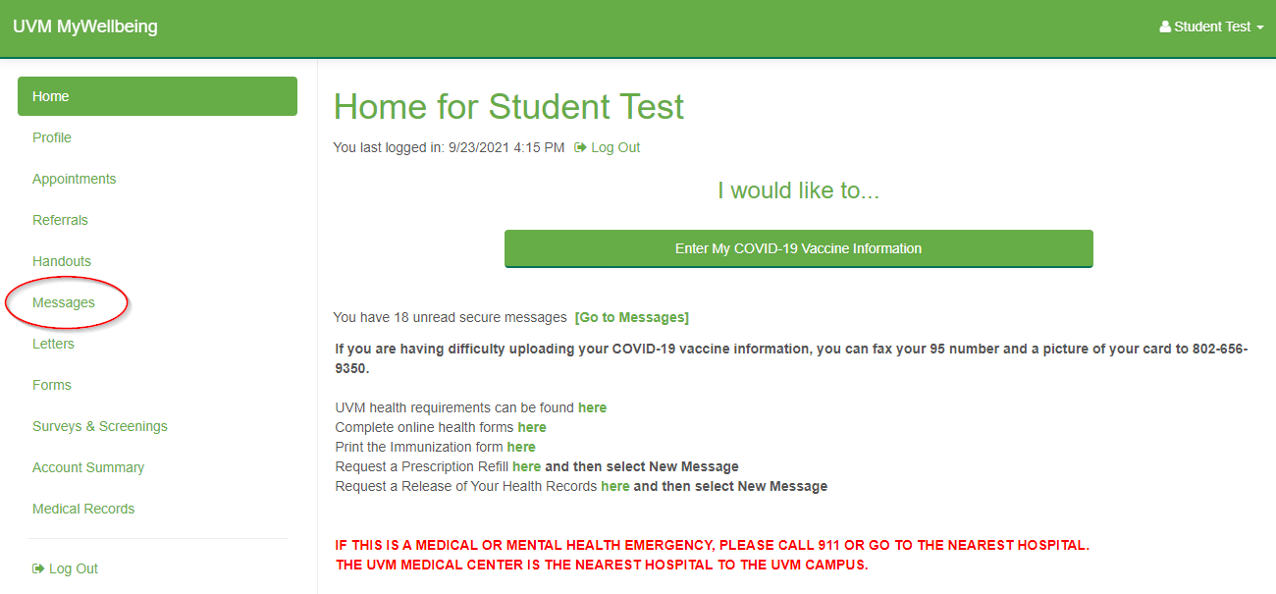

- Select “New Message”
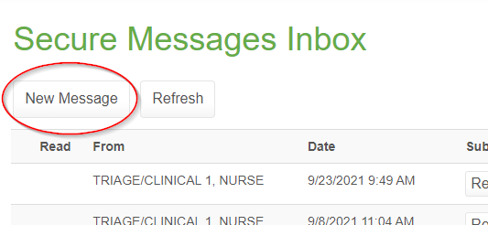

- Select “I want to submit an Animal Handler Questionnaire and click “Continue.”

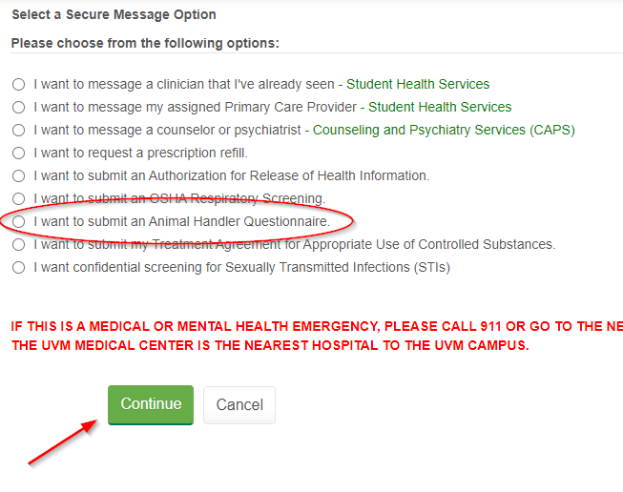

- Complete the Animal Handler Questionnaire in full.
- To participate in the Occupational Health and Safety program, select “I ACCEPT” at the bottom of the questionnaire and click the “Send” button to transmit the questionnaire to Student Health Services for review.
- Student Health may have questions about your questionnaire, so it is a good idea to monitor your UVM email for message notifications or check Mywellbeing for new messages.

