IRB

UVMClick Website https://www.uvm.edu/ovpr/uvmclick Email Support UVMClick@uvm.edu
UVMClick Login https://irb.connect.uvm.edu/IRB Phone Support (802) 656-5040

How to Create and Submit a Modification to Close an External Study

Click does not have a specific closure submission type. You will need to submit an amendment to close the protocol.

Create a Modification (Close Study)

- From “My Inbox” or the IRB>Submissions screen, navigate to the appropriate protocol and click on the name to open it.

For External IRB Protocols you must submit amendments through the Site record not the study record. Make sure you are in this record
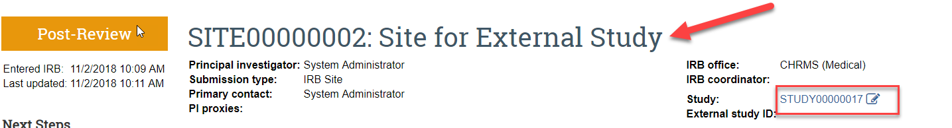

Not this record
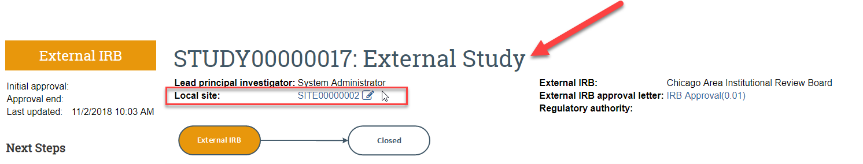

- Click Create Modification
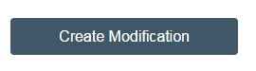

- Select the modification radio button and hit Continue.
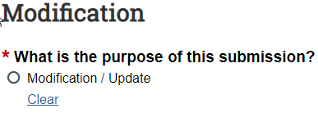
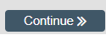
- Check the option “other”.

- Complete the question “Summarize the Modifications” by stating that the protocol is being closed. Note that this is required field entry as it is prefixed with a red asterisk.
Note: When filling in the question “Summarize the Modifications” this text will appear on the future approval letter. Please make sure to type the text carefully as there isn’t any spellcheck in UVMClick.
Important!
- If all sites are closed, attach acknowledgement from the single IRB.
- If only UVM is closing, explain why the UVM site is closing and certify that all responsibilities to the single IRB have been met.

After clicking “Finish” to exit the Modification, the status of the submission will continue to still display as “Pre-Submission” and will remain visible in your in-box until submitted to the IRB Office for processing.

To submit a finished Modification submission to the IRB Office for their review and processing,
- Make sure the Modification is open
- Click the activity on the left that says “Submit”.

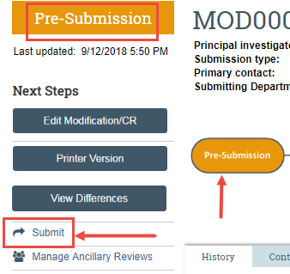
When clicking the Submit activity, certification text will appear. Read the text and click OK.
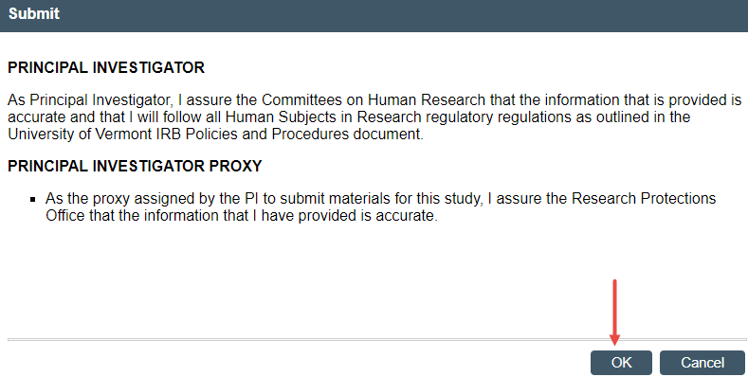
Once submitted, the status of the Modification is no longer “Pre-Submission”. It has changes to “Pre-Review” indicating it is in the hands of the IRB Office for processing.
You will also note that the Modification is now in View Mode and no longer in Edit mode.
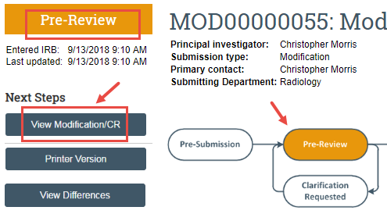

The Modification has now been submitted and removed from your In-Box. It now displays in the In-Box for the IRB Office. The Office will acknowledge the request to close and change the status of the protocol in the system.

