Child Assent Template with Guidance - 3/24/2021
For use with children, generally 11-17 years old

This template provides guidance and examples of text to be used within each section. Please customize each section in accordance with your protocol.

University of Vermont Assent to Participate in Research

Title of Research Project: title

Lead Investigator: name

Affiliated Hospital Investigator: (as applicable)
If Central Vermont Medical Center (CVMC) is participating include local Investigator’s name here – no other affiliates are conducting research at this time

Sites Where Research is University of Vermont
Being Conducted University of Vermont Medical Center (if applicable)
(list Central Vermont Medical Center as applicable)

Faculty Advisor: If you are a student, list your faculty sponsor here. Please refer to the Research Manual for the definition of a student.

Introduction
You are being invited to take part in this research study because [explain how/why the child qualifies or may qualify for the study].

Key Information to Help You Decide Whether or Not This Study Is Right for You
- All consent forms should provide a concise and focused presentation of key information that is most likely to assist in understanding the reasons why one might or might not want to participate in the research.
  - Use this section of the consent form to summarize the study using plain, non-technical language.
  - Highlight that the person has a choice to make. The consent form should be used as a decision making tool, not a sales pitch.
  - Include a brief description about why the study is being conducted and what is being asked of the participant (e.g. time commitment, procedures involved).
  - When deciding what risks or side effects to include in the summary, consider whether a potential participant would attach significance to the risk in deciding whether or not to participate. If applicable, state that “A complete list of the risks is given in the following pages.”
  - This summary should be limited to one page.
  - Assent forms are recommended to be written at a level appropriate to the age range, preferably lower than 8th grade. Microsoft Word has a readability program which can be found by:
    - Click the File tab, and then click Options.
    - Click Proofing.
    - Under “When correcting spelling and grammar in Word”, make sure the “Check grammar with spelling” check box is selected.
    - Select Show readability statistics.
    - After you enable this feature, open a file that you want to check, and check the spelling. When Word finishes checking the spelling and grammar, it displays information about the reading level of the document or just the highlighted section.

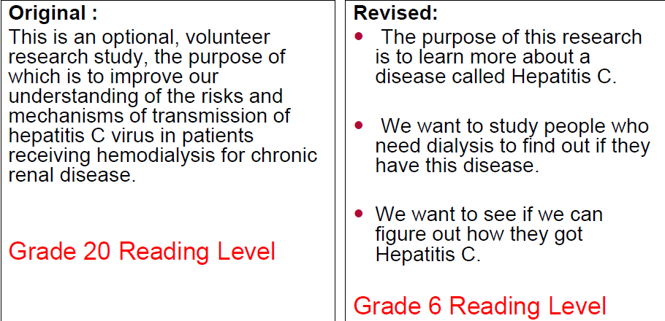
To improve subject comprehension the RPO office encourages researchers to use:
- Headings
- Bolded type
- Pictures
- Tables
- Consider using bulleted points to highlight key information.
- Keep sentences short and simple.
- Do not use fractions or %. Instead, state “1 out of 10 people will…”
- Use lay language – see plain language dictionary

[Include the below statement at the end of the concise summary:]
The information above is only a brief summary of the study. If you are interested in learning more, it is important to read the following pages for additional detailed information about the study. If you decide to take part in the research, you will be asked to provide written consent at the end of this document.

[Examples of model summary statements are available on the IRB website and may be found Here.]

What will happen to me in this study?
If you want to be in the study, this is what will happen: [list all study procedures, where they will occur and how long it will take, bullet the list]
Can anything bad happen to me?
[Use simple and general terms to explain the risks and what you will do to decrease them.]

What are the Benefits of Being in this Study? [If no direct benefit, include the following information:]
You may not benefit directly from this study, however we hope to learn something that could help other children in the future.
[If behavioral treatment or intervention, include the following information:]
Taking part in this study may help you feel better, but we do not know this for sure. We also hope to learn something that could help other children in the future.

Do I have other choices?
[If applicable, describe the alternatives open to the child, otherwise include the following statement:]
You do not have to be in this study if you don't want to.

Will I receive any payment or gifts if I am in this study?
[This section should be included when appropriate to clarify if the adolescent will be compensated for his/her inconvenience; discomfort, etc... include the form of the compensation, such as gift cards, gift certificates, iTunes, etc...]

Will anyone know I am in the study?
We will do everything we can to make sure that any private information about you is kept private.

[Indicate when a child's research information will not be shared with a parent or legal guardian.]

[Describe what will happen (mandatory reporting requirements) should child reveal harm to self or others.]

What happens if I feel uncomfortable or if I am harmed?
Your parents or guardian have been given information about what to do if you are harmed. If you are uncomfortable during the study please let us know right away.

Can I stop being in the study or be taken out of the study?
If you join the study and then change your mind, it is okay for you to stop being in this study.

Also we might decide to take you out of this study. This might happen if we find out that it is not safe for you (or for others like you) to stay in the study. Or it might happen if you cannot come to enough of the study visits. If we ask you to leave the study, we would always explain why.

What if I have questions?
You can ask questions whenever you have them. You can ask the researcher or other people working with him/her on the study (insert PI name and study team contact information). We have also explained this study to your parent(s), so you can ask them questions as well. However, if you do not want to be in the study, that is okay.

If you are not happy with this study and want to talk with someone else, not the researcher or the people working with the researcher, you can contact the Director of the Research Protections Office at the University of Vermont at 802-656-5040.

If you want to be in this study, please sign your name. You will be given a copy of this form to keep so that you can look at it again later.

_____________________________________________________________
Minor Providing Assent Date
(applicable for children 11 years of age or older dependent upon their understanding)

____________________________________________________
Name of Minor Providing Assent Printed

_____________________________________________________________
Signature of Researcher or Designee Date

________________________________________________
Name of Researcher or Designee Printed

Name of Principal Investigator:
Address:
Telephone Number:

Name of Faculty Sponsor:
Address:
Telephone Number:

