University of Vermont
Training Record for New A/BSL-3 Users

Trainee Name:
Position: |  | Department:
PI/Supervisor: |  | BSL-3 Mentor:
Checklist
Pre-Approvals and Environmental Health & Safety (EH&S) |  |  | Trainer or Training Doc/Dept | Trainer  Initials or Verified By | Date  Completed
- CITI Specific Trainings (online):
- CITI BSL-2 Basic Course
- CITI OSHA Bloodborne Pathogens
- CITI Select Agents/DURC
- A/BSL-2 Training Course (in person)
- UVM Specific Laboratory Safety Training
Online:
- Laboratory Safety Roles and Responsibilities
- Laboratory Ventilation and Chemical Fume Hoods
- Chemical Safety in the Laboratory
- Chemical Waste Disposal
- Biowaste Management Procedures
- Safe Use of Biosafety Cabinets
In Person:
- Keeping Your Lab Safe
- Emergency Response for Laboratory Workers
- Review of:
- A/BSL-3 Researcher Experience Form &
- UVM Biosafety Plan for A/BSL-3 & S.A. or Toxins
- UVM Security Plan for A/BSL-3 & S.A. or Toxins
- UVM Incident Response Plan for A/BSL-3 & S.A. or Toxins
EH&S and Occupational Health
- Fill out, submit the medical questionnaire for respirator users, and obtain medical clearance
- A/BSL-3 Introductory Training (in person)
- Review of:
- PPE and Respirator Training
- Non-Disposable, Air-Purifying Respirator Training (online)
- Review A/BSL-3 SOPs and work practices
ABSL-3 Only Requirements for OACM
Not Required if not Working with Animals
- CITI Animal Biosafety Course (online)
- Standard bio-methods course with OACM vet staff
- Animal handling training with OACM vet staff
- Demonstrate proficiency with animal procedures at ABSL-2 level
A/BSL-3 Orientation and Mentored Training
- Complete A/BSL-3 Orientation Training
  - Entry 1 (Donning/Doffing and Entry/Exit)
  - Entry 2 (Biological Spill and Emergency Responses)
  - Entry 3 (SOPs and Specific Work Practices)
  - Select Research Track - General Laboratory or Animal
- Complete A/BSL3 Mentored Training Program
  - Practice A/BSL-3 procedures at BSL-2 (hours vary)
  - Proficiency assessment of BSC usage/microbiological methods
  - Practice A/BSL-3 procedures at BSL-3 (15-60 hours)
  - Proficiency assessment of A/BSL-3 work practices
VDHL Requirements
- Read BSL-3 Biosafety Manual:  - D-AD-019 Rev 7 Dec 2022 - ABSL-3/BSL-3 and Select Agents or Toxins Management Procedure  - P-MIC-065 Rev 17 Dec 2022 - ABSL-3/BSL-3 and Select Agent or Toxin Biosafety Plan  - P-MIC-075 Rev 17 Dec 2022 - ABSL-3/BSL-3 and Select Agent Security Plan  - D-MIC-001 Rev 15 Dec 2022 - ABLS-3/BSL-3 and Select Agent Incident Response Plan  - D-AD-017 Rev 5 Dec 9 2022 Guidelines for Medical Surveillance of Laboratory Personnel Working with Potential BSL-3 Agents  - P-MIC-049 Rev 1 May 2022 Containment and Decontamination of Spilled Biological Materials in the ABSL-3/BSL-3 Suite  - Micro 1034 Rev 5 Dec 2017 Required Procedures for Entering Exiting ABSL-3/BSL-3 Labs  - D-AD-016 Annex A Rev 4 April 12 2022 Evacuation and Emergency Response Plan  - D-AD-016 Annex F Visitors Policy  - D-AD-016 Annex G Rev 3 June 2016 Eating Drinking Policy  - D-AD-016 Annex I Rev 1 June 2019 Personal Electronic Devices Policy  - Select Agent List: https://www.selectagents.gov/sat/list.htm  Stericycle Biowaste Management (may be needed at a later time)  - Biohazardous Waste Training  - DOT Training  BSL-3 Autoclave Training - Only if authorized by Joyce |  |  | D-AD-019  P-MIC-065  P-MIC-075  D-MIC-001  D-AC-017  P-MIC-049  Micro 1034  D-AD-016 Annex A  D-AD-016 Annex F  D-AD-016 Annex G  D-AD-016 Annex I  FSAP Select Agent
- Review of Facility Safety Equipment and Alarms
- Review of Facility Entry & Exit Procedures
- Emergency Action Training, Person Down Response -
VDHL Facility Tour 1 (in concert with step 13) and
A/BSL-3 Facility Tour 2 (final step)

- BSL-2 Basic Training Completed and A/BSL-3 SOPs Reviewed
PI Signature | Date
- ABSL-2 Handling/Methods Completed and ABSL-3 Work Approval
OACM Personnel | Date
- Completed Initial VDHL/CRF Tour
VDHL Biosafety Officer | Date
- Completed Biosafety Review and Orientation Training
UVM Biosafety Officer | Date
- Reviewed all SOPs and Completed Mentored Training
Trainee | Date
INSTRUCTIONS: GREEN numbers 1-4 must be completed first prior to contacting UVM Biosafety for further training. YELLOW numbers 5-8 (plus 9-12 for ABSL3 users) can be completed in any order. All GREEN and YELLOW numbers PLUS notifying the VDH biosafety office to receive badge and initial tour MUST be completed before beginning RED numbers 13 & 14. All BLUE VDH requirements occur once UVM training is completed to receive unrestricted building access.

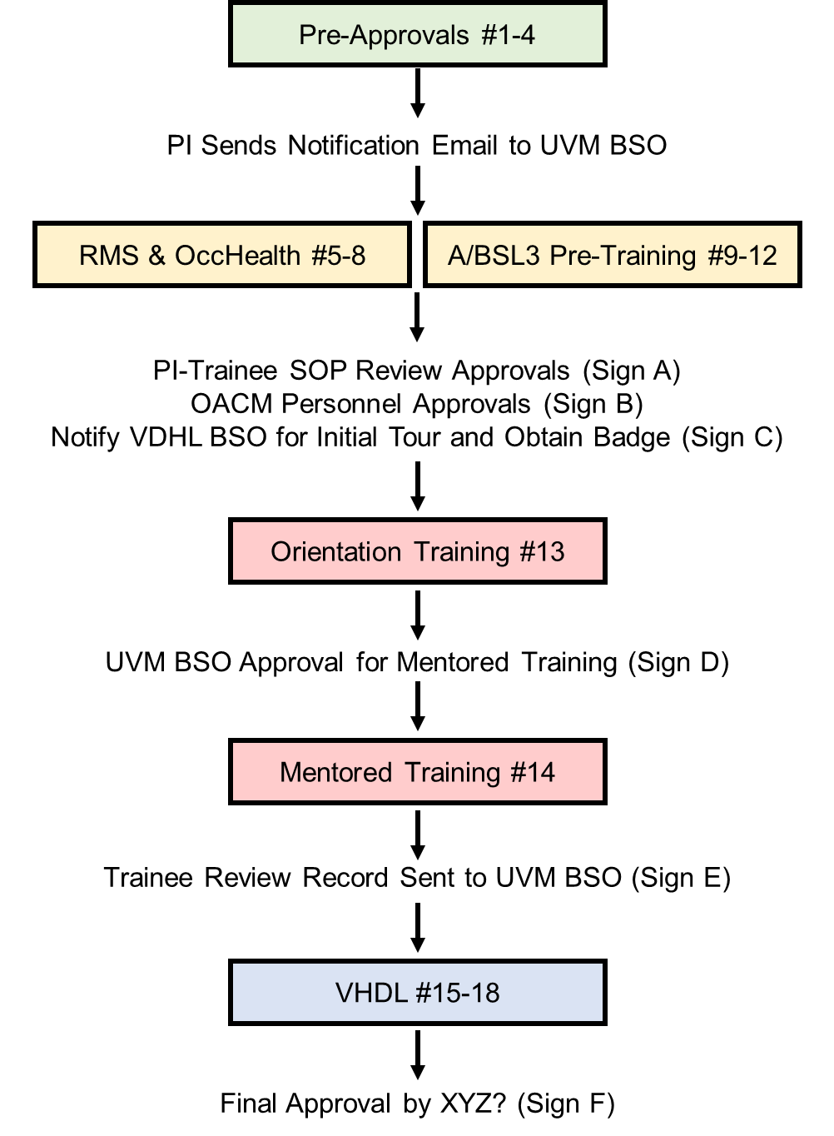

- FINAL APPROVAL FOR FULL A/BSL3 ACCESS
UVM Biosafety Officer and VDHL Biosafety Officer | Date

