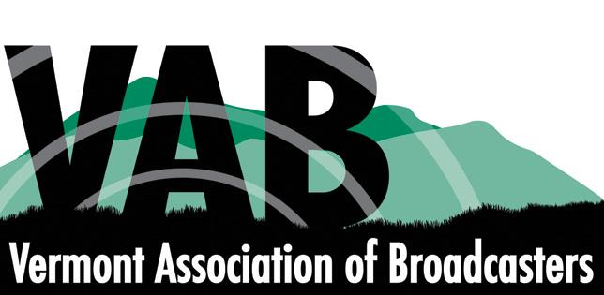 2021 Internship Opportunities
Requirements:
In order to qualify for a VAB internship, students must:
- Be entering their Junior or Senior year at an accredited college, university or trade school, whose intentions are to return to or stay in Vermont after graduation.
- Be majoring in communications, broadcast media, digital media, marketing, event management, film studies or other related fields.
- Working knowledge of Google Apps and the WordPress admin dashboard is required for Opportunity #1. Digital graphic design/layout software is also required for Opportunity #2. Working Knowledge of video production software is required for Opportunity #3.
- Participate in an interview via ZOOM
Opportunity #1 - Association Management Overview:
Activities in which the student can expect to gain experience include Membership Engagement, Government Relations, Development and Administration:
Membership Engagement:
- Communicate with station liaisons and review industry publications to seek out article topics that celebrate, unite and promote the broadcast industry.
- Write articles for and find or create supporting graphics and publish in the VAB Voice e-newsletter, on VAB.org and on social media pages.
- Publicize job opportunities provided by members and assist with the creation of a Virtual Job Fair.
- Prepare agendas for and participate in Board and Committee meetings and organize and distribute meeting minutes to committee members afterwards.
- Research professional growth opportunities including in-person and online training and certifications.
- Participate in an Alternative Broadcast Inspection and assist with FCC license renewals for radio.
- Brainstorm new ways to engage with members and keep the VAB top of mind as a valuable asset.
- Work with VT Dept. of Emergency Management for stations to submit EAS monthly test results.
- Set up a submission portal for, promote and manage entries in either the Production of the Year Competition (Summer Internship) or Hall of Fame & Awards Banquet (Fall Internship).

Government Relations:
- Monitor VT House and Senate bills on the VAB’s “watch” list for activity.
- Assist in the writing of testimony if/when the VAB is asked to testify in a policy committee.
- Review Federal Legislation with possible stakes for broadcasters.

Development:
- Research non-profit and government agency outreach or communications directors contact information.
- Assist in the preparation of proposals for potential Public Education Partnership (PEP) Program sponsors.
- Process outgoing membership dues invoices and incoming checks and online payments.
- Brainstorm new member benefits and/or ways to increase the value proposition so members will renew.

Opportunity #2 - Event Management Project:
Overview: Summer Intern will assist with all aspects of producing the VAB’s Annual Convention in July. Fall Intern will assist with all aspects of producing the VAB’s Hall of Fame & Awards Banquet in December.
Activities in which the student can expect to gain experience:
- Work with VAB Membership Committee to obtain event guidance and goals.
- Researching venue space, availability and costs.
- Work with Venue Event Coordinator on the contract & BEO including room reservations, menu, A/V needs, floor diagrams, etc.
- Assist with the hiring of vendors to provide A/V rentals, centerpieces, promotional items, awards, etc.
- Work with Graphic Designer/Printer to create promotional assets (web banners, posters, event program)
- Manage event registration portal, payments and master list of participants to produce nametags.
- Work with Emcee to coordinate timing of all event elements to create an efficient and functional itinerary.

Opportunity #3 -Video Production Project:
Overview: Student will be responsible for all aspects of producing a series of short videos promoting career opportunities in TV and Radio targeted to students ages 16-24. Activities in which the student can expect to gain experience include:
- Consultation to focus goals, concept, consistent vision, timeline, number of videos, length of each, etc.
- Writing and editing of scripts and creating storyboards.
- Working with the Creative Services Directors of the 4 TV stations to collect already existing interviews, footage, etc.
- Working with the Promotions Directors of select radio stations to find staff that Gen Z would identify with, get them to participate, decide on dates/times/filming locations, etc.
- Edit raw footage and add voice overs, transitions, etc.
- Deliver the finished product for use by the VAB and have something to add to your own portfolio!

Internship Supervisor and Contact:
Wendy Mays, VAB Executive Director, (802) 233-0296, vab@vab.org

UVM Internship Scholarship Coordinator:
For information about and guidance with the UVM Summer Internship Scholarship, please visit this website and contact Jenny Grosvenor, Student Media Advisor, (802) 760-7911, jenny.grosvnor@uvm.edu

