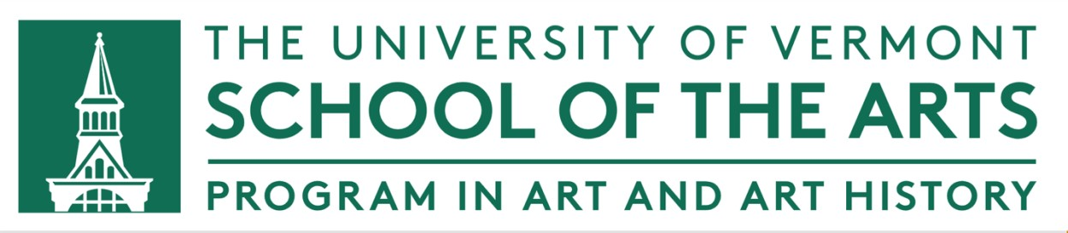

STUDIO ART MAJOR/MINOR APPLICATION

Due to high demand, there is an application process to major or minor in Studio Art.

Current University of Vermont students may apply to major or minor in Studio Art at any time during their first three years as undergraduates. Students must have a minimum GPA of 2.3.

If you are a student in a College other than CAS, or if you are seeking a double major in CAS alone or across Colleges, I will also seek approval from your College.

To apply, please fill out this form and send to:
Pamela Fraser, Program Head, Art and Art History. Professor Fraser will respond to you in a timely fashion.

Date ____________

Name _______________________________________

Student ID # (95-number) ________________________

Applying for _______ Studio Art major

_______ Studio Art minor

What College(s) are you in, and what is/are your other degree program(s)?

Art and Art History courses taken to this point, with term (ex: ARTS 1100, SP24):

