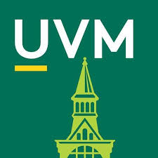
Academic Leadership Special Events Fund
Funding Request Form 11.11.19

Please complete and forward this form electronically to your dean, vice president, or advisor (for student groups) who will indicate their approval by forwarding the form to Kerry Castano in the Office of the Provost.

Please submit your request no later than six weeks before the event. Once the Academic Leadership Special Events Fund has been fully allocated, there will be no further awards that year.

Today’s Date:
Name of Requester:
Title of Requester:
Requester’s University of Vermont E-mail Address:
Home Department/Group:

Date of Event:
Event Title:
Description of Event:
Goals of the Event:
Audiences the Event is Open To:
Estimated Attendance:
If this event has been held before, list prior date(s) and attendance:
Are there other major events on the date of this event?

Total Event Budget:
Will admission be charged at this event?
What percent of the total event budget will be generated by admission fees?
Amount of Academic Leadership Special Events Funding requested:
Other non-academic unit sponsors from whom funds have been requested/provided (and amounts):

Please describe the ways in which the proposed event supports no fewer than three of the following criteria:
Supports positive institutional impact

Impacts multiple departments/programs/colleges/schools

Enhances institutional reputation

Enriches academic or co-curricular activities

Supports student success and satisfaction

Responds to critical or timely issues
Advances the University’s Academic Excellence Goals

Supports innovation and/or entrepreneurship

Furthers or celebrates academic, research, scholarly, or creative achievements

