Meet with a Study Abroad Advisor

If you would like to meet with a Study Abroad Advisor, before scheduling an appointment please make sure that you have:
- Researched study abroad programs using the GoAbroad search function and have identified your desired term abroad and host country
- Narrowed down the programs you’re considering so that you have 1-3 specific programs to discuss with your Study Abroad Advisor
- Met with your academic advisor to discuss your academic needs while studying abroad, and completed the Academic Planning form (available on the Study Abroad Forms page). Make sure you know what an academic advisor's role is in the study abroad process, as compared to the role of a study abroad advisor, so that you can know what questions to ask

Students applying to UVM Bilateral Exchange, ISEP Exchange, ISEP Direct, and the NUI Galway Semester program are required to meet with a study abroad advisor. Meeting with an advisor is optional for students applying to External or Direct programs.

Currently UVM Study Abroad Advisors are meeting with students who are planning their study abroad for Spring 2021, Summer 2021, Fall, 2021, and Academic Year 2021-22. Advisors will begin meeting with students considering later terms following the deadline for Summer/Fall/Academic Year 2021 programs (February 15, 2021).

The Office of International Education schedules study abroad advising meetings using the Navigate App. To schedule an appointment, follow the steps below:
- Don’t have the Navigate app? Click here to download.
Note: Mobile and desktop versions are available.
- Sign in with your UVM NetID and password. Select “Appointments” and “Schedule and Appointment”
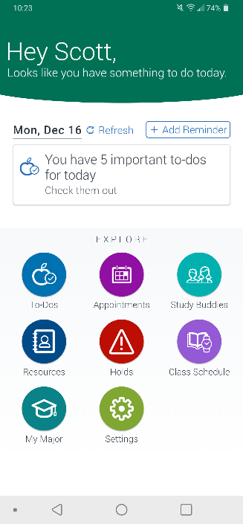
- Make the following selections:
Type of Appointment: Student Support Offices
Department: Office of International Ed – Study Abroad
Reason for Appointment: Your desired host country

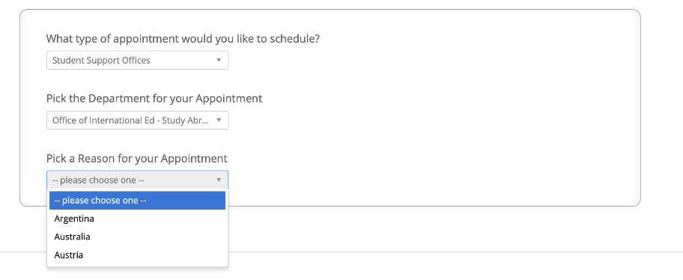

- Select the Appointment Location (Office of International Ed – Study Abroad). Then, either select a Staff Person or Click Next to be directed to all available times for staff at that location.
Note: UVM is operating primarily remotely due to COVID-19. Even though you are selecting the Office of International Ed – Study Abroad as the appointment location, your actual meeting with most likely take place using Microsoft Teams or via phone.
- Select an available time and confirm the appointment details. (You may need to scroll to future weeks to locate a time that is available.) You will be asked to choose how you want to receive reminders about the meeting, and there is space provided to enter any details that you want the advisor to know about prior to the appointment time (i.e. specific questions, topics of discussion, etc.)

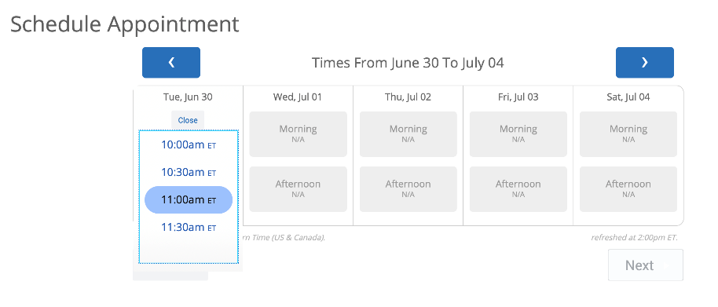
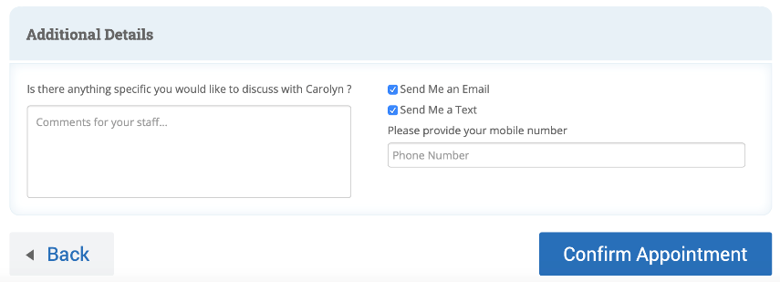

Have additional questions about appointment scheduling? Not able to find an appointment time that works for you? Contact studyabroad@uvm.edu.

