Faculty Program Proposal Instructions
(for those without full-time appointments at UVM and without previously made GoAbroad accounts)
Part 1: Expression of Interest

- Select the correct program below:
- Faculty-Led Program Proposal: New Domestic Program
- Faculty-Led Program Proposal: Audit Year Domestic Program
- Faculty-Led Program Proposal: Recurring Domestic Program
- Faculty-Led Program Proposal: New International Program
- Faculty-Led Program Proposal: Audit Year International Program
- Faculty-Led Program Proposal: Recurring International Program

- Click the “Apply Now” button.

- Click on the “I do not have login credentials to this site” option and then click the “Submit” button.
- Complete the New User Form with all your information. Read the terms and check the box to agree to them. Then click the “Create Account” button.
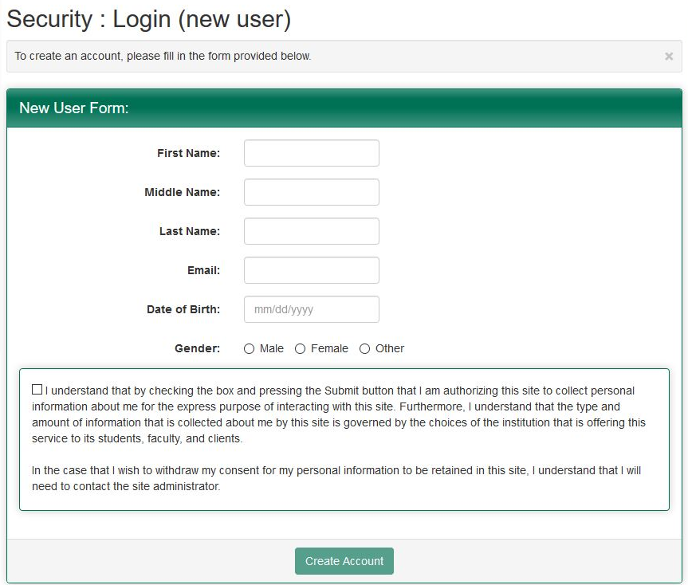
- You will get a message that looks like this. Click OK, and then check the email address you listed in the previous form. You should get an email with a User ID and Temporary Password.

- Use the link in the email for “General non-UVM Network ID login”. It should take you back to the page you were on in Step 3, but this time, select “I have login credentials to this site that I received by email” and click the “Submit” button.

- You will then arrive at this page. Please fill in the fields here with your User ID and Temporary Password that were sent to you via email, then click the “Login” button.

- You will then be able to choose your security questions. Please do so and then click the “Update” button.

- You will then be able to change your password. Please do so and then click the “Change” button.
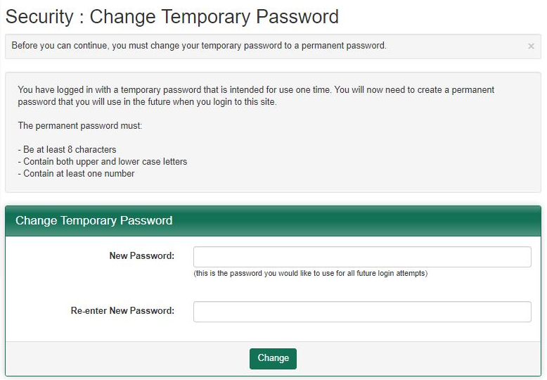

- Once you do this, it will automatically bring you to your Applicant Home page. This is where students would search for programs. Instead of searching for a program, please click the appropriate program as listed below:
- Faculty-Led Program Proposal: New Domestic Program
- Faculty-Led Program Proposal: Audit Year Domestic Program
- Faculty-Led Program Proposal: Recurring Domestic Program
- Faculty-Led Program Proposal: New International Program
- Faculty-Led Program Proposal: Audit Year International Program
- Faculty-Led Program Proposal: Recurring International Program

- Click the “Apply Now” button again.

- Once you are logged in, you will need to select the term to which you are proposing to lead a Travel Study course. Choose the right term and click the “Apply” button.
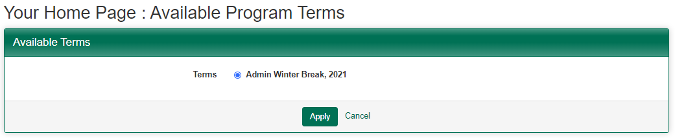

- GoAbroad will create an application for you and bring you to your home page where you will see the Faculty-Led Program Proposal specific to your location (domestic vs. international) and if this program is new, recurring, or requires an audit (audit year). Click on the application.
- Scroll down and you will see your first list of required forms (part 1 of 2). Click on the “Get Started!” button and complete the forms, clicking the “Sign” or “Done” button after each form. Be aware that the Expression of Interest form contains multiple pages, and you will want to make sure you’ve clicked “Save” after completing each page.

- As you progress, you can see your completed forms listed at the bottom of the screen, where you can open them up to view using the eye icon to the right.

- Once you have completed all of the requirements, scroll up to the “Submit your application” button. Click on it. Once you do so, you will have completed Part 1 of 2 of the required program proposal process. Your Expression of Interest will then be reviewed by your Dean’s office and Continuing and Distance Education.

