Faculty Program Proposal Instructions
(For Full-Time Faculty)
Part 1: Expression of Interest

- Select the correct program below:
- Faculty-Led Program Proposal: New Domestic Program
- Faculty-Led Program Proposal: Audit Year Domestic Program
- Faculty-Led Program Proposal: Recurring Domestic Program
- Faculty-Led Program Proposal: New International Program
- Faculty-Led Program Proposal: Audit Year International Program
- Faculty-Led Program Proposal: Recurring International Program

- Click the “Apply Now” button. If you are already logged in on your browser to a UVM site, you may be brought right to your itinerary. If so, skip to step 4. If not, you will be asked to log in. Please select “I have a UVM Network ID username and password” and click the “Submit” button.
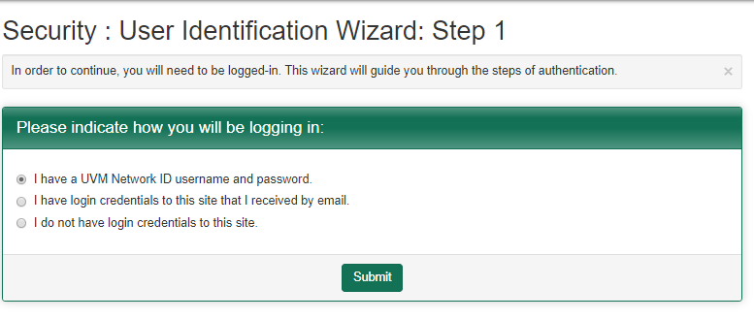
- You will then be asked to log in with your NetID and password.
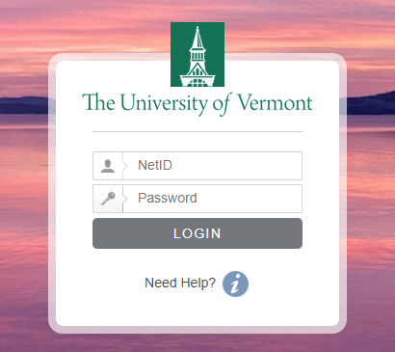

- Once you are logged in, you will need to choose the term to which you are proposing to lead a Travel Study course. Choose the right term and click the “Apply” button.
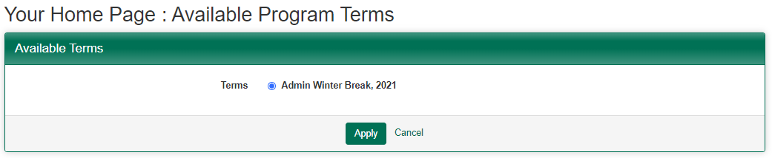

- GoAbroad will create an application for you and bring you to your home page where you will see the Faculty-Led Program Proposal specific to your location (domestic vs. international) and if this program is new, recurring, or requires an audit (audit year). Click on the application.
- Scroll down and you will see your first list of required forms (part 1 of 2). Click on the “Get Started!” button and complete the forms, clicking the “Sign” or “Done” button after each form. Be aware that the Expression of Interest form contains multiple pages, and you will want to make sure you’ve clicked “Save” after completing each page.
- As you progress, you can see your completed forms listed at the bottom of the screen, where you can open them up to view using the eye icon to the right.

- Once you have completed all the requirements, scroll up to the “Submit your application” button. Click on it. Once you do so, you will have completed Part 1 of 2 of the required program proposal process. Your Expression of Interest will then be reviewed by your Dean’s office and Continuing and Distance Education.

