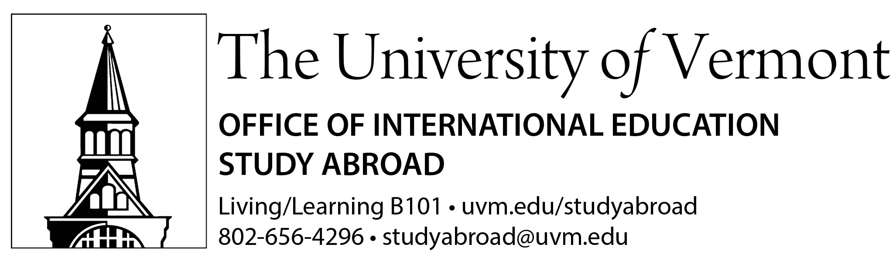 | 
I want to help UVM meet its Generation Study Abroad goals of growing and diversifying study abroad participation at UVM by 2020! I will …
- Complete the “Count Me In!” registration with my UVM email address to receive updates about Generation Study Abroad: bit.ly/2eONhMX (case sensitive)

Count ME in!
- Encourage five (5) first- or second-year students who might not otherwise consider an international experience to pursue one.
- Encourage UVM colleagues to complete the “UVM faculty/staff who’ve studied abroad survey”: bit.ly/2fLTJZh (case sensitive)
- Encourage UVM alumni who studied abroad to complete the survey (details to follow in January!)
- My innovative idea: _________________________________________________________

