UVMLogoOutline3425

*Human Resources, Diversity and Multicultural Affairs*

**Performance Review Workflow**

Completing the Review Online - Uploading Paper Forms

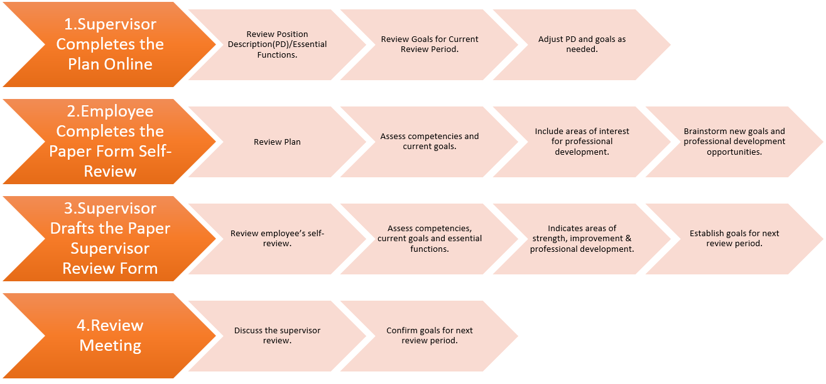 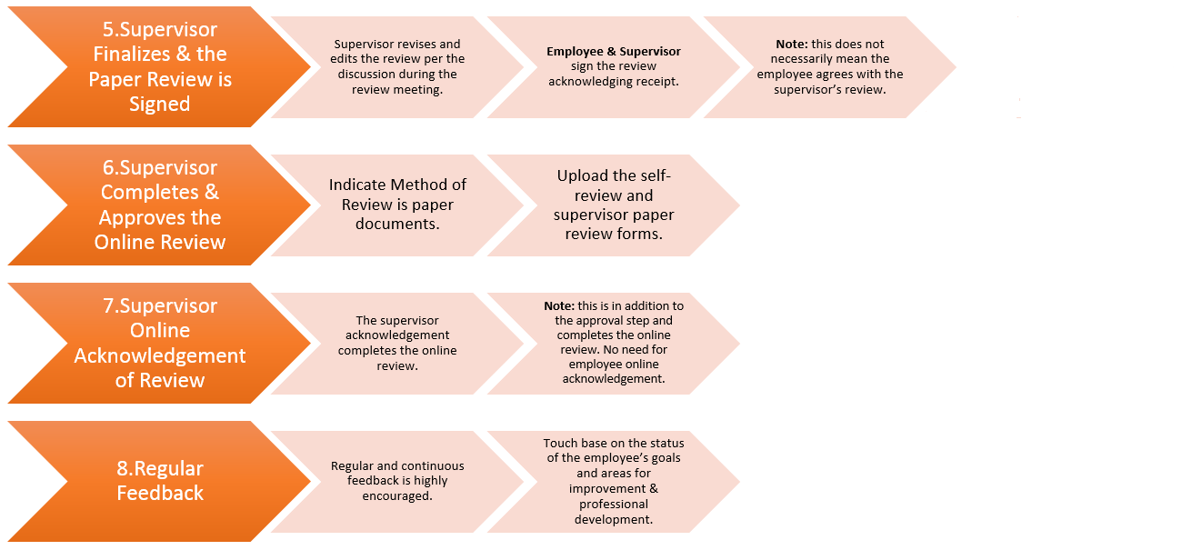

If you would like additional information about the Performance Review Process, contact your supervisor, assigned [HR Rep](https://www.uvm.edu/sites/default/files/Human-Resource-Services-and-Operations/HR_Reps_10.22.18.pdf), Business Manager or [Labor & Employee Relations (LER) Professional](https://www.uvm.edu/sites/default/files/Human-Resource-Services-and-Operations/HRSDocs/Mangers_Corner/LER_Responsibility_Areas_Oct_2017.pdf). For questions regarding access to PeopleAdmin contact [Human Resource Services](mailto:HRSinfo@uvm.edu?subject=Performance%20Management%20Inquiry) at [hrsinfo@uvm.edu](mailto:hrsinfo@uvm.edu) or call 656-3150.