The Kahm Clinic | - Package  - •  - Options
Please read the package descriptions below:  General Wellness Package  Designed for those who believe that their health, for whatever reason, can be improved by altering their diet, but would like some expert and customized guidance. The initial visit includes Metabolic Testing and Body Composition Analysis, which enables us to see how your current diet is serving you and also allows us to provide a highly customized and therefore effective meal plan. The remaining visits also include Body Composition Analysis, enabling us to track your progress. Depending on the person, these visits may include diet and exercise recommendations for weight management, fatigue, pre-diabetes/diabetes, eating disorders, etc.  Sports Nutrition Package  Designed for those looking to boost their athletic performance. It includes an initial Metabolic Test and Body Composition Analysis at each visit, allowing us to see the rate at which you are burning calories, what substrate you are using for fuel, as well as the exact proportion of muscle and fat mass. The data from these tests allow our nutritionist to create individualized meal plans that improve athletic performance, build muscle, speed up recovery, as well as decrease fatigue, muscle soreness, and injury rates. Our nutritionist, who has extensive experience working with division I athletes (NC State and Virginia Tech), can help you prepare for an upcoming athletic event or simply improve your performance. | 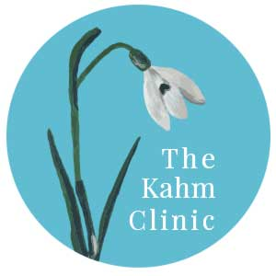  Contact Info  https://www.thekahmclinic.com/

