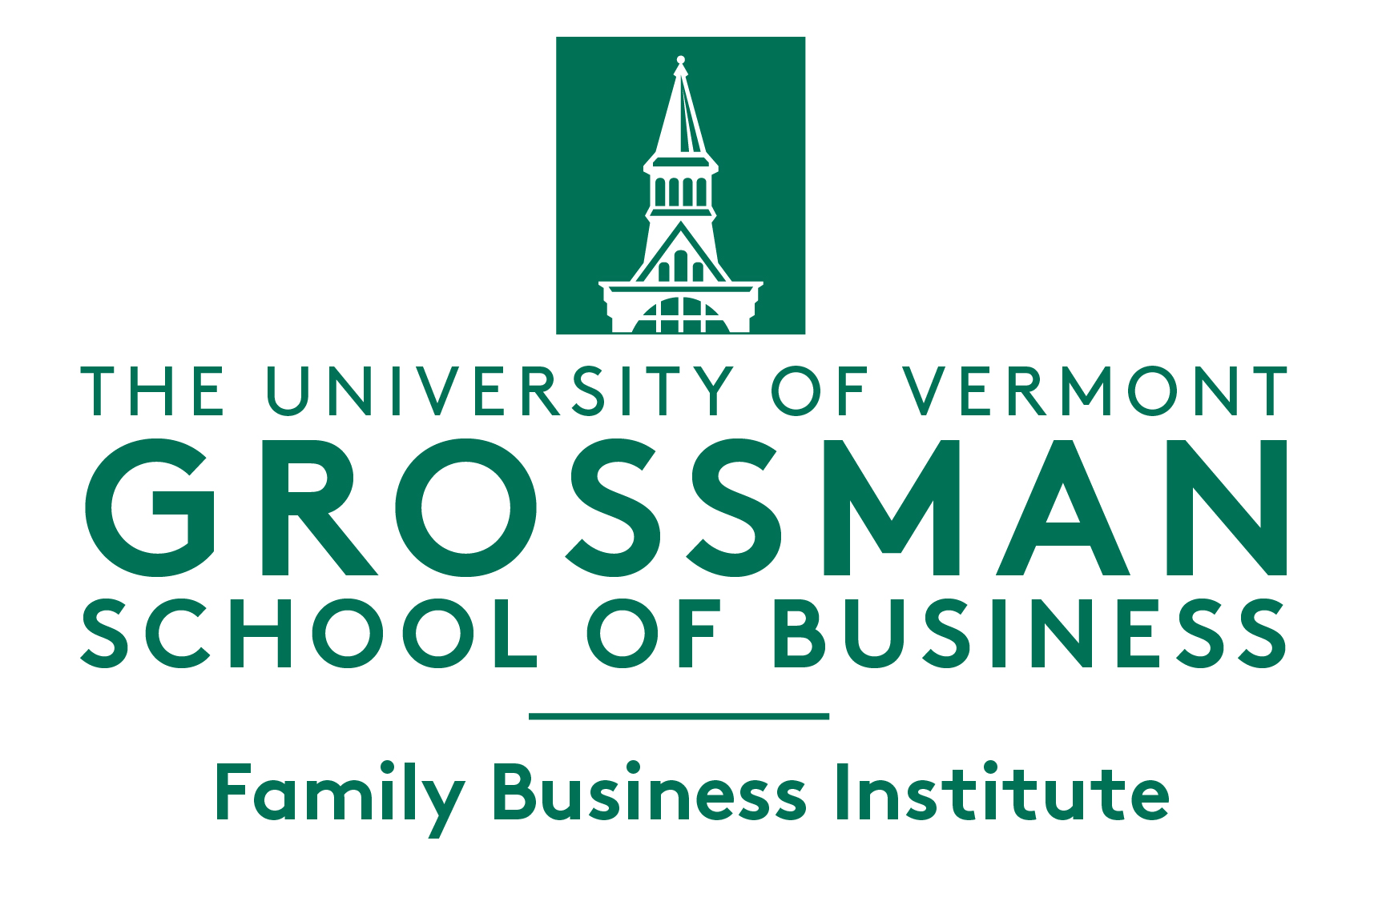

2022 UVM Family Business Awards
Nomination Form

Please send completed nomination form to gsbfba@uvm.edu by May 15, 2022

Section I: Personal Information

- Your full name: Click here to enter text.

- Your relationship to the nominee: Click here to enter text.

- Your e-mail address: Click here to enter text.

- Your phone number: Click here to enter text.

If a Current Student of UVM:

- Your net ID: Click here to enter text.

Section II: Nominated Company Information

- Company Name: Click here to enter text.

- Name of contact person of the nominated company: Click here to enter text.

- Relationship of the contact person with the nominated company: Click here to enter text.

- Company website (if known): Click here to enter text.

- E-mail address of contact person (if known): Click here to enter text.

- Phone number of contact person (if known): Click here to enter text.

- Rationale (Please provide a few sentences stating the reason(s) for the nomination):

Click here to enter text.

Category of Nominated Business (Check only ONE box, if known):

☐ 1st Generation Family Enterprise:
Start-up or purchased firm with multiple family members in ownership or operations

☐ Multi-Gen: US Based Family Enterprise
Firm that has completed at least one generational transfer within the family

☐ Multi-Gen: Global Family Enterprise
Firm that has completed at least one generational transfer within the family

☐ Vermont Legacy Family Enterprise:
Vermont based family business recognized for outstanding and long lasting success

Please note that after evaluating the application, the selection committee may modify the category selected by the applicant if another category is deemed more appropriate.

NEXT STEPS:

After 15 May 2022 we will invite the contact person from your nominated company to submit a full application. Due date for completed applications is 10 July, 2022.

- Do you wish to remain anonymous? (Please check one box) ☐Yes ☐No

