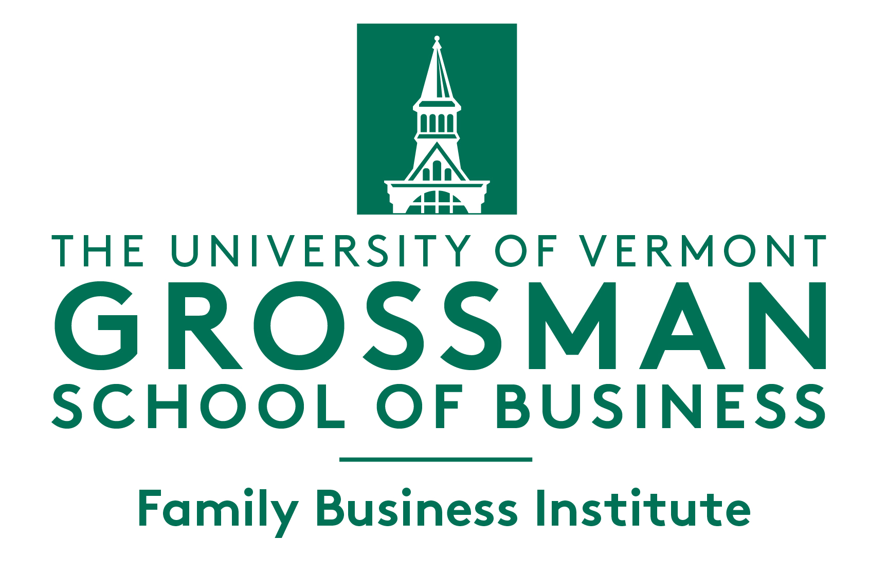
2022 UVM Family Business Awards
Application Form

Please return to gsbfba@uvm.edu by July 10, 2022

Please Note: The information provided is kept strictly confidential. The UVM personnel involved in related processing and the award judges sign a non-disclosure agreement (NDA).

Category (Check only ONE box):

☐ 1st Generation Family Enterprise:
Start-up or purchased firm with multiple family members in ownership or operations

☐ Multi-Generational U.S. Based Family Enterprise:
Firm that has completed at least one generational transfer within the family

☐ Multi-Generational Global Family Enterprise:
Firm that has completed at least one generational transfer within the family

☐ Vermont Legacy Family Enterprise:
Vermont based family business recognized for outstanding and long lasting success
Please note that after evaluating the application, the selection committee may modify the category selected by the applicant if another category is deemed more appropriate.

Section I: Applicant Information

Company name: Click here to enter text.
Company address: Click here to enter text.
Company web address: Click here to enter text.
Name of contact person submitting this application: Click here to enter text.
Relationship of the contact person with the applicant company: Click here to enter text.
E-mail address of contact person: Click here to enter text.
Phone number of contact person: Click here to enter text.

Section II: About the Company

Number of employees (FT): Click here to enter text.(PT): Click here to enter text.
Year founded: Click here to enter text.
Company’s primary industry: Click here to enter text.
Principal product(s) or service(s): Click here to enter text.
Number and locations of company’s current operations: Click here to enter text.
Name(s) of principal owners: Click here to enter text.
Number of family members currently employed by the company (including board of directors): Click here to enter text.
Number of generations currently involved in the company: Click here to enter text.
Number of generations involved since the company was founded: Click here to enter text.
Generation that currently runs the company: Click here to enter text.
Institution Name(s), Graduation year(s), and Name(s) of controlling family members who may have completed undergraduate or graduate degrees.
Click here to enter text.

Section III: Application Questions
Please address the following four topics (400 words or less per topic).
- History of Your Family Business
Give a brief history of your family business. Consider how the company was started, how it has changed, its present nature and a glimpse of its future.
Click here to enter text.
- Governance of Your Family and Your Business
What governance structure/s does your family / business use (click all that apply):
☐ Board of Directors
  - Number of Family Members on the Board: Click here to enter text.
  - Number of Total Board Members: Click here to enter text.
☐ Family Foundation / Family Office
☐ Family Council
☐ Formally facilitated regular family meetings
☐ Un-facilitated regular family meetings
How has the control and ownership of your firm been transferred from one generation to the present OR how future continuity is planned
Click here to enter text.

Describe the level of communication within and between generations on matters of governance and succession plans?
Click here to enter text.

- Contributions of Your Family Business and/or Family to Society
Provide 2-3 examples of the contributions of your family / business to the communities and/or the natural environment in which you operate.
Click here to enter text.

Provide 2-3 examples of the contributions of your family business to raising standards in your industry and/or preserving your craft.
Click here to enter text.
- Innovative business practices or strategies
Provide 2-3 examples of innovative new technologies or business models adopted by your company over the years. Did any of these initiatives help expand the reach of your company to new market segments or customer groups? If so, please elaborate.
Click here to enter text.
PLEASE SET THE ‘ENTER TEXT’ TO ACCEPT UPTO 400 WORDS

- Financial Data: Please provide the following information.
 | 2021 | 2020 | 2019 | 2018
Gross Revenues | Click here to enter text. | Click here to enter text. | Click here to enter text. | Click here to enter text.
Net Profits (before taxes) | Click here to enter text. | Click here to enter text. | Click here to enter text. | Click here to enter text.
% of firm owned by controlling family | Click here to enter text. | Click here to enter text. | Click here to enter text. | Click here to enter text.

Section IV: Additional Information Requested (Optional)
- A company brochure or catalog
- Copies of newspaper or magazine articles about your company
- Business-related and family photographs

Information Accuracy:
I confirm that, to the best of my knowledge and belief, all information provided in this application is true and complete. In addition, all short-listed entries will be required to provide more information and/or meet in an interview with members of the selection committee. If selected as award winners, we are expected to attend the award presentation ceremony in October 2022 at the University of Vermont (Ifshin Hall) in Burlington. Details to be announced.

Applicant’s Name (please print):
Click here to enter text.

Applicant’s Signature:
Click here to enter text.

Date:
Click here to enter text.

