50th Anniversary of
Earth Day:
The Impact of UVM Research & Teaching on Sustainability

Summit Participant Workbook

Table of Contents
Introduction | 1
Objectives, Approach, Pedagogy | 2
Pedagogy | 3
Agenda | 4
Instructions | 5
Reference list | 6

Appreciative Inquiry Phases
Part I: Discovery Phase | 7
Part II: Dream Phase | 17
Part III: Design Phase | 23
Part IV: Debrief/Closing | 31

Note: You are encouraged to write in this document. Please note that when you write in this document, page numbers might shift, so the page numbers listed in the above Table of Content page might change as well.

Summit Objective
The purpose of this virtual Summit is “How might we achieve and measure the impact of our sustainability teaching, research, and outreach efforts.” Because the Summit takes place on April 22nd, the 50th anniversary of Earth Day, it is a good opportunity for an inflection point for students, faculty, and staff at UVM and the broader UVM community to see how we can drive sustainable change within our own systems for the next 50 years. This is a virtual meeting that is interactive, participative, and co-facilitated by UVM students who are applying tools (e.g., Appreciative Inquiry, World Cafe) that they have learned in the Sustainable Innovation MBA, especially those during a course titled Driving Sustainable Change. Following is a brief explanation of the approach that we will use during this Summit.

Summit Approach
- Discovery: This is the first phase of the Summit. Typically, most planning processes begin with a vision first and then do a gap analysis between current reality and vision. Rather, we will first focus on the strengths of the system. In our case, the Discovery phase of this particular Summit has introductory interview questions that focus on what the strengths of UVM are as they relate to sustainability. Ideally, this is conducted through paired interviews through which participants share stories, but we will use a similar process virtually. Then in small groups, the key themes are distilled. In terms of duration, this part usually takes a day and can be done in many forms. For example, one part can be done with mixed stakeholder groups and then another with each stakeholder group individually discussing what strengths they bring. In our case, we will do a condensed version in only 1.5 hours.

- Dream: In this second phase of the Summit, the most important is that visions are based on strengths from the prior Discovery phase. In other words, imagine that strengths are amplified times 10, times 100, and what that would like in the future (e.g., 5 years). There is no special format, however creativity and fun are encouraged (e.g., news headline, magazine cover, picture collage, poem/song, memes, etc.). Each group usually presents. Given the time limits of our Summit, it will have to be very brief.

- Design: This is the third phase in which small working groups are formed related to different parts of our shared visions for sustainability at UVM. In this particular Summit, the groups will work on creating bottom-up sustainability initiatives / ideas / projects for UVM based on the visions of participants (resulting from the Dream Phase). Typically, there is a break between the Dream and Design phases (in this case, we will have a lunch break). Then during this break, a select number (usually a smaller number such as 3-5 works better) of facilitators and sometimes a few key organizational champions come together to theme the “dreams” and decide what the main working groups will be. In addition, these same facilitators will usually take notes during the presentations in the prior Dream phase in order to listen for “opportunity areas” (i.e., breakout group topics). Typically, this phase will use methodologies such as Open Space Technology and/or Design Thinking. One note: it seems counterintuitive that these groups might work in parallel because it might make sense that there is a linear sequence for some groups (e.g., a group working on strategy might make sense to be done prior to work on a topic such as marketing and communication). However, what usually happens during the prior phases (i.e., Discovery and Dream) is that a collective mind is built (i.e., we are building on our collective intelligence). Therefore, groups working in parallel are able to accomplish more both quicker and at a larger scale. In addition, participants can float from group to group and interact. At the end of this phase, presentations are typically done with the most important being that any ideas are harvested using the template provided (the links are below).

- Deployment Phase (also sometimes referred to as Destiny): We will not be covering this during this Summit. For this phase, project-planning skills are typically used after the Summit. Often, the planning system that is used within the organization is employed so that a new system is not created. In our case, we will encourage that the breakout groups continue their work after the Summit.

Our Pedagogy
Setting the tone in our shared space.
- We prize respectful exchange.
- We assume best intent in all interactions.
- We invite equal participation across participants/stakeholders.
- We aim to continually cultivate our own awareness of our personal and collective positionality to power.
- We listen closely to those who are most directly affected by the results of the decisions we are making together.
- We approach participation and learning not from our places of ultimate power but from our places of ultimate vulnerability and connectivity.
- We value enthusiastic support for authentic sharing toward a true understanding of perspectives, with the goal of allowing new solutions to emerge.
Informed and Inspired by: Standpoint Theory, Paulo Freire, J.K. Gibson Graham

Summit Agenda

Wednesday, April 22, 2020

Time | Session / Task
9:00am – 9:30am | Intro to Day and Task  (including welcoming remarks from  Dean Sanjay Sharma, Grossman School of Business & Taylor Ricketts, Director, Gund)
9:30am – 11:00am | Phase I - Discovery
11:15am – 12:30pm | Phase II - Dream
12:30pm – 1:30pm | Lunch
1:30pm – 3:15pm | Phase III - Design
3:30pm – 4:30pm | De-brief and Closing  (including closing remarks from  Provost Patricia A. Prelock)
4:30pm | Keynote: Dr. Nalini Nadkarni  (Optional, see Gund Events)

Instructions

Forming Groups

Suggested Self-Management and Group Leadership Roles:
Each small group manages its own discussion, data, time, and reports. Here are useful roles for managing this work. Leadership roles can be rotated. Divide up the work as you wish. Each role member should perform the duties outlined below alongside the activities in each exercise.

- Time Keeper: Keeps the group aware of time left for the activity and monitors report-outs to signal time remaining for the reporter.

- Reporter: Delivers report to the larger group in time allotted.

- (optional) host / facilitator: Ensures that each person who wants to speak is heard and keeps the group focused on the topic.

Principles

- Whoever comes is the right person(s)
- Whatever happens is the only thing that could have happened
- When it starts is the right time
- When it’s over, it’s over

Reference List

Below are all the links you will need for this summit. You can click on the link directly below. If that does not work, you also have the full URL provided which you can then copy/paste into your web browser:
- Virtual Tablecloth : https://docs.google.com/document/d/1bSKpKtjjdToxfXcfF7ZNpure9JBTMXkOqgEneVqMMRU/edit#

- Public Folders (includes pdf versions of slides, workbook, and folders for breakout groups to use) : https://drive.google.com/drive/u/0/folders/189fXi5tEc12Fq0ZdNckkc-oE7c7VhZDq

- Email Verification : https://tinyurl.com/AddressConsent

- Pollev.com/aglavas (used for group questions throughout)

- Jamboard for Part I: Discovery - Round 3 Small Group Harvest : https://jamboard.google.com/d/1eUc_0RQU1gxNaMkfJDAxPa2fPxjS-qHVdS_IH3HjGmc/viewer?f=0

- Feedback Survey : https://forms.gle/Uy956WK1Vuw3f1v99

Part I: Discovery

Appreciative Inquiry Process

Appreciative Inquiry forms the basis of the overarching process that we will use for the Summit today. For more information about Appreciative Inquiry, click here.

- Recognize the best of what is…
Let’s recognize our strengths, what UVM is doing well in
sustainability and how we are achieving and measuring the
impact of our teaching, research, and outreach efforts.

- Imagine what might be…
Based on the aforementioned strengths, let’s imagine the most
sustainable UVM and the impact that it creates. What does it
look, feel, or sound like?

- Design what should be…
Building on strengths and vision, let’s describe and put into
words / drawings how might we achieve and measure the
impact of our sustainability teaching, research, and outreach
efforts?

- Create what will be…
Let’s work together to create everything we’ve described
above.

World Café: About

The World Cafe is the methodology that we will use for this part of the Summit. For more information about the World Cafe, click here.

Why host a world café to instigate change?
- Typically, the best conversations in a conference take place during the breaks or evenings. Here, we flip that and try to make those conversations the center of the conference.
- A world café is a facilitated large-group dialogue that enables and encourages insights balanced from all stakeholders.
- It focuses on questions that matter to us individually, that we are not able to solve by ourselves, but that our collaborative / collective intelligence could solve.
- The framework also allows people to engage in conversations that matter in a judgement free space.
- The setting: cozy café feel ~ Let’s try to recreate this at home with a coffee, tea or cocoa!
The structure of a World Café involves:
- Welcome + introduction
- Small group rounds focused on key questions. Each round goes deeper into the core questions.
- In each round, groups are mixed so that each participant brings their notes from the prior round. For example, if a new round has 5 participants, it will represent the conversations that these 5 participants had with another group of colleagues. In this way, by the final round, there is a collective field formed.
- Presentations / reports are limited, consensus is reached quickly.
- A key aspect is harvesting the findings to take away. In our virtual session, we will do that via “virtual post-it notes” in jamboard (instructions are below).

Agenda
1 | Round 1 – Small Group Interviews (15 min)
2 | Round 2 – Small Group Discussion (15 min)
3 | Round 3 – Small Group Harvest (15 min)
4 | Final Large Group Discussion

Reminder: Forming Groups

Suggested Self-Management and Group Leadership Roles:
Each small group manages its own discussion, data, time, and reports. Here are useful roles for managing this work. Leadership roles can be rotated. Divide up the work as you wish. Each role member should perform the duties outlined below alongside the activities in each exercise.

- Time Keeper: Keeps the group aware of time left for the activity and monitors report-outs to signal time remaining for the reporter.

- Reporter: Delivers report to the larger group in time allotted.

- (optional) host / facilitator: Ensures that each person who wants to speak is heard and keeps the group focused on the topic.

Round 1 - Small Group Interviews (15 min)

Instructions:

- Participants will be sent to breakout rooms of 2-3 participants.
- Read the question below as a group in your breakout room.
- Take a minute to think about your question individually (you have space below for personal notes).
- Once everyone in your group is ready, discuss each person’s perspective one at a time.
- Then as a group reflect on key strengths of sustainability within the UVM community, making note of key words or phrases that regularly emerge into the Virtual Tablecloth. Once in the Virtual Tablecloth, please go to the space in “Part I: Discovery - Round 1 - Small Group Interviews”. Your breakout group number should correspond to the Breakout group number you see in Zoom. If there are more breakout groups than the ones listed there, please find some space below and list key themes from your discussion.
- Additional notes should be kept in your Workbook and/or journal.

You will each be asked to share a summary of key themes (i.e., UVM sustainability strengths) that emerged in your discussion during the next round of small group discussion (in new, mixed small groups).

Discovery Question:
“Describe meaningful moment(s) at UVM that made you think / feel positively about sustainability within the UVM community?”

Feel free to think about any of the following sub-questions as well to facilitate discussion:
- Please describe a moment or experience related to sustainability at UVM when you felt the most alive, energized and/or full of passion.
- Where have you seen UVM at its best in relation to sustainability?
- Was there a moment when you personally felt most connected to UVM’s sustainable efforts or messages?
Personal notes:

Use the space below to write any personal notes, journal, etc. You can also use this space to capture anything that comes out of your small group discussions that you might want to share with your subsequent groups.

Round 2 - Small Group Discussion (15 min)

Instructions:

Individuals will be transferred into new 4-6 person breakout rooms.

- Think about the below question again. One at a time, go around the table and share key insights from the last breakout group. These insights should be related to strengths in sustainability of the UVM community. Which of your main themes (UVM sustainability strengths) are the same? Does this new group have perspectives you did not consider? Take some time to reflect on new discovered strengths, as well as new lessons learned.

- Please note key themes (related to the strengths of the UVM community in sustainability) identified by your breakout group in the Virtual Tablecloth in the section “Part I: Discovery - Round 2 - Small Group Discussion.” You will be asked to share these in the next round.

- As you come up with ideas, please keep personal notes in your Workbook and/or personal journal.

Discovery Question:
“Describe meaningful moment(s) at UVM that made you think / feel positively about sustainability within the UVM community?”

Feel free to think about any of the following sub-questions as well to facilitate discussion:
- Please describe a moment or experience related to sustainability at UVM when you felt the most alive, energized and/or full of passion.
- Where have you seen UVM at its best in relation to sustainability?
- Was there a moment when you personally felt most connected to UVM’s sustainable community, efforts or messages?

Personal notes:

Use the space below to write any personal notes, journal, etc. You can also use this space to capture anything that comes out of your small group discussions that you might want to share with your subsequent groups.

Round 3 - Small Group Harvest (15 min)

Instructions:

Individuals will be transferred into new 4-6 person breakout rooms.

- Think about the prior question again (i.e., meaningful sustainability moments at UVM). One at a time, go around the table and share key insights from the last group. Where are your main themes (UVM sustainability strengths) the same? Does this new group have perspectives you did not consider? Take some time to reflect on new discovered strengths well as new lessons learned.
- Based on all your discussions this morning, your breakout group should come up with 2-3 sustainability-related strengths of the UVM community.
- Then please submit these 2-3 UVM sustainability strengths as “virtual post-its” to Jamboard (example is shown below).
- Please limit your submissions to one strength per post-it (i.e., a total of 2-3 post-its), and try to summarize these strengths in one word, max three words.
- The facilitators will cluster the post-its during the next possible break and present common themes spoken about during the following large group discussions.
- These same instructions can also be found in our Virtual Tablecloth under “Part I: Discovery - Round 3 - Small Group Harvest”.

Once you’re on the Jamboard website, here is how you can create virtual post-it notes! To access jamboard, please click here.

Please create 2-3 post it notes that represent the key strengths of UVM in sustainability. These strengths should be a summary of the key themes that emerged from all of your discussions. Please use a separate post-it for each strength and try to summarize in one word (three words max).

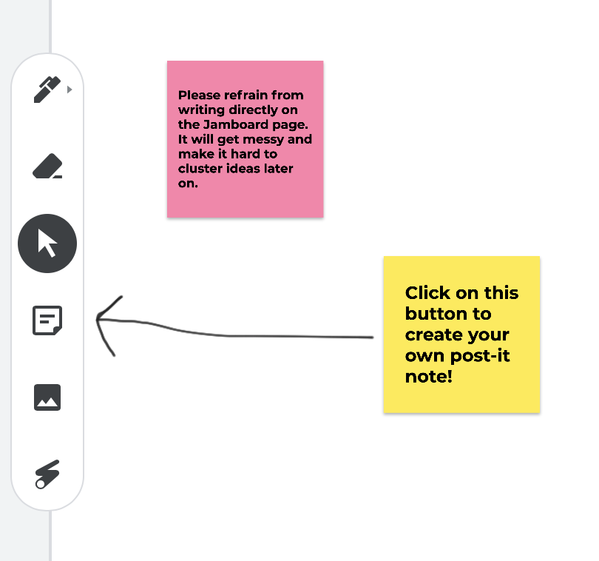

Personal notes:

Final Round - Large Group Discussion

Instructions:

- All members of the summit will come back together in the main Zoom meeting room to debrief on the morning’s work.
- Participants may volunteer to share what they learned throughout the course of the morning and/or any other thoughts/feelings they have.
- Participants may share their insights out loud (if possible, please turn on your video while sharing) and/or using Zoom’s chat feature.
- The facilitators will cluster the post-its during the next possible break and present common themes spoken about during the discussions.

Personal notes:

Part II: Dream

Agenda

1 | Introduction & Objectives
2 | Step 1: Silent Visualization of Future (3 min)
3 | Step 2: Small Group Visualize the Future (30 min)
4 | Step 3: Presentations

Objective

“Imagine a time five years from now. Imagine what your experience would be, wherever you are - How has the sustainability work of UVM translated in the greater world in the university and outside it. What does 100x success in sustainability impact look like?”

Group Roles

As soon as you get into your groups please assign:
- Time Keeper: Keeps the group aware of time left for the activity and monitors report-outs to signal time remaining for the reporter.
- Reporter(s): Delivers report to the larger group in time allotted.
- (optional) host / facilitator: Ensures that each person who wants to speak is heard and keeps the group focused on the topic.

Principles

- Whoever comes is the right person(s)
- Whatever happens is the only thing that could have happened
- When it starts is the right time
- When it’s over, it’s over

Step 1: Visualize the Future (Individual)

Instructions:

- Drawing on the strengths described in the prior phase (Part I: Discovery), imagine your life 5 years from now, whether at UVM or outside.
- Individually visualize what it would be like if you scaled up the aforementioned strengths (from Part 1: Discovery) 10x, even 100x and the resulting sustainability impact achieved by UVM.
Think about:
“What do you see, feel, think about this new world at UVM and the greater world outside it? How are we achieving and measuring the impact of our sustainability teaching, research, and outreach efforts?

- Spend 3 min in silent contemplation of what this looks like. If you have any key themes from your visualization that you would like to share with others, please post in the Virtual Tablecloth in the section “Part II: Dream - Step 1 - Individually Visualize the Future”.

As you create your mental image of the future, you may wish to consider any of the following:
- What is UVM like? What makes you most proud?
- How is work and your life in general different?
- What impact will sustainability efforts by UVM have on campus?
- How will that impact your daily routine?
- What external interactions will you experience - media, research citings, content used by students and professionals, translation into business and community practices, or other forms (maybe even ones that do not exist now)?
- What are the intangible consequences (e.g., well-being, better health, minimalist lifestyles, etc.)?

Personal notes:

Step 2: Visualize the Future
(Small groups - 30 min)

Instructions:

You will be placed into random small groups of 4-6 people.

- In 30 minutes, use this time to discuss with your teams the visions you imagined (based on the following question), to take notes in the table in the Virtual Tablecloth, and to prepare your presentation.

Imagine it is five years from now. You are in a future in which the strengths of UVM (the ones discussed in the prior Discovery phase) are scaled up 10x, even 100x:
“What do you see, feel, think about this new world at UVM and the greater world outside it? How are we achieving and measuring the impact of our sustainability teaching, research, and outreach efforts?”

Let your imagination run wild… the sky’s the limit!

- Discuss with each other what your vision of UVM is 5 years from now.

- Complete table form. Take note in the Virtual Tablecloth in the table in the section “Part II: Dream - Step 2 - Small Groups Visualization” of (a) elements of the vision you find most important or exciting key themes or (b) opportunities and possibilities for action.
  - Especially important is the right-hand column (i.e., action opportunities) because this will be the input for forming breakout groups in the afternoon

- Presentations. Prepare your presentations:
- Choose a creative way to present your vision as if it is happening now. Presentations should be no more than one minute.
- We will ask for the group speaker(s) to present and explain your creative presentation. Be prepared to share your screen if you have a visual.

You can choose any way in which to present your ideas - be creative! Some examples of creative presentations include:
- Magazine cover
- News headlines
- Poem/ song
- Picture collage
- Memes
- Powerpoint
- Any other way you want, be creative!

Personal notes:

Part III: Design

Design Challenge / Task:
Assuming anything is possible in relation to your opportunity area…
“How might we achieve and measure the impact of our sustainability teaching, research, and outreach efforts?”

Agenda
You have a total of 60 minutes to complete this. We will meet back at 2:45pm in the main Zoom room. We will be using another platform called iChair and those instructions will be given in our main Zoom meeting room.
1 | Phase A – Brainstorming & Ideation Session (Step 1 is
Brainstorming and Step 2 is Ideation)
2 | Phase B – Rapid Prototyping

Instructions - Technical

- This part of the Summit is self-organized, meaning you choose which breakout group you want to join.
- We will first meet at 1:30pm in the main Zoom meeting room where instructions will be given.
- You will then be prompted to go to another platform that we will use for the breakout groups called iChair. If you have RSVPed for the Summit before yesterday (i.e., by end of day on Monday, April 20) we have pre-registered you for using this platform. You just simply have to go to the following link and enter the e-mail you used to RSVP for the Summit: https://checkin.ichair.org/login
  - You will then be automatically logged in and you will see the Summit site with the breakout groups.
  - Please note that when you enter the iChair site for the first time, there will be a brief demo that takes about a minute. Click the “done” button after you are finished going through all steps.
  - Once you are in iChair, you will find a list of the 10 breakout groups. Feel free to choose any breakout topic or wander between them.
  - As an alternative option if the above login does not work, you can also manually register (it takes less than a minute) by going to https://app.ichair.org/register - please make sure that you enter the following group “token” in the last field: ichair-M74GWEZ5
- We will then return to the main Zoom meeting room at 2:45pm.
- Support: If you have any issues and/or have not RSVPed for the Summit (which means that we did not pre-register you for iChair), you can send a private message in the Zoom chat to “Sustainable Innovation MBA” and/or e-mail ante.glavas@uvm.edu

Instructions - Procedural

- During this time, we will rapidly and collectively build on the strengths and visions from the morning sessions. Based on your work, your presentations, and the information you submitted in the Virtual Tablecloth, we will create 10 breakout groups during the lunch break. These groups will be announced in the main Zoom meeting room, where we’ll meet at 1:30pm. Further instructions will be given as well as how to access the breakout groups.
- You have 60 minutes to complete both Phase A and Phase B (instructions are below) in your breakout groups. We have also included suggested times below which in summary are as follows: Phase A, Step 1 - 10 minutes; Phase A, Step 2 - 20 minutes; Phase B - 20 minutes, and a 10-minute buffer (e.g., for brief introductions, time for reading instructions, organizing). However, we leave it to your group to decide how you want to use the time.
- We will then return to the main Zoom meeting room at 2:45pm.
- In order to ensure proper follow-up after the Summit, we would greatly appreciate it if each group filled out the corresponding table for your breakout group in the Virtual Tablecloth - it can be found in Part III: Design (Phase A, Step 2 - Breakout Group Ideation).

Group Roles

Each breakout group manages its own discussion, data, time and reports. Here are useful roles for self-managing this work. Leadership roles can be rotated. Divide up the work as you wish:
- Time Keeper: Keeps the group aware of time left for the activity and monitors report-outs to signal time remaining for the reporter.
- Reporter: Delivers report to the larger group in time allotted.
- (optional) host / facilitator: Ensures that each person who wants to speak is heard and keeps the group focused on the topic.

Principles

- Whoever comes is the right person(s)
- Whatever happens is the only thing that could have happened
- When it starts is the right time
- When it’s over, it’s over

Personal notes:

Design Phase A: Brainstorming & Ideation
Working with Key Opportunity Areas

Objective

To come up with tangible initiatives in response to the below design question. The specific focus of your breakout group is in the title of your room. Please feel free to change, narrow, expand, or do anything else with the focus of your group.

Design Challenge / Task:
Assuming anything is possible in relation to your opportunity area…
“How might we achieve and measure the impact of our sustainability teaching, research, and outreach efforts?”

Instructions:
- Step 1 - Brainstorm (suggested time: 10 minutes). Brainstorm ideas to the Design Challenge / Task using the above-mentioned brainstorming rules.
  - You can start with each person writing down all of their suggested ideas onto the Virtual Tablecloth under your breakout group area in Part III Design: Phase A, Step 1. There are no bad ideas, only good ones!
  - Alternatively, if you wish, you can also create your own Jamboard if you want to use virtual “post-its” for brainstorming, similar to how we used it during Part I: Discovery by clicking here: https://jamboard.google.com
  - Whatever method you choose, please keep track of your group’s ideas.
  - Then after brainstorming is finalized, discuss as a group and agree on your top 1-3 ideas. Tip: Each person can vote by splitting up 3 points any way they want to their top ideas (e.g., it can be all 3 points to one idea, one point to three ideas, etc.). The reasoning is that we do not want a strict vote, but rather a way to quickly ascertain and discuss the top ideas.
  - Brainstorming rules:
    - Defer judgment— don’t dismiss any ideas
    - Encourage wild ideas— be radical
    - Build on the ideas of others— no “buts” only “ands”
    - Stay focused on the topic
    - Hold one conversation at a time
    - Be visual
    - Go for quantity

- Step 2 - Ideation (suggested time: 20 minutes). In addition to choosing your top idea(s), below are some important questions to answer, and to keep in mind for our prototyped ideas (that is the next phase) to become a reality! Please fill out the corresponding form for your breakout group in the Virtual Tablecloth.

- Summarize from your brainstorming, what is/are the top 1-3 main idea(s)?
- What are your hopes for potential future outcomes?
- What is one BHAG (Bold Hairy Audacious Goal) for the next few years?
- What are 1-3 quick wins to generate momentum for your ideas (ideas that can generate the most impact with the least amount of effort)?
- What resources (a) do we already have amongst ourselves in this breakout group and (b) would we still need?
- What follow-up plan do you suggest for next (ideally list a desired plan and a contingency plan if the current situation continues)
- Who will be in “charge” of the idea?
- Who would participate in that effort?
- What will be the follow up in 6-12 months?
- Please also list names of who in the group wants to be included in Summit follow-up communication regarding this breakout group and (b) if there is a one (or more) point person(s) for communication around this topic. For example, Gund, SIMBA, or others at UVM might want to follow-up directly with your group.

Please note you have Public Folders set up for your breakout group that you can use to store and share documents during and after the Summit. Please click here to access the folders or you can copy/paste the following URL: https://drive.google.com/drive/u/0/folders/189fXi5tEc12Fq0ZdNckkc-oE7c7VhZDq
Personal notes:

Design Phase B: Rapid Prototyping

Objective
To focus in and take the most promising areas from the prior brainstorming and ideation phase to build and design a “prototype” or model. Through this process, we will bring the ideas into life and thus help us realize our visions that build on the strengths identified in the morning session. The end goal is to begin prototyping an initiative that has strategic value for the UVM community.

Instructions:

(Suggested time is 20 minutes)
- With your group, look over your ideas from brainstorming and ideation in the prior Phase A. Identify one idea for which your group will create a prototype.
- Come up with a sentence that represents the prototype your group will focus on.
  - This will be called the “prototype concept”.
- Build the prototype and make it visual! You can mix and match any way to present your prototype! Some examples include:
  - Storyboarding, collaging, sketching
  - Skit, interpretive dance
  - Powerpoint presentation
  - Or any other form, be creative!

- Be prepared to do a 1-minute presentation (and to share your screen of a visual) of how your opportunity area will contribute to how UVM might achieve and measure the impact of our sustainability teaching, research, and outreach efforts.
Your presentation should include:
  - What your prototype is and a one sentence explanation
  - One bold idea for your group
  - 1-3 small steps that can be taken immediately

We highly encourage that you save any visuals or anything else that came out of your breakout group in the shared public folder (there is a folder created for your breakout group) by clicking here or copy / pasting the following URL into a browser:
https://drive.google.com/drive/u/0/folders/189fXi5tEc12Fq0ZdNckkc-oE7c7VhZDq

Personal notes:

Part IV: De-brief & Closing

Debrief Question:
“What is one word that encapsulates the discussions and activities we have engaged in throughout the Summit?”

Instructions:
- Individually: Think about the above question for 1 minute to yourself. Also, write down any insights you have from the Summit and/or any other thoughts / feelings at this moment.
- Small group work (10 minutes; you will be randomly put it into small breakout groups in Zoom):
  - Share your insights and any other thoughts / feelings at this moment.
  - Before you return to the large group, come up with one word (maximum three words) that you agree upon that encapsulates the discussion and activities we have engaged in throughout the Summit. Please enter that word at PollEv.com/aglavas
- After you have collected your thoughts, write down key themes / insights in the Virtual Table Cloth in the section Part IV: De-brief & Closing.
  - You can do this individually, no need to decide as a group

Personal notes:

Follow-Up

Take a few minutes to fill out our Feedback Survey!

Keep up-to-date with all the latest UVM sustainability news, connect with fellow summit participants, and continue co-creating together!

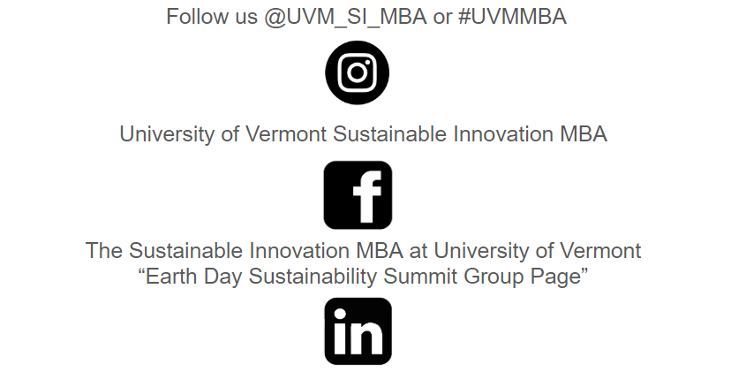

Personal notes:

