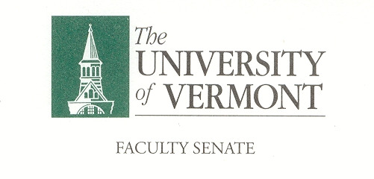
Student Affairs Committee
September 3, 2020
Microsoft Teams
8:30am -10:00am

Agenda

- Committee membership for 2020/ 2021 and introductions
- Minutes from May 2020
- SAC Operating Procedures
- Items for 2020/ 2021
- Old Business
- New Business

Charge of the SAC

This committee shall have responsibility for matters relating to student affairs, their effect on the educational process, and the academic climate of the University, including items referred to in Sections 1.1d, 1.2e, 1.2f, 1.4, and 1.5. It shall recommend policy with respect to honors programs, remedial programs, athletics, discipline, health service, placement, housing, student activities, etc. It shall include among its duties in-depth and ongoing review of University admissions and financial aid policies, including their relation to projected enrollments. This committee shall establish policy in matters related to general admissions standards and prerequisites, as referred to in Section 1.1d, and shall review, recommend and participate in formulation of admissions procedures. The committee shall establish a continuing liaison with student government groups and with all appropriate administrative and academic office

