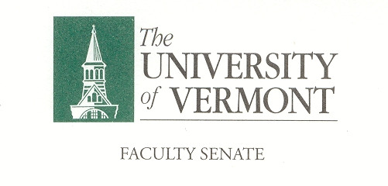

Student Affairs Committee

May 7, 2020

Microsoft Teams

8:30am -10:00am

**Agenda**

1. Review Minutes
2. Review committee membership for 2020/ 2021
3. Parking lot items for Fall 2020
4. Covid-related concerns/ questions to be shared with Executive Committee.

***Charge of the SAC***

**This committee shall have responsibility for matters relating to student affairs, their effect on the educational process, and the academic climate of the University, including items referred to in Sections 1.1d, 1.2e, 1.2f, 1.4, and 1.5. It shall recommend policy with respect to honors programs, remedial programs, athletics, discipline, health service, placement, housing, student activities, etc. It shall include among its duties in-depth and ongoing review of University admissions and financial aid policies, including their relation to projected enrollments. This committee shall establish policy in matters related to general admissions standards and prerequisites, as referred to in Section 1.1d, and shall review, recommend and participate in formulation of admissions procedures. The committee shall establish a continuing liaison with student government groups and with all appropriate administrative and academic office**