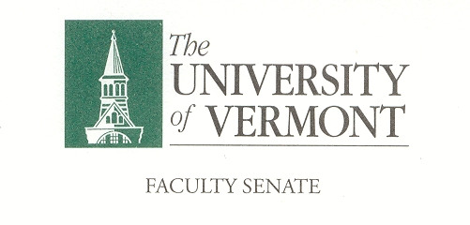
Student Affairs Committee
November 7, 2019
Waterman 427a
8:30am -10:00am

Agenda

8:30 Approval of Minutes from October
8:35 Athletics Policy Revision Nancy Welch, Berke Tinaz, Jonathan Flyer
8:50 Policy Recommendation GPA Calculations for Repeated Courses J Dickinson
9:10 Draft Policy on Course Expectations Outside of the SOC Ken Allen
9:30 Revisit Resolution to Suspend Navigate Jennifer Prue
9:45 Discuss Resolution on Faculty Language around Alcohol and Drug Use Aiden Dougherty
10:00 Adjourn

Charge of the SAC

This committee shall have responsibility for matters relating to student affairs, their effect on the educational process, and the academic climate of the University, including items referred to in Sections 1.1d, 1.2e, 1.2f, 1.4, and 1.5. It shall recommend policy with respect to honors programs, remedial programs, athletics, discipline, health service, placement, housing, student activities, etc. It shall include among its duties in-depth and ongoing review of University admissions and financial aid policies, including their relation to projected enrollments. This committee shall establish policy in matters related to general admissions standards and prerequisites, as referred to in Section 1.1d, and shall review, recommend and participate in formulation of admissions procedures. The committee shall establish a continuing liaison with student government groups and with all appropriate administrative and academic office

