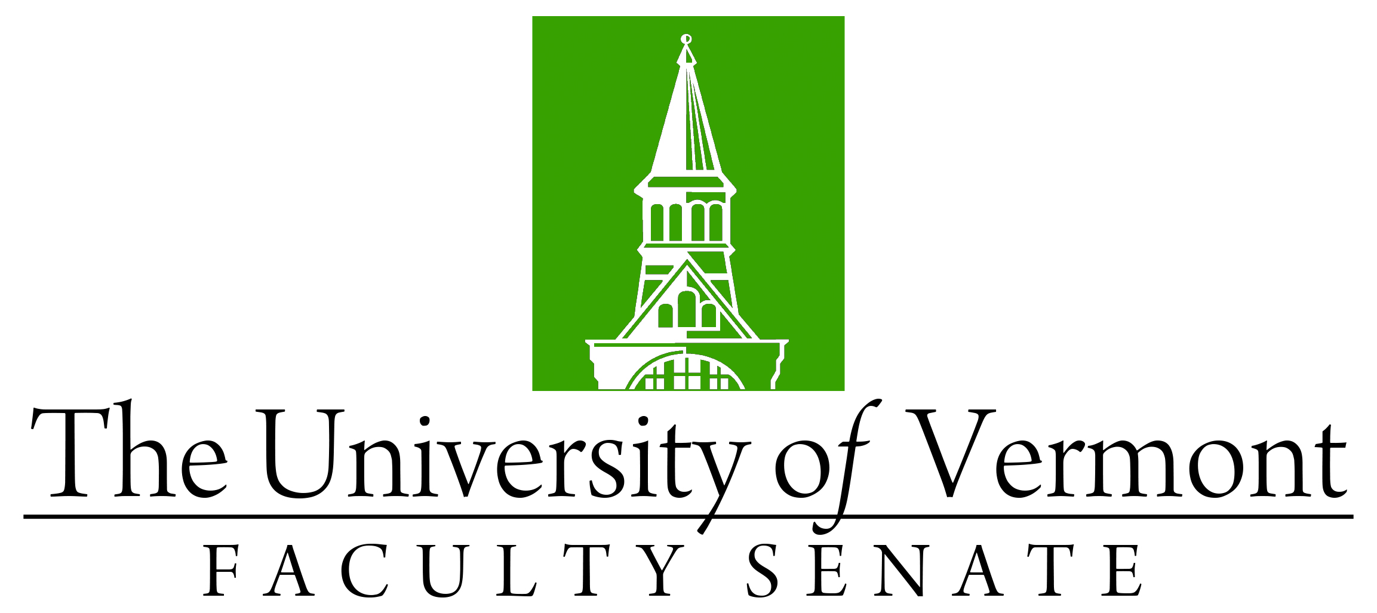

Faculty Senate Meeting
Monday, December 20, 2021
3:00 – 4:30 pm, Online via Teams

Agenda

3:00 | - Faculty Senate President’s Remarks – Thomas Borchert [5 min]
3:05 | - Consent Agenda (vote) [5 min]  - Minutes of the November 2021 Faculty Senate Meeting  - Report of Curricular Affairs Actions that Do Not Require a Senate Vote, including:  - Revision to the Communication Sciences & Disorders Minor (CNHS)  - Revision to the English Major (CAS)  - Revision to the Theatre Major and Minor (CAS)  - Revision to the Dance Major and Minor (CAS)  - New Course Prefix: EDRM Education Research Methods  Curricular Affairs Actions that Require a Senate Vote:  - No-Contest Deactivation of the Geology BA & BS, and Minor (CAS)  - No-Contest Deactivation of the CALS ENSC BS and ENVS BS  - No-Contest Deactivation of the CAS ENSC BS  - No-Contest Deactivation of the RSENR ENVS BS  - New Micro-Certificate of Graduate Study in Sustainable Family Enterprise (GRAD/GSB) *This item was added on 12/16/21 and will require a quorum of three-quarters of voting members present.
3:10 | - Resolution In Memoriam for Lucien Paquette (Extension) – Chris Callahan (vote)
3:15 | - Resolution for Reconsideration of the Allocation of Senate Representation – Ignacio Lopez-Vicuna (vote)
3:30 | - Academic Reorg Working Group Report – Dean David Jenemann (Discussion)
3:50 | - Library post-Elsevier – Dean Geffert (Discussion)
4:15 | - New Business [5 min]
4:30 | - Adjourn

2021-2022 Faculty Senate Meetings
Mondays 4:00 – 5:30 PM (exceptions noted)
12/20/21 – 3:00 – 4:30 PM
1/24/22
2/28/22
3/28/22
4/25/22
5/19/22 – 3:00 – 4:30 PM Thursday

