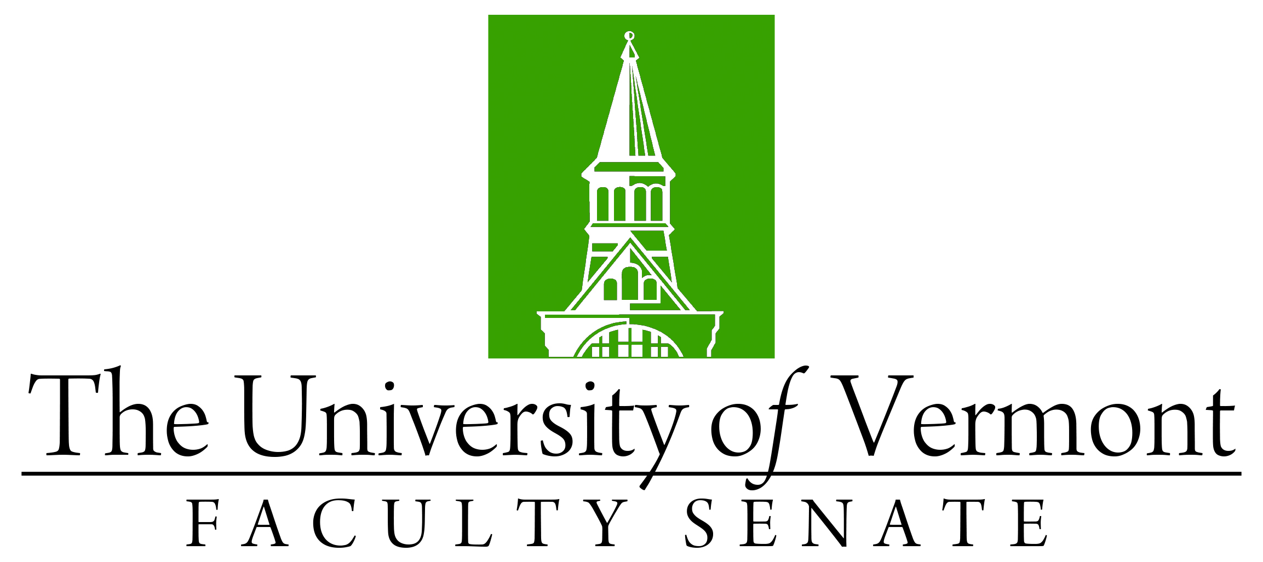

Faculty Senate Meeting
Monday, December 19, 2022
3:00 – 4:30 pm on Teams

Agenda

3:00 | - Faculty Senate President’s Welcome Remarks – Thomas Borchert
3:10 | - Minutes of the November 2022 Faculty Senate Meeting
3:15 | - Proposal to establish Institute For Agroecology (discussion)
3:30 | - Proposal to create a School of World Languages and Cultures (discussion)
3:50 | - HELIOS Discussion (Mary Cushman, co-chair Research, Scholarship & the Creative Arts Committee of the Faculty Senate)
4:10 | - Reports that do not require a Senate vote:  - Student Affairs Committee - Change to Final Exam policy  - Curricular Affairs Committee – prefix change
4:15 | - New Business
4:30 | - Adjourn

