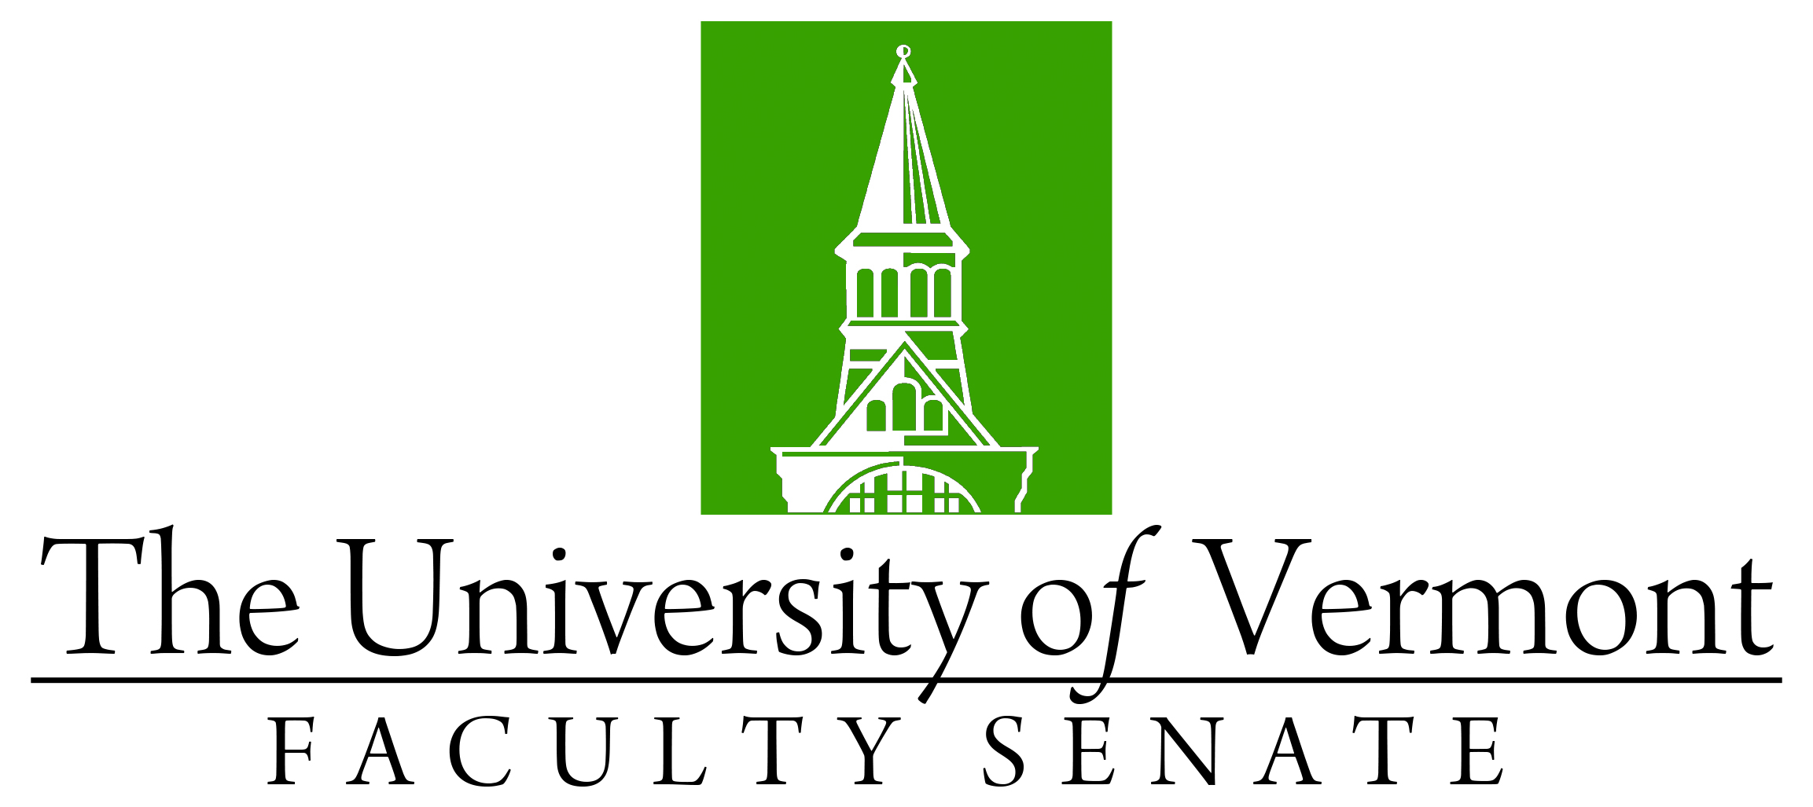

Faculty Senate Meeting
Monday, December 18, 2023
3:00 – 4:30 pm, Teams

Agenda

3:00 | - Faculty Senate President’s Welcome Remarks – Thomas Borchert
3:05 | - Resolutions in Memoriam (vote)  - Thomas Achenbach presented by Jeremiah Dickerson
3:10 | - Consent Agenda (vote)  - Minutes of the November 2023 Faculty Senate Meeting  - Curricular Affairs  - Name Change Dept of Plant & Soil Science from PSS to Dept of Agriculture, Landscape, and Environment (ALE)(CALS)  - Name Change Electrical Engineering Program from EE to Electrical and Computer Engineering (ECE)(CEMS)
3:15 | - Reports that do not require a Senate vote:  - Curricular Affairs Committee: New Prefixes and two APR reports  - ERTC and RSCA: Library Alma Migration  - AI Working Group memo  - April 2024 Senate Meeting Date Change from 4/22 to 4/29
3:20 | - Resolution to Accept the Proposal to Establish the Water Resources Institute (vote)
3:30 | - UVM Go faculty presentations
3:40 | - MyUVM portal transition (Susan Skalka and Veronika Carter)
4:00 | - University Finances Update (Richard Cate, VP of Finance)
4:25 | - New Business
4:30 | - adjourn

