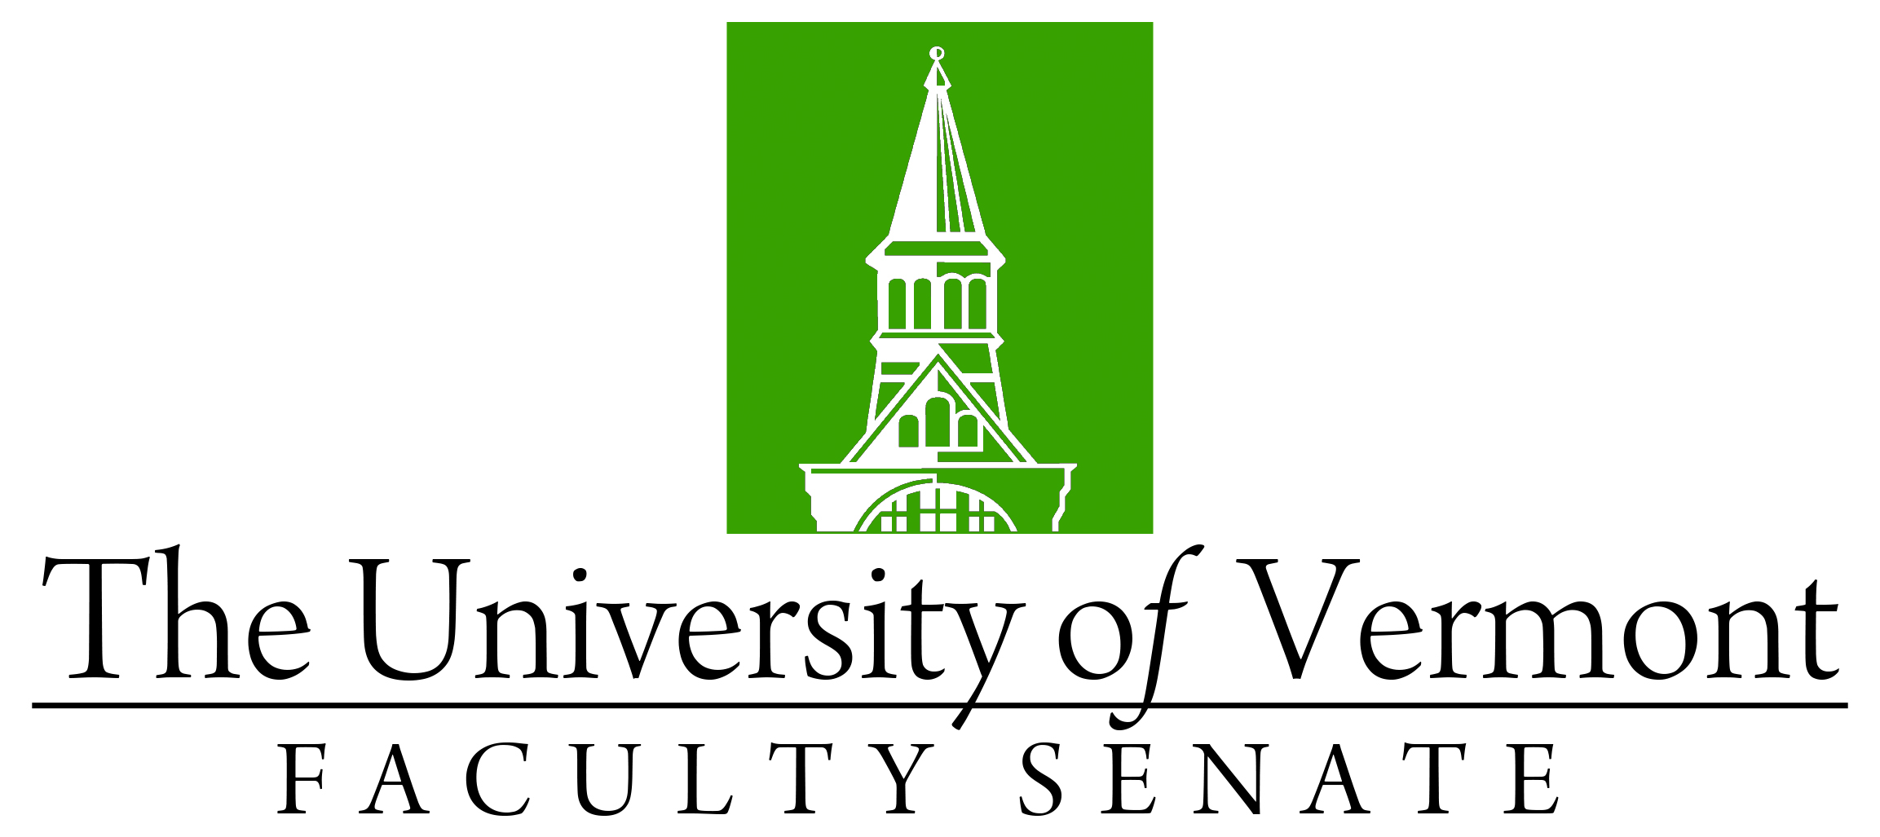

Faculty Senate Meeting
Monday, November 28, 2022
4:00 – 5:30 pm, Waterman 338

Agenda

4:00 | - Faculty Senate President’s Welcome Remarks – Thomas Borchert
4:05 | - Consent Agenda (vote)  - Minutes of the October 2022 Faculty Senate Meeting  - CAC materials  - No Contest Deactivation of MA in German, CAS  - No-Contest Deactivation of Gerontology Minor
4:10 | - Resolution in Memoriam (vote)  - Carroll McClure Lewin (Anthropology) – Presented by Luis Vivanco
4:15 | - Fleming Museum change within University Manual (discussion and possible vote)
4:30 | - Procedures for establishing centers and institutes (discussion and vote)
4:50 | - Reports that do not require a Senate vote:  - Curricular Affairs Committee (CAC) report on items voted by the CAC that do not require a Senate vote
4:55 | - Brightspace presentation – Wendy Barenback
5:10 | - Update on University Finances (Richard Cate)
5:25 | - New Business
5:30 | - Adjourn

