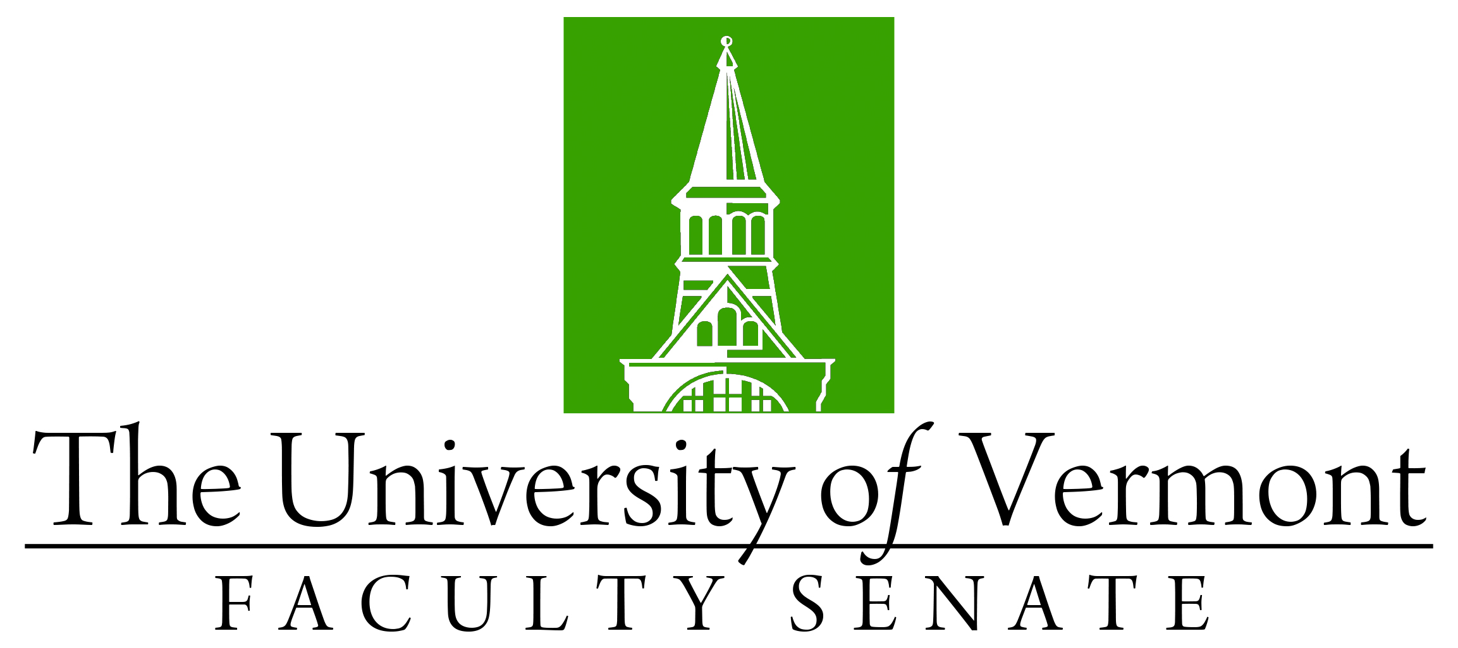

Faculty Senate Meeting
Monday, October 18, 2021
4:00 – 5:30 pm, Online via Teams

Agenda

4:00 | - Faculty Senate President’s Welcome Remarks – Thomas Borchert
4:05 | - Consent Agenda (vote)  - Minutes of the September 2021 Faculty Senate Meeting  - Ad hoc Committee on Senate Authority – Amendment to Resolution regarding ad hoc committee membership  - Curricular Affairs  - No-contest Deactivation of the RN-BS Program in Nursing (CNHS)  - No-contest Termination Italian Studies Major (CAS)  - No-Contest Termination Italian Minor (CAS)  - No-Contest Termination Speech and Debate Minor (CAS)  - No-contest Termination VT Studies Minor (CAS)  - New Certificate of Graduate Study and Micro-Certificate of Graduate Study in Education for Sustainability (GRAD/CESS)
4:10 | - Reports  - Curricular Affairs Committee Report on Actions Taken in Committee  - Student Affairs Committee Report on Actions Taken in Committee
4:15 | - Degree Conferrals – Graduate Degrees (vote)
4:20 | - Revised Procedures for Academic Organization (vote)  - Senate Procedures Related to the Establishment, Reorganization, and Elimination of:  - Colleges and Schools  - School within a College  - Department
4:45 | - Catamount Core Curriculum Committee (GenEd) Pablo Bose and/or J. Dickinson
5:05 | - New Business

2021-2022 Faculty Senate Meetings
Mondays 4:00 – 5:30 PM (exceptions noted)
10/18/21
11/15/21
12/20/21 – 3:00 – 4:30 PM
1/24/22
2/28/22
3/28/22
4/25/22
5/19/22 – 3:00 – 4:30 PM Thursday

