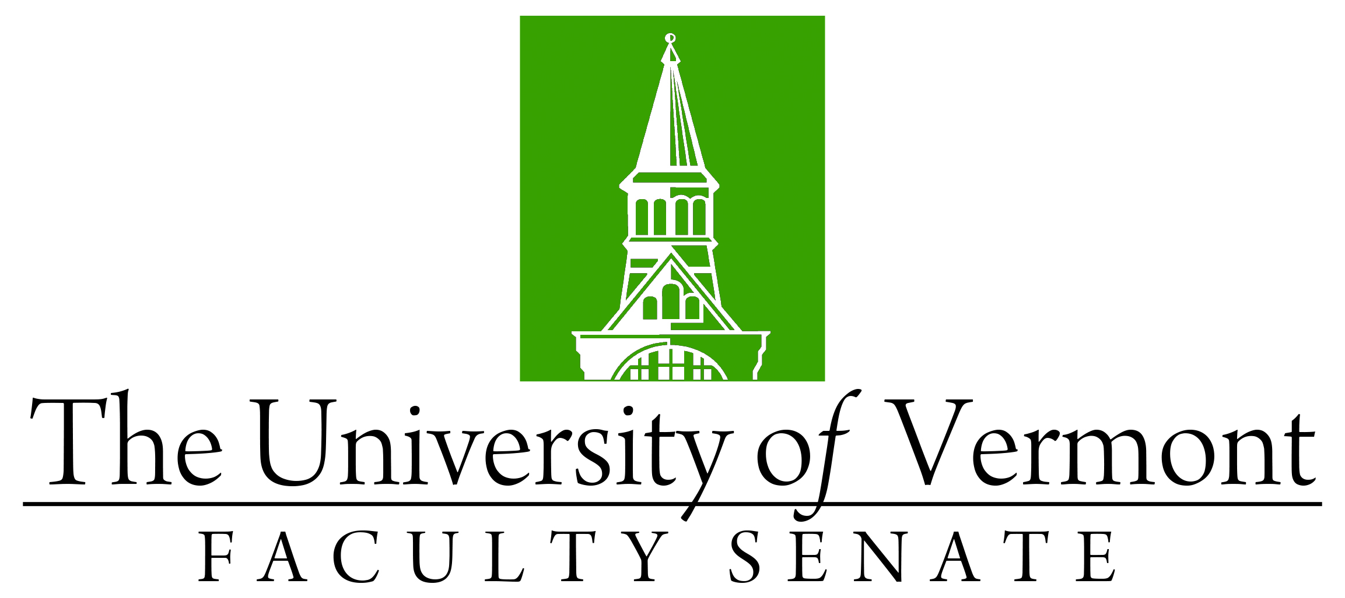

Faculty Senate Meeting
Monday, September 19, 2022
4:00 – 5:30 pm, on Teams

Agenda

4:00 | - Faculty Senate President’s Welcome Remarks – Thomas Borchert [5 min]
4:05 | - Consent Agenda (vote) [5 min]  - Minutes of the August 2022 Faculty Senate Meeting  - Curricular Affairs  - New PhD Social Emotional Health and Inclusive Education, CESS  - No-Contest Termination of B.S. Athletic Training, CNHS
4:10 | - Degree Conferrals (vote) [5 min]
4:15 | - Catamount Core (GenEd) changes (vote)
4:25 | - Proposal to establish Osher Center for Integrative Health (discussion)
4:50 | - Reports that do not require a Senate vote:  - CAC Report Out – Prefix Changes
4:52 | - Report on University DEI activities (Amer Ahmed, Vice Provost for Diversity, Equity and Inclusion, Paul Yoon, Senior Advisor for Inclusive Excellence, and Sherwood Smith, Senior Executive Director Office of VP for Diversity, Equity, and Inclusion)
5:15 | - Senate Representation (Report/Discussion: Chris Burns)
5:25 | - New Business
5:30 | - Adjourn

