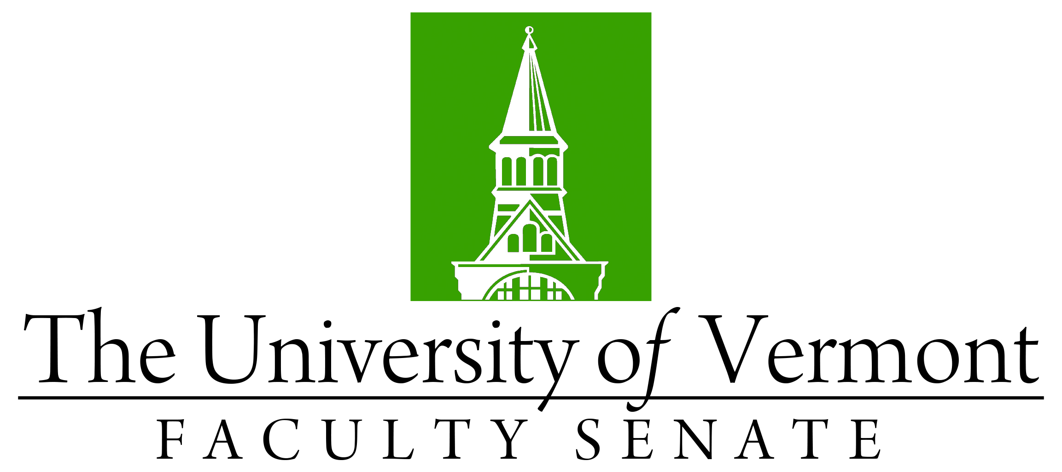

Faculty Senate Meeting
Thursday, May 18, 2023
3:00 – 4:30 pm, on Teams

Agenda

3:00 | - Faculty Senate President’s Welcome Remarks – Thomas Borchert
3:05 | - Degree Conferrals (vote)
3:10 | - Consent Agenda (vote)  - Minutes of the April 2023 Faculty Senate Meeting  - Resolutions to reappoint the Senate ad hoc Diversity, Equity & Inclusion (DEI) Committee for AY 2023-2024  - Curricular Affairs  - New Minor in Equine Studies (CALS)
3:15 | - Resolution in Memoriam (vote)  - Canute VanderMeer, Professor Emeritus of Geography, Presented by Shelly Rayback, Professor, Department of Geography and Geosciences
3:20 | - Revision to policy on Academic Freedom (vote)
3:30 | - Resolution on the University’s Response to the U.S. Department of Education Office for Civil Rights (OCR) Investigation (vote)  - OCR Letter Re: Outcome of Complaint No. 01-22-2002  - Resolution Agreement between UVM and OCR.
4:10 | - Catamount Core Curriculum (General Education) Report (Pablo Bose and J. Dickinson)
4:25 | - Reports that do not require a Senate vote:  - Gund Institute – Five-Year Review  - Report/memo from February round tables  - Religious Holidays Policy  - Reports from Senate Committees  - Report on moving CALS Biochemistry major from Deans office to Microbiology and Molecular Genetics  - Curricular Affairs Committee: Substantial Revision to Mathematical Science Major (CEMS), Substantial Revision to Wildlife Fisheries Major (RSENR), Substantial Revision to Masters in Public Health (CNHS), Revision of CAC Operating Procedures
4:30 | - Faculty Senate President’s Closing Remarks – Thomas Borchert
4:35 | - New Business
4:37 | - adjourn

