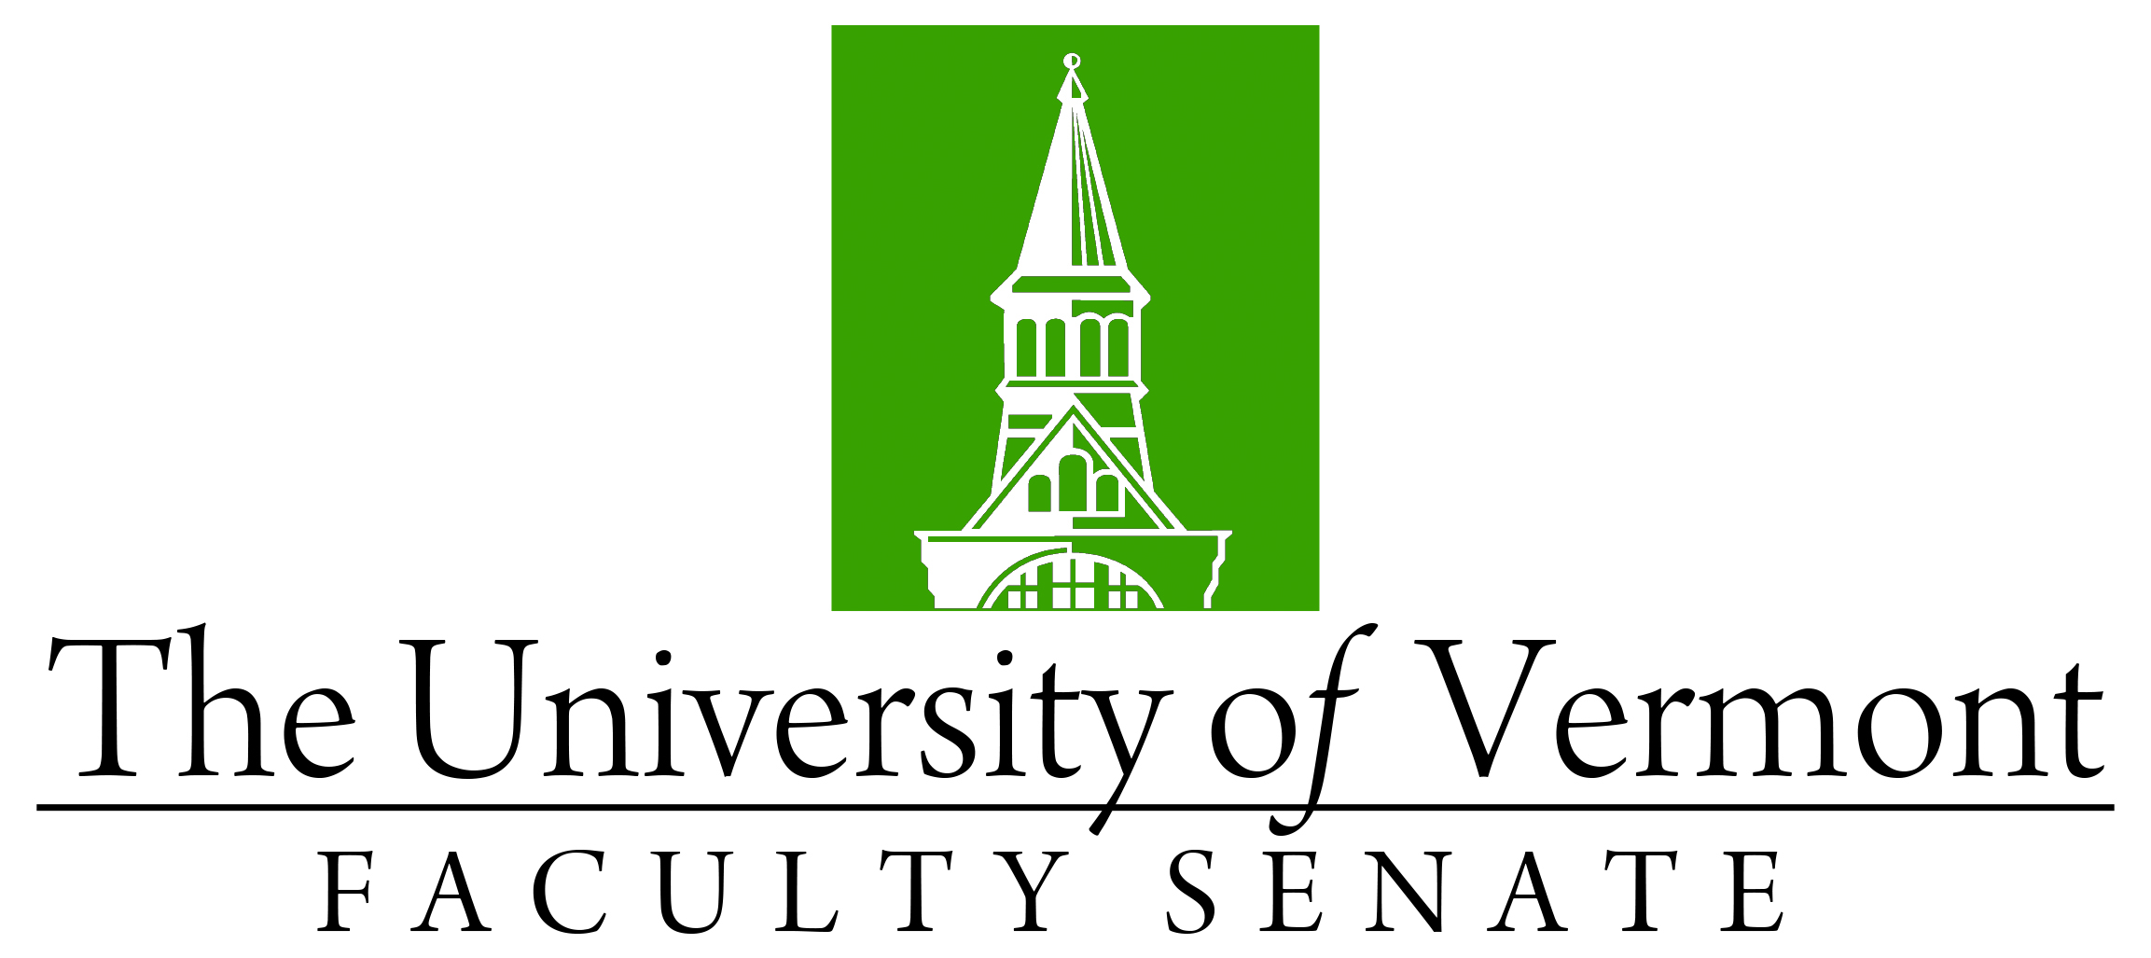

Faculty Senate Meeting
Monday, February 28, 2022
4:00 – 5:30 pm on Teams

Agenda

4:00 | - Faculty Senate President’s Welcome Remarks – Thomas Borchert
4:05 | - Consent Agenda (vote)  - Minutes of the January 2022 Faculty Senate Meeting  - Curricular Affairs  - Transdisciplinary Leadership and Creativity for Sustainability PhD
4:10 | - Reports that do not require a vote  - CAC APR report on Translational and Clinical Science  - The closing of the Geology Department at end of year
4:15 | - Composition of the UVM Board of Trustees (Discussion)
4:30 | - Art and Science Report “Institutional Strategy Study” (Discussion)  https://www.uvm.edu/provost/art-and-science-group
5:15 | - New Business
5:20 | - Adjourn

Spring 2022 Faculty Senate Meetings
Mondays 4:00 – 5:30 PM (exceptions noted)
1/24/22
2/28/22
3/28/22
4/25/22
5/19/22 – 3:00 – 4:30 PM Thursday

