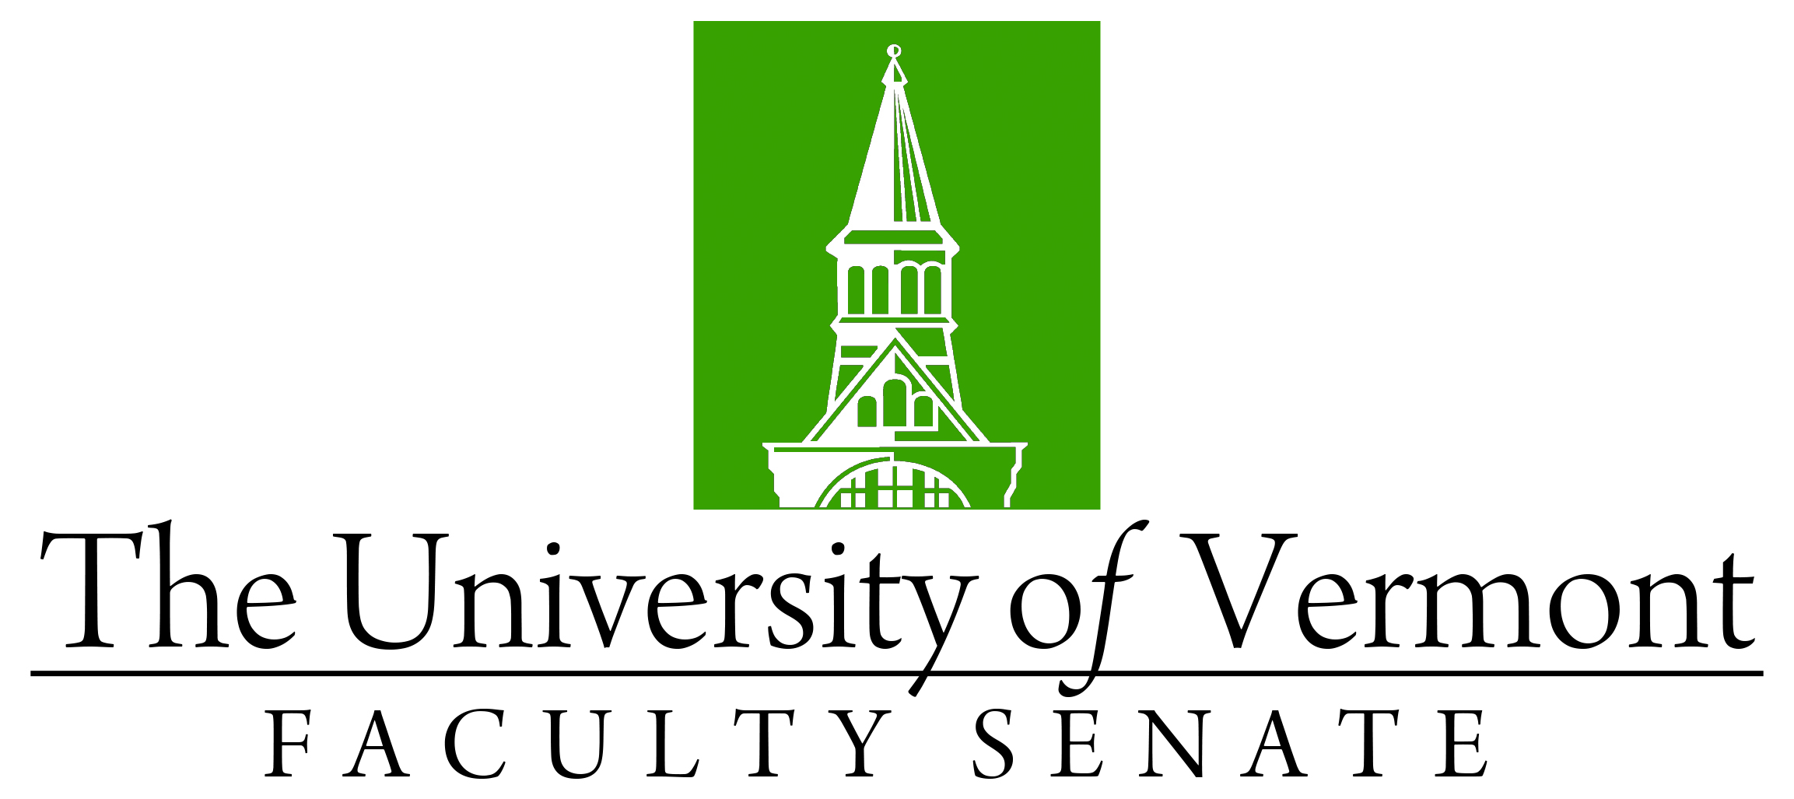

Faculty Senate Meeting
Monday, October 28th, 2019
4:00 – 5:30 pm, Waterman Memorial Lounge

Agenda

4:00 | - Faculty Senate President’s Welcome Remarks – Thomas Chittenden [10 min]
4:10 | - Consent Agenda (vote) [10 min]  - Minutes of the 5/16/19 Faculty Senate Meeting  - Minutes of the 9/23/19 Faculty Senate Meeting  Curricular Affairs  - Name change for the major and minor in Ecological Agriculture to Agroecology (CALS)  - Report Out: Revised Policy Documents (“Research Endeavor” removed from document titles and introductory paragraphs)
4:20 | - Conferral of Graduate Degrees (vote) [5 min]
4:25 | - Advising and EAB Navigate – Provost Prelock and J. Dickinson [30 min]
4:55 | - General Education Alignment Task Force – J. Dickinson [30 min]
5:25 | - New Business [5 min]
5:30 | - Adjourn

