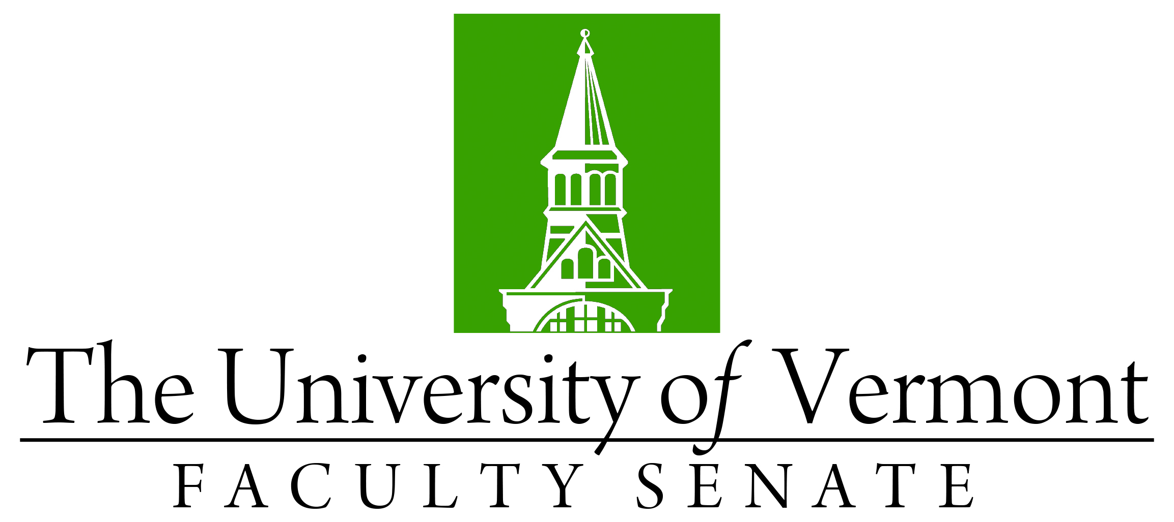
DRAFT

Faculty Senate Meeting
Monday, November 18th, 2019
4:00 – 5:30 pm, Waterman Memorial Lounge

Agenda

4:00 | - Faculty Senate President’s Welcome Remarks – Thomas Chittenden [5 min]
4:05 | - Consent Agenda (vote) [5 min]  - Minutes of the 10/28/19 Faculty Senate Meeting  Curricular Affairs  - No Contest Termination of the Master of Education in Reading and Language Arts (CESS/Grad College)  - New Minor in Bioinformatics (CALS)  - Name change of the Department of Romance Languages to the Department of Romance Languages and Cultures (CAS)  - Name change of the PhD in Human Functioning and Rehabilitation Science to the PhD in Interprofessional Health Sciences (CNHS/Grad College)  - Report Out: Substantial Changes to the BS in Business Administration (GSB)
4:10 | - Resolutions in Memoriam (vote) [10 min]  - Susan Brody Hasazi (CESS) presented by Katherine Shepherd  - Kenneth N. Fischell (CESS)presented by Charlie Rathbone
4:20 | - Course Evaluation Platform Explorance Blue Update – Thomas Chittenden [10 min]
4:30 | - GPA Calculation Change for Repeated Courses – Ken Allen [15 min]
4:45 | - Residential Learning Communities Ad Hoc Committee Update – Chris Burns & J Dickinson [20 min]
5:05 | - Petition to discuss and vote on the impact of the basing of the F35 at the Burlington International Airport - Meaghan Emery (vote)[20 min]
5:25 | - New Business [5 min]
5:30 | - Adjourn

