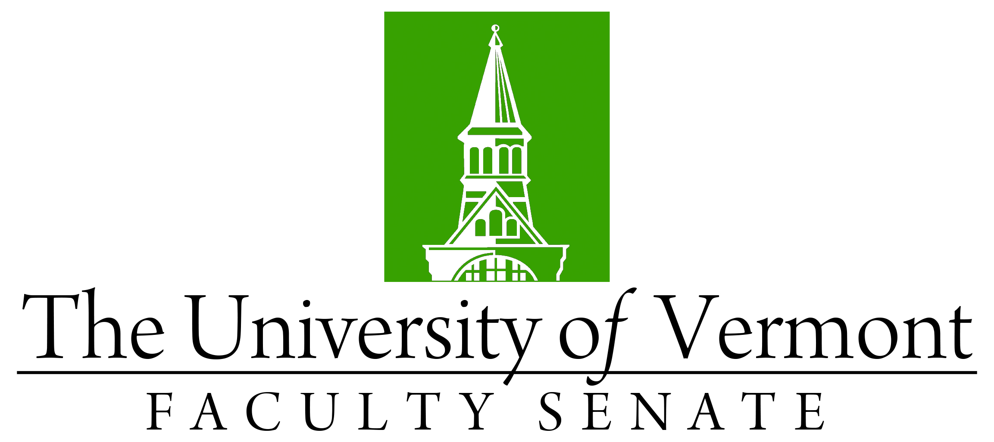

Faculty Senate Meeting
Thursday, May 14th, 2020
3:00 – 4:30 pm, Microsoft Teams

Agenda

3:00 | - Faculty Senate President’s Welcome Remarks – Thomas Chittenden [10 min]
3:10 | - Consent Agenda (vote) [2 min]  - Minutes of the 4/20/20 Faculty Senate Meeting  Curricular Affairs  - New Place-Based Education Undergraduate Certificate (CESS, RSENR)  - New PhD in Sustainable Development Policy, Economics and Governance (CALS)  - Deactivate the French Master of Arts (CAS)  - Name Change: MS in Mathematics to the MS in Mathematical Sciences (CEMS)  - Report Out of items that do not require a Faculty Senate vote
3:12 | - Presentation of Candidates for Degrees (vote) [8 min]
3:20 | - President Garimella Remarks [10 min]
3:30 | - UVM Board Chair Ron Lumbra [20 min]
3:50 | - General Education Credit Hour Allocation (vote) [20 min]  Catamount Core Curriculum – Total required credits in each requirement  Motion: All undergraduate degree students will complete the following requirements: 6 credits in the Arts and Humanities category; 6 credits in Social Sciences; 6 credits in Natural Sciences; 3 credits in Mathematics; 3 credits in Quantitative and Data Literacy; 3 credits in Foundational Writing and Information Literacy; 3 additional credits from either Writing and Information Literacy 2 or Oral Communication and information literacy courses; 3 credits in Sustainability; 3 credits in Global Citizenship; 3 credits of D1 courses, and an additional 3 credits of either D1 or D2 courses.
4:10 | - RLC data – results of the assessment – Provost Prelock [15 min]
4:25 | - New Business [5 min]
4:30 | - Adjourn

